Linux OS :

[Complete Linux Training Course to Get Your Dream IT Job 2024 (youtube.com)](https://www.youtube.com/watch?v=w-kt1lXp1Wo)

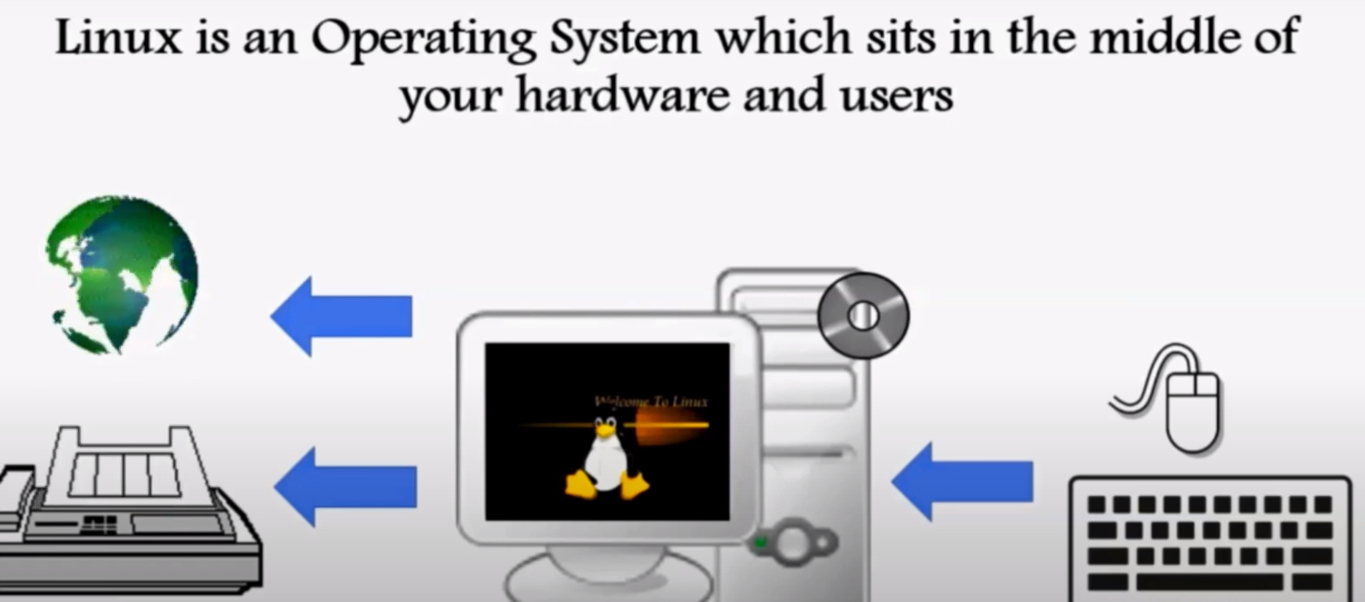

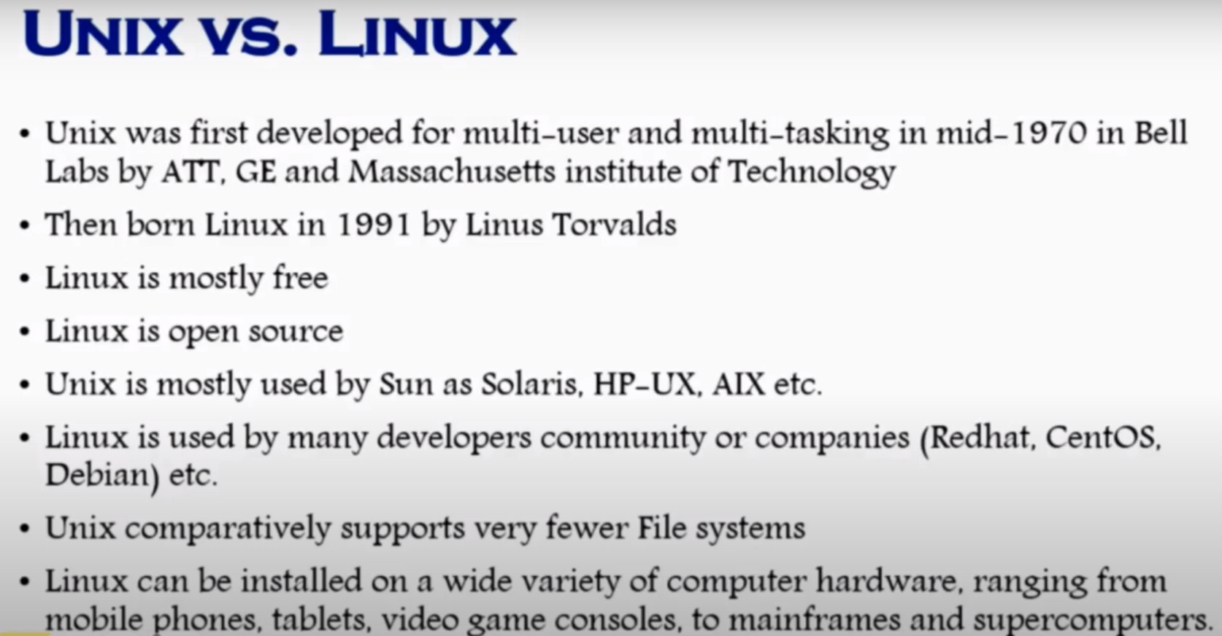



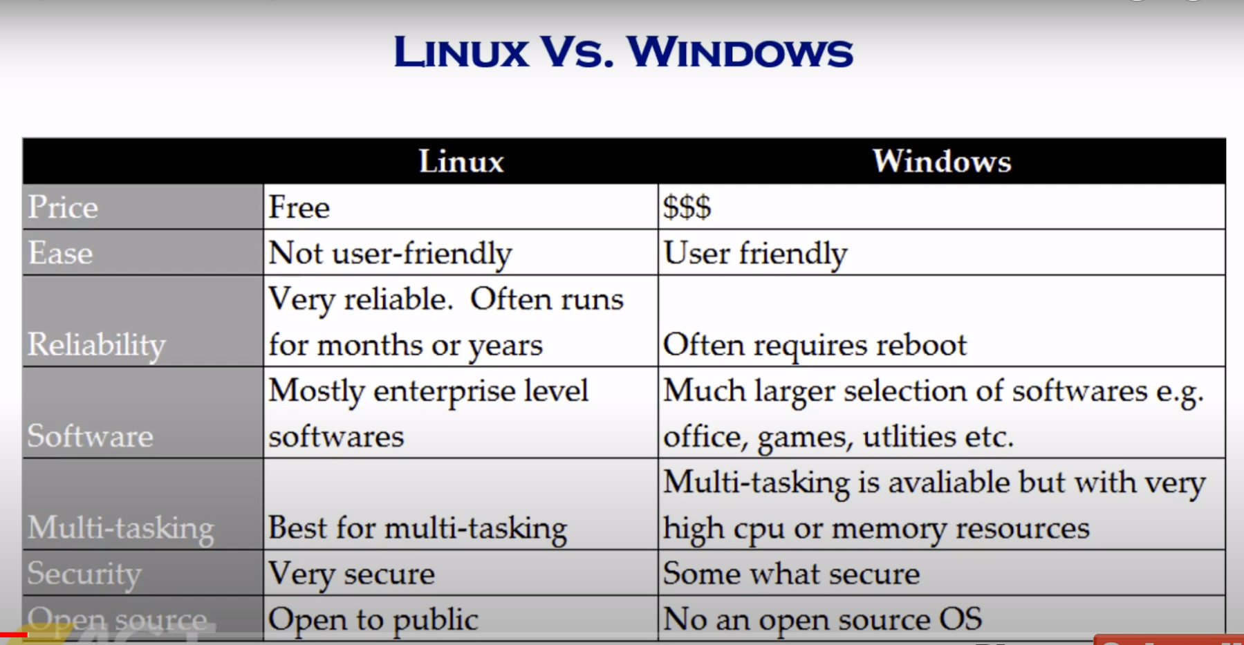

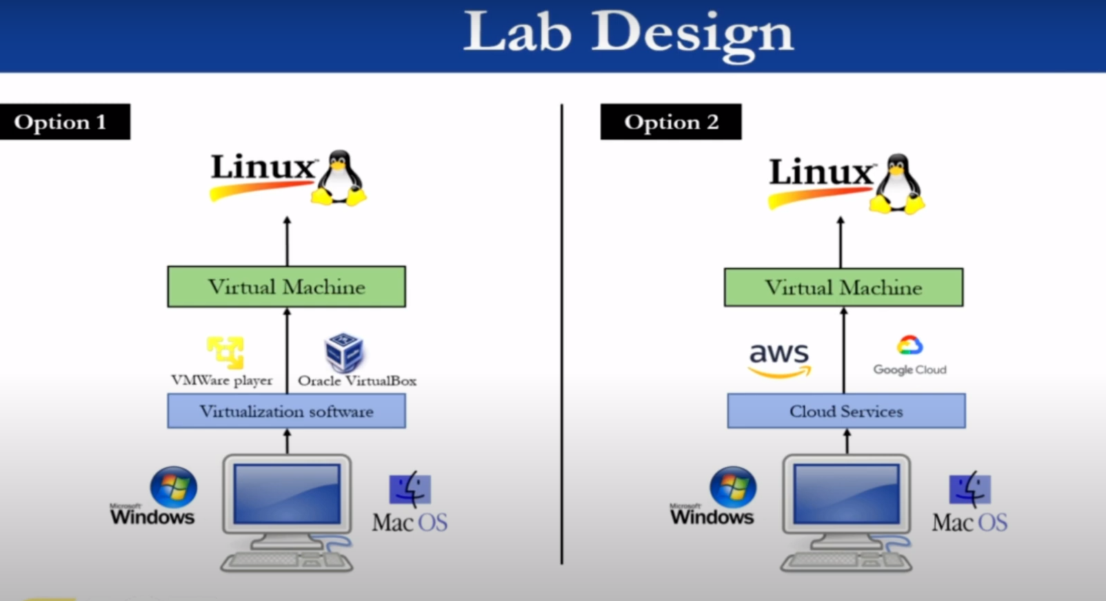

Clickshare : The target infrastructure consists of at least 2 servers: the landing server and a build node. To make this more scalable we can add more build nodes. R&D will login to the landing server. On that server they can select which build environment they want to use. This will create a docker build environment on a build node. The docker container will have 2 mounted storages, the user’s persistent storage and a fast-volatile storage. The user’s persistent storage will be used to store the user’s config files such as git private keys and will be hosted by the landing server. The fast-volatile storage, that is available on the build node, will be used as working directory, this will be very useful for large compiling tasks.  
  
Docker is a platform designed to make it easier to create, deploy, and run applications by using containers. Containers allow developers to package up an application with all the parts it needs, such as libraries and other dependencies, and ship it all out as one package. This ensures that the application runs seamlessly in any environment, whether it is a developer's laptop, a testing environment, or a production server.

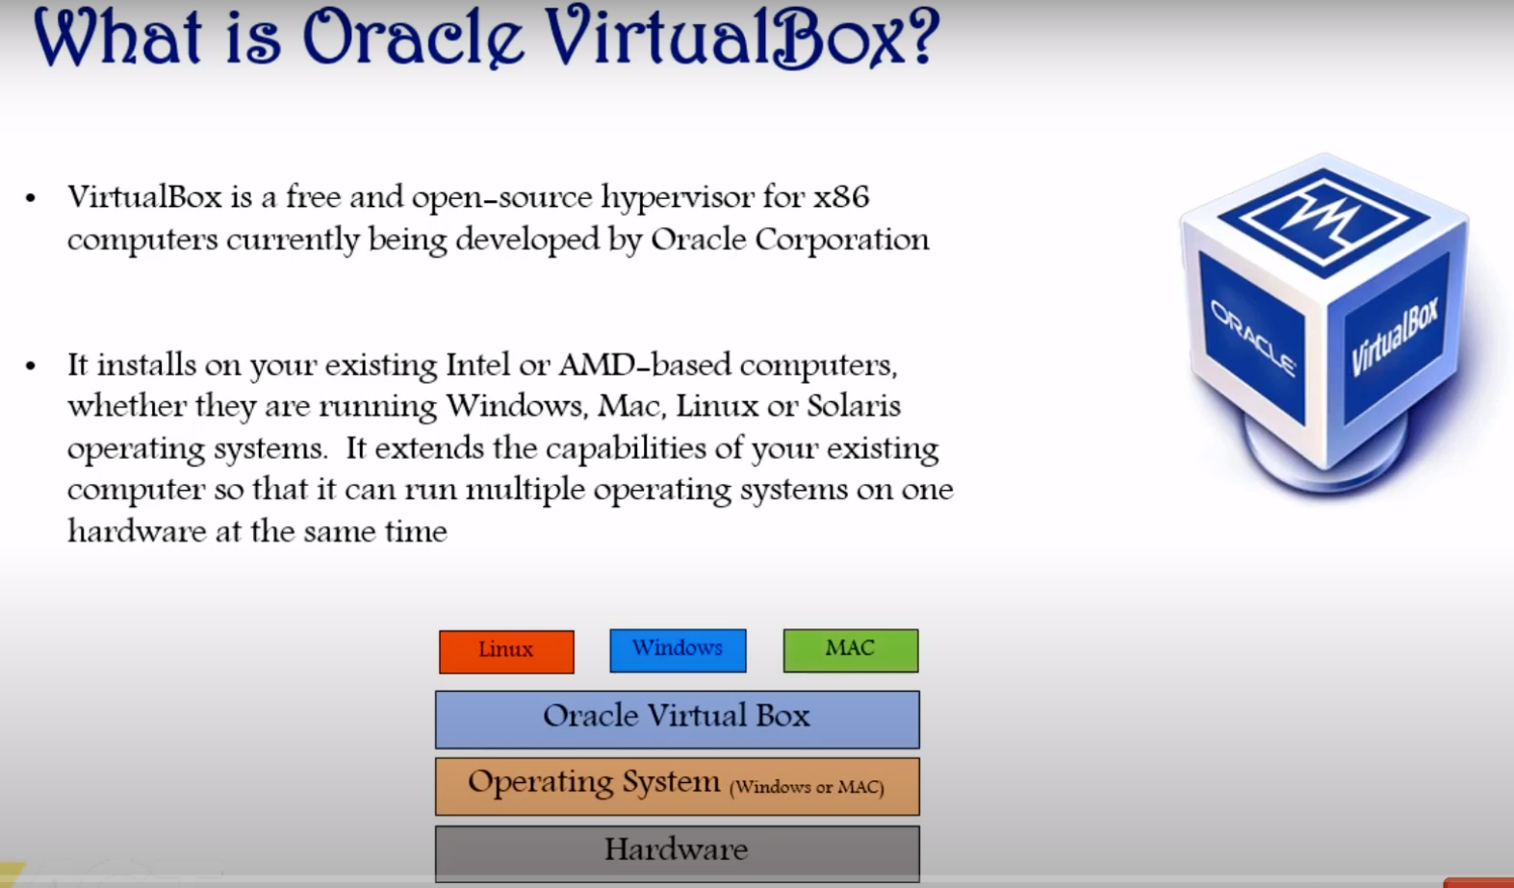

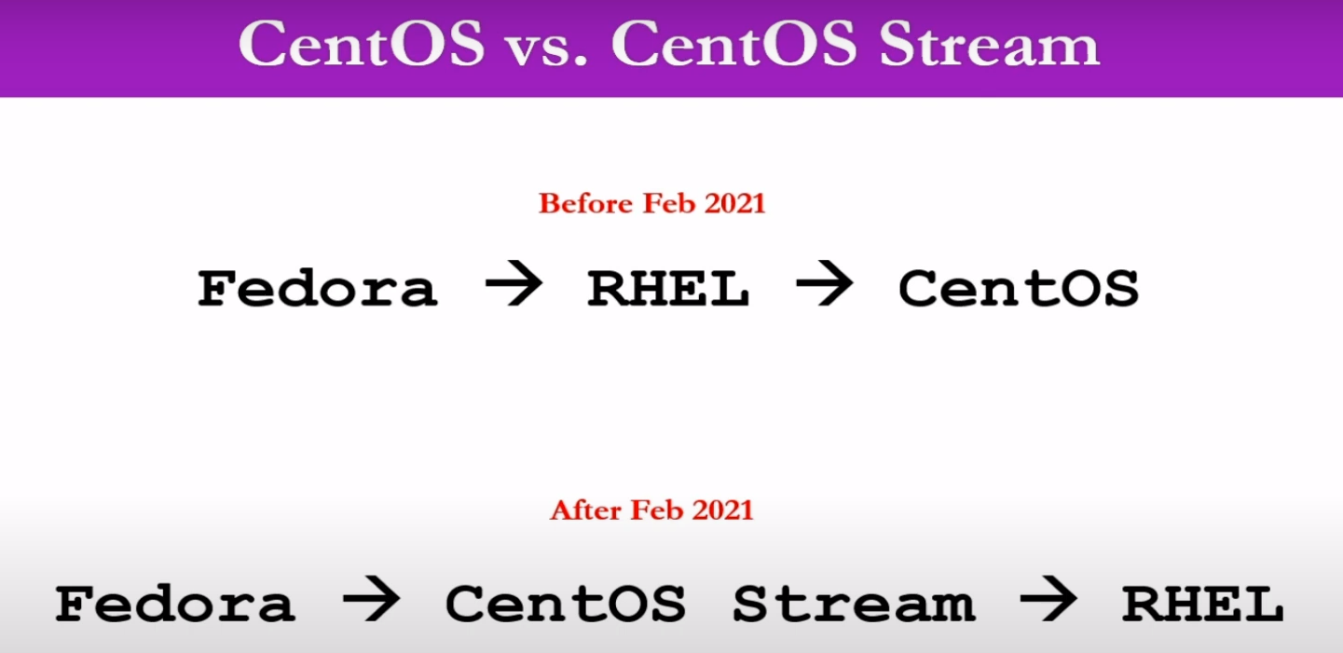

Enable virtualization in BIOS settings if you want VMWare to work. Once virtual machine software is installed, you must attach an iso image of the OS to it.

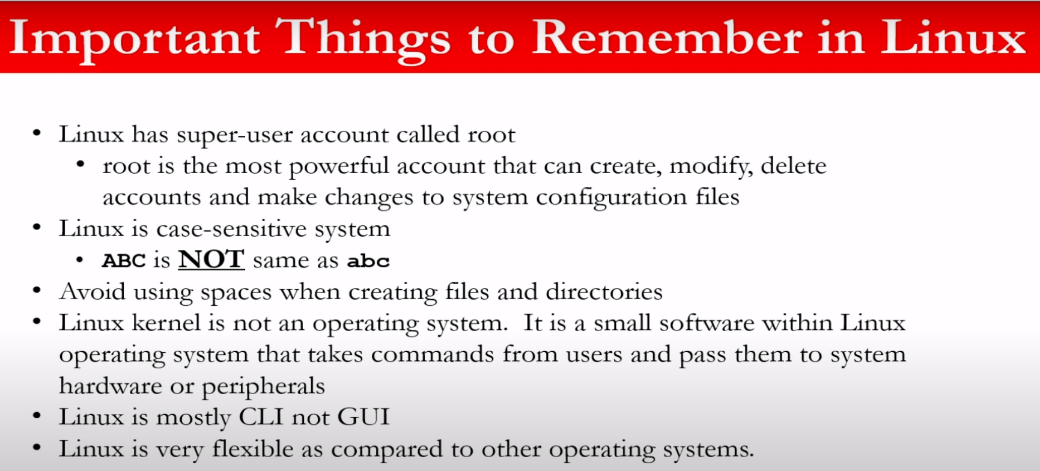

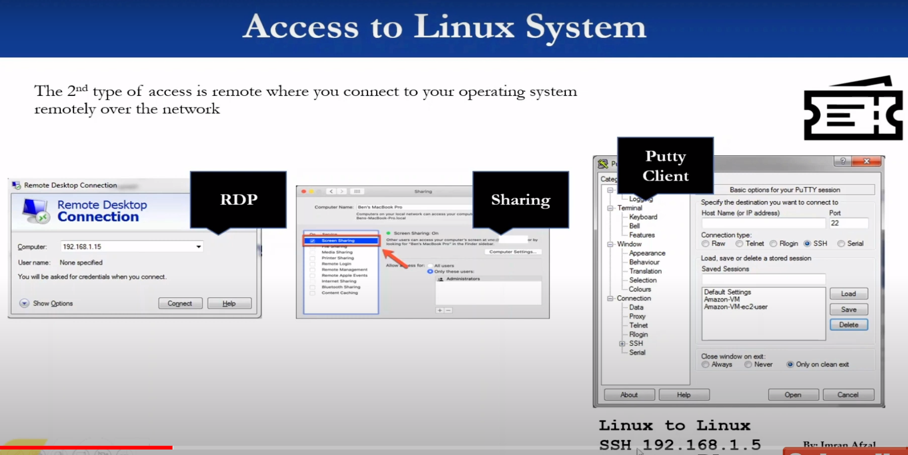

Putty software is used to connect from windows machine to Linux machine.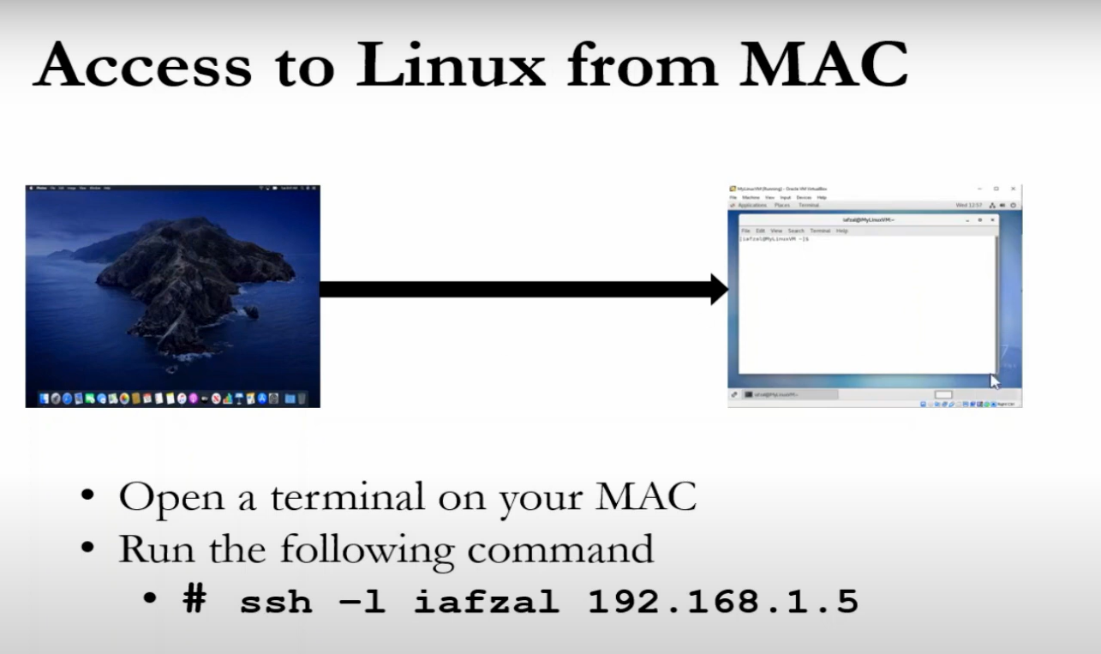

To check ip on Debian system, I used : “hostname -I”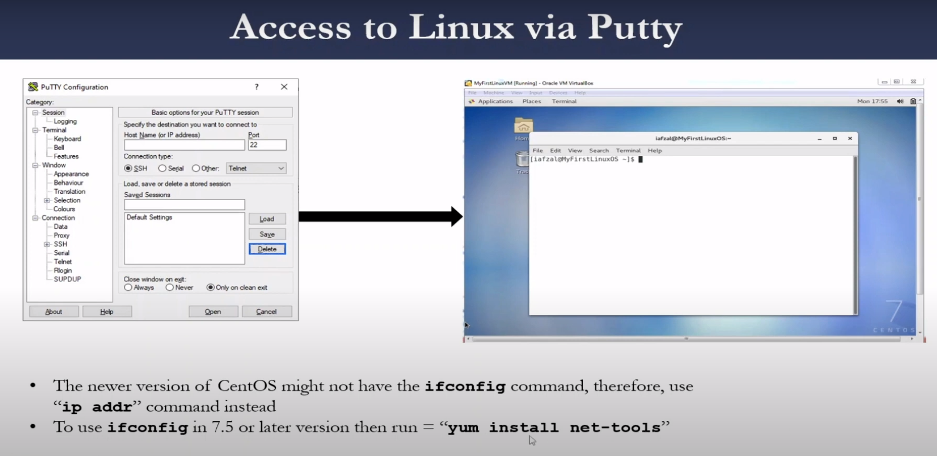

Connecting through putty gives us the command line operation of the remote linux dektop, it opens a terminal for us on the window side.

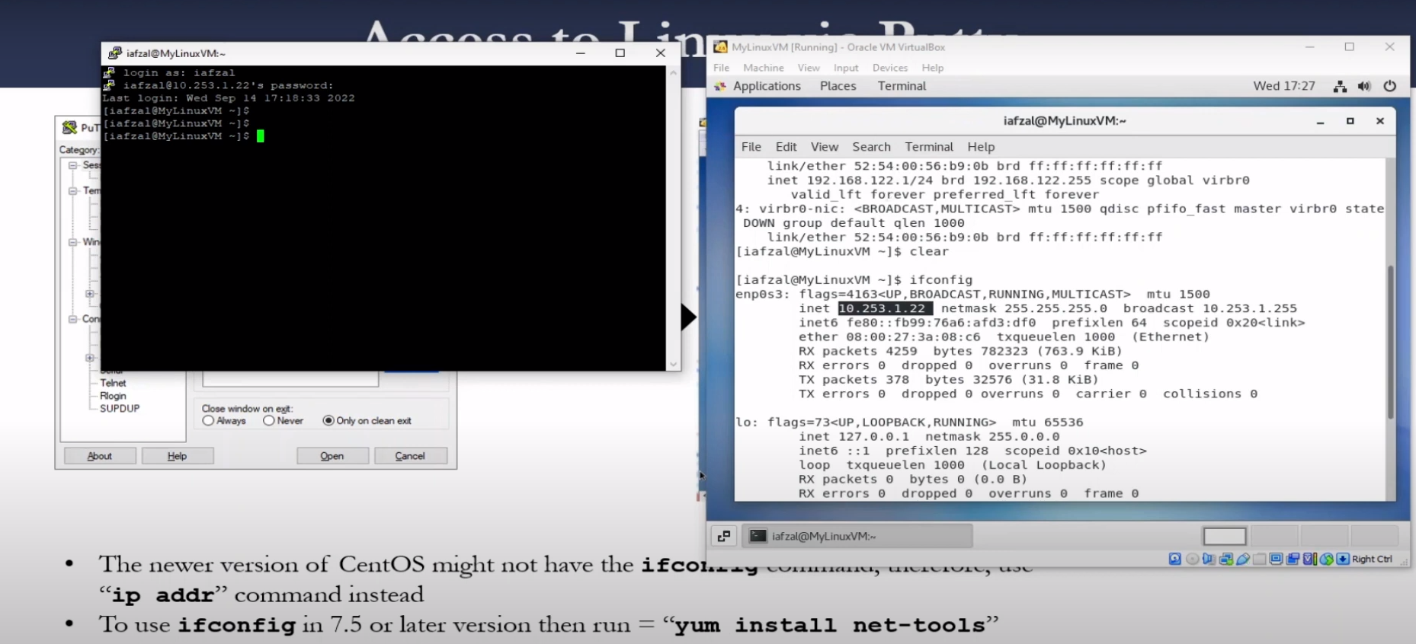

If you see # symbol, that means u r logged in as root, if $ sign that means as non root user( but this can be configured) or u can us “whoami” command to check ur root status.

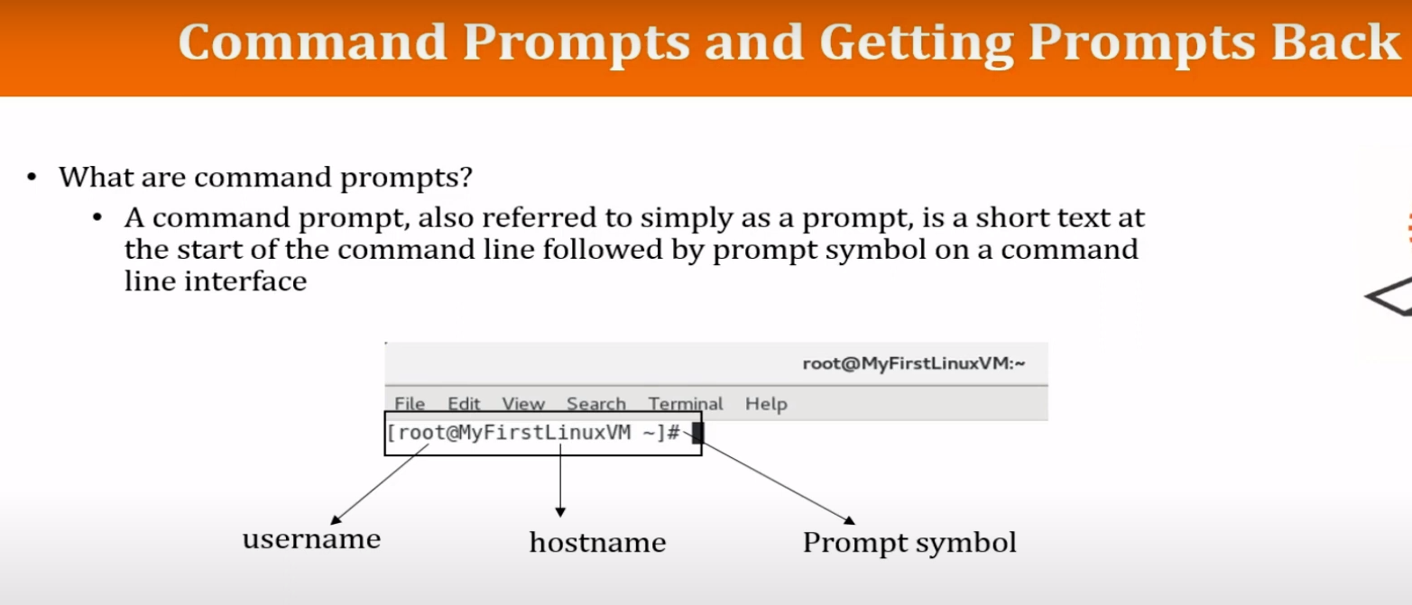

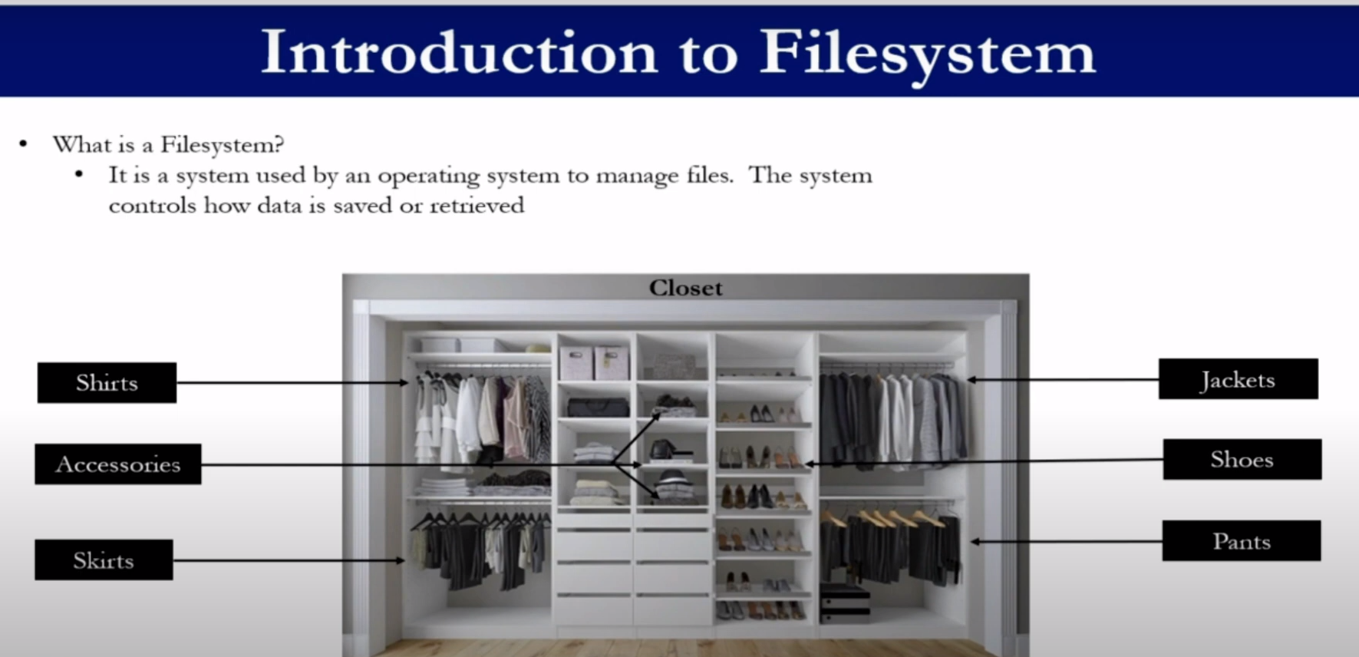

If there are no divisions on your filesystem it will look like this:  
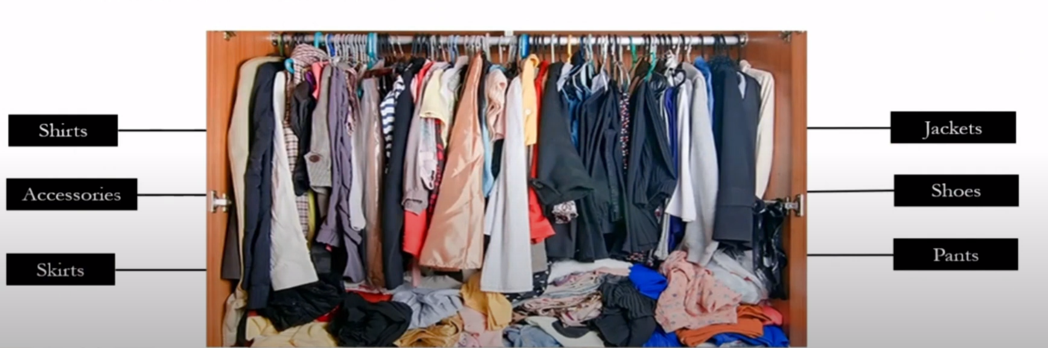

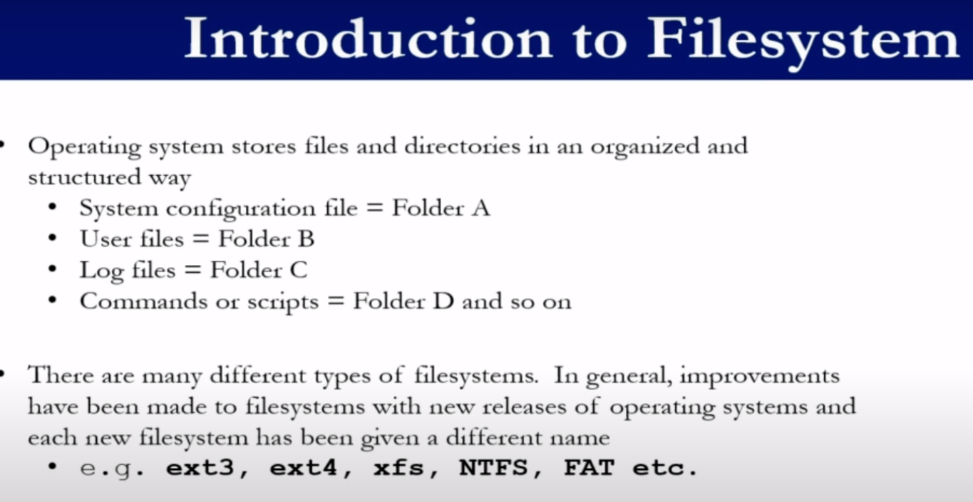

First time, the linux system boots up, it looks for a /boot folder.

/root is not same as “/” : this is root. /root is root user’s home directory.

/etc : contains configuration files.

/bin or /usr/bin : everyday user commands.

/usr/sbin : for system file system related files.

/opt : optional apps not part of OS system.

/proc: currently running processes, when u shutdown your system, there will be nothing in /proc.

/libs : Cmds like pwd and ls are able to run because they have their supporting libraries present here.  
 If you want to know which library is being used for which command, you can use,  
 strace -e open pwd

/media : in case of running from virtual machine, the iso image is shown here, otherwise its meant for showing CD roms etc.

/var : system logs

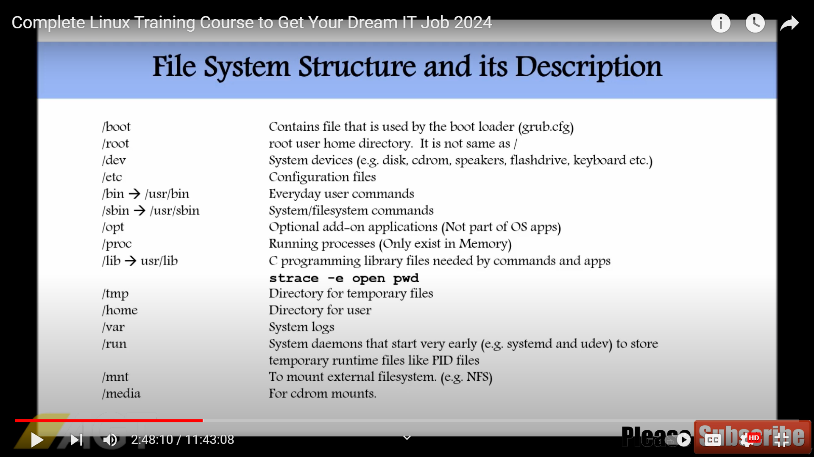

The **/sys** directory in Linux is a virtual filesystem provided by the kernel to interact with kernel data structures and expose information about the system's hardware configuration. It stands for the "sysfs" filesystem.  
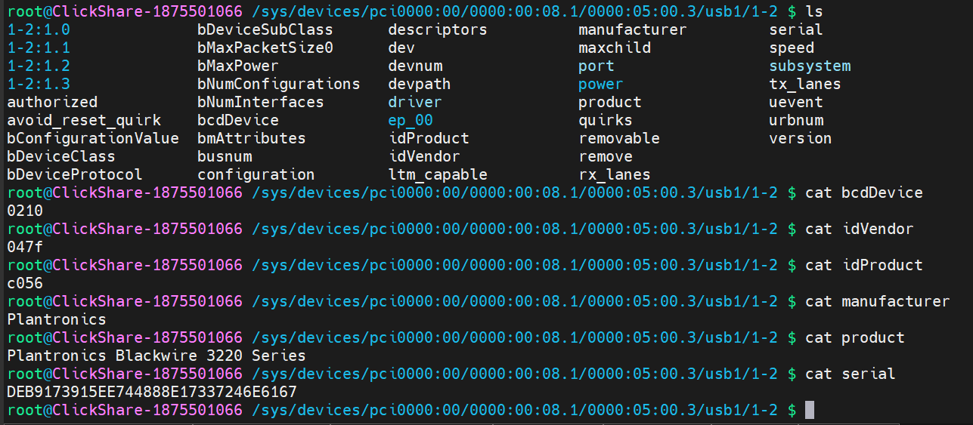

Here are some common uses of the **/sys** directory:

1. **Device Information**: It contains information about detected hardware devices, their drivers, and their configuration. You can navigate through the **/sys** directory to access details about various devices connected to the system.
2. **Kernel Parameters**: You can view and modify certain kernel parameters and settings in the **/sys** directory. This includes things like CPU and memory settings, power management parameters, and more.
3. **Hardware Configuration**: **/sys** provides a way to view and modify hardware configuration settings, such as IRQ assignments, DMA channels, and I/O port addresses.
4. **System Information**: It offers access to various system information, such as CPU and memory usage, system uptime, and more.
5. **Kernel Modules**: You can interact with loaded kernel modules through the **/sys** directory, including loading and unloading modules and querying module parameters.
6. **Power Management**: It provides interfaces for power management features, allowing you to control system sleep states, CPU frequency scaling, and more.

Overall, the **/sys** directory serves as a bridge between the kernel and user space, providing a way for users and system administrators to interact with and query kernel data and settings in a hierarchical and structured manner.

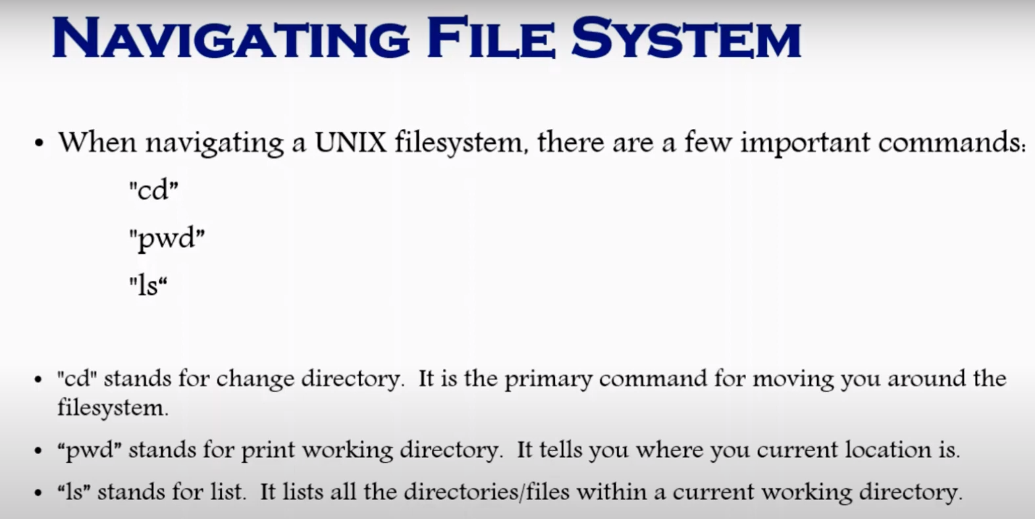

In this image, anything that starts with - means file, d means directory, l means link.

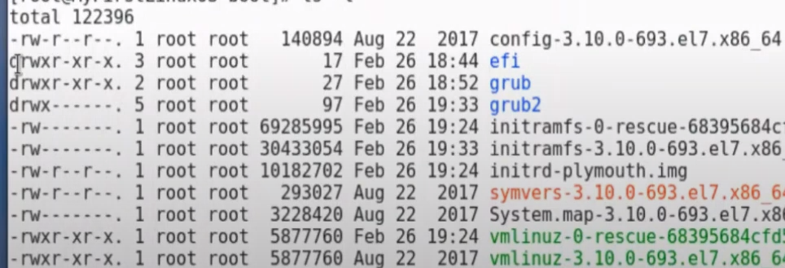

If you simply write, cd , it will take you to root directory.

If you want to see the properties of the subdirectory , do ls -l

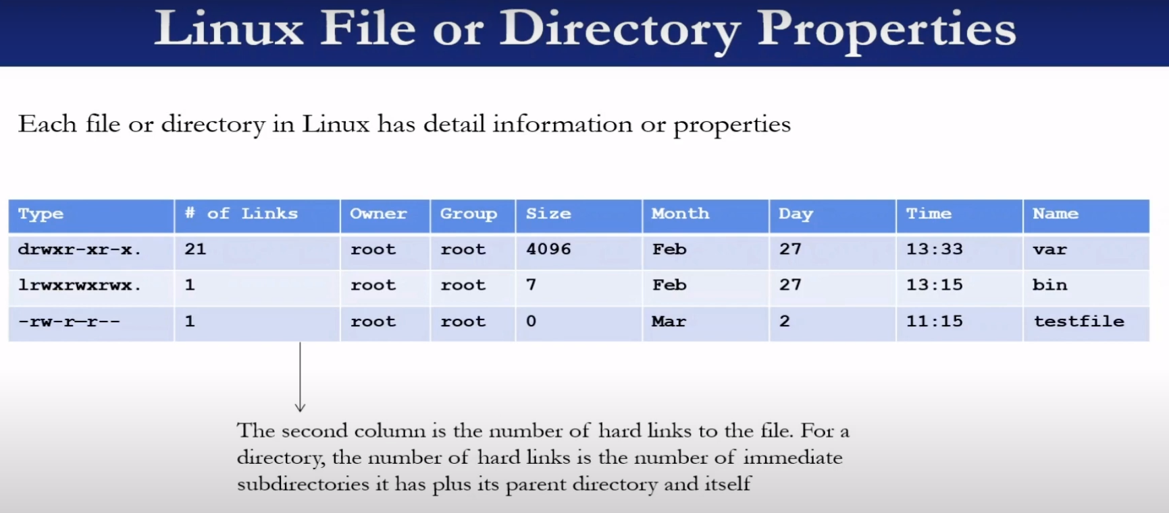

File type starting with c means system files, means if you plugin something like device driver etc will show up as c type.

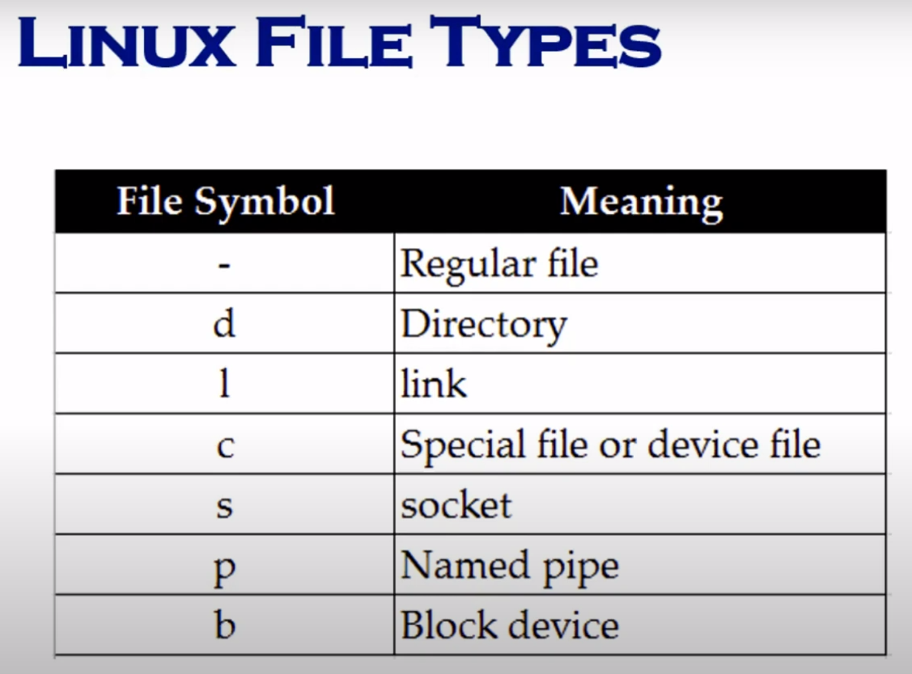

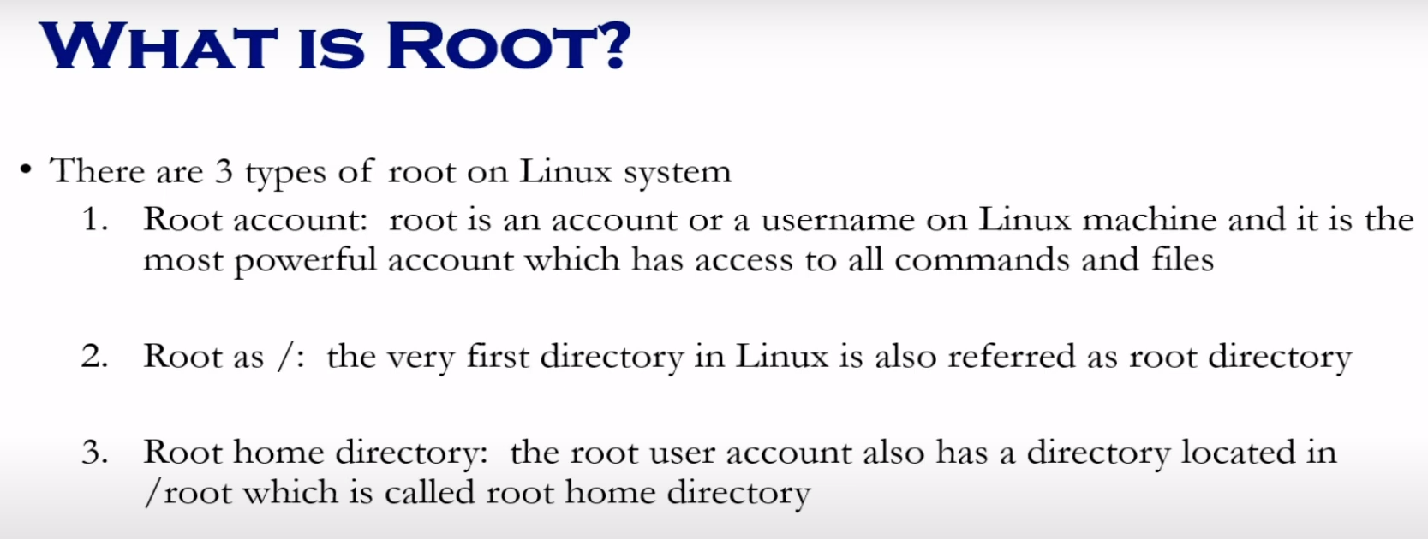

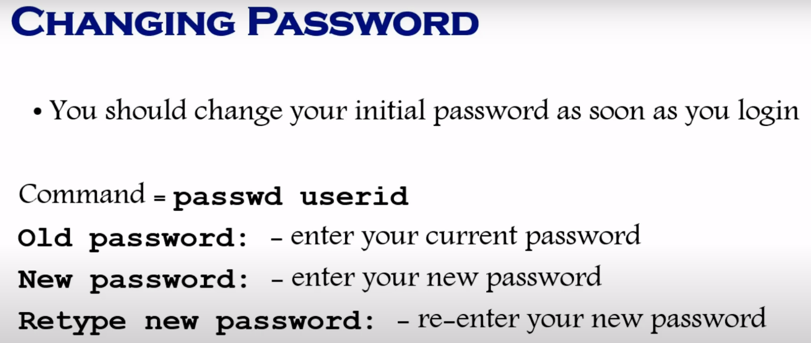

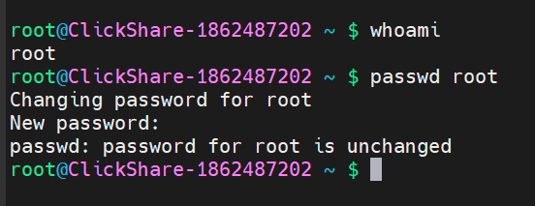

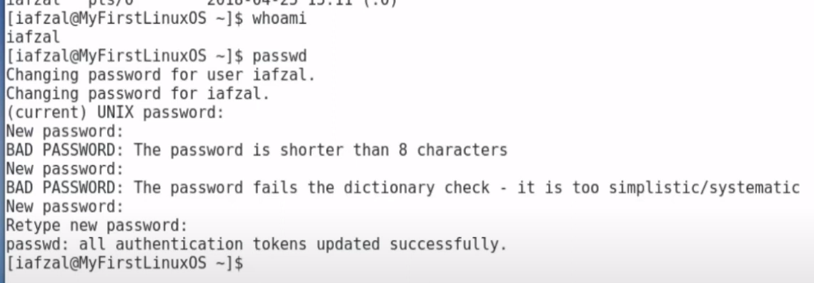

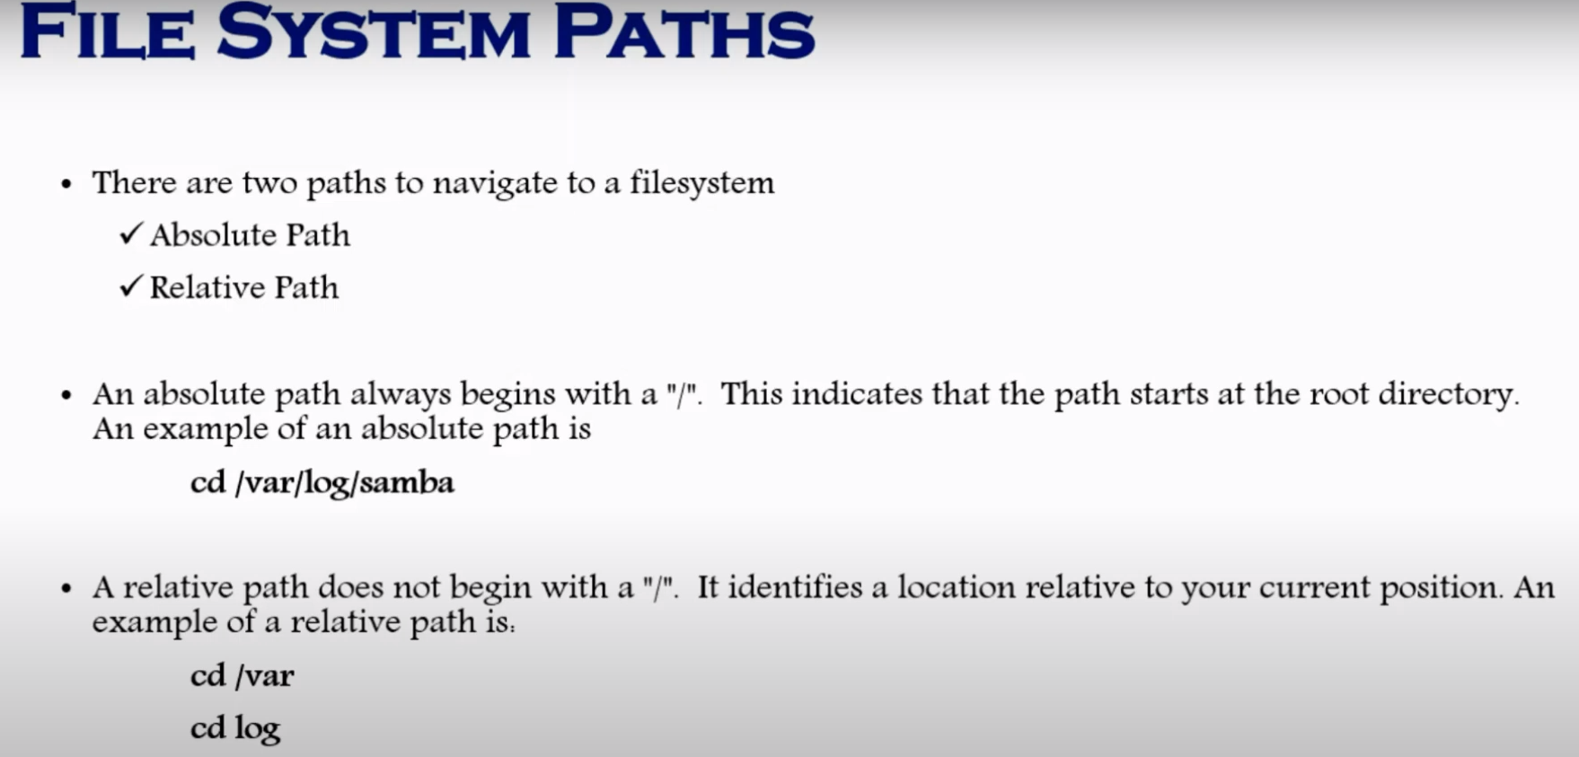

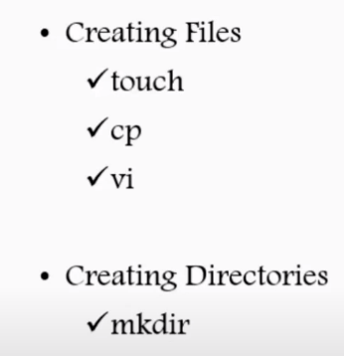 Ls -ltr lists directories by order of last updates or created, in reverse.

Using cp to create a copy of existing file :  
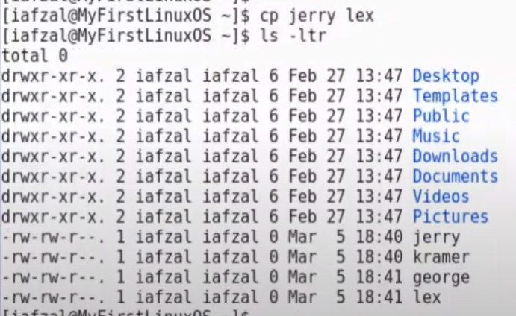

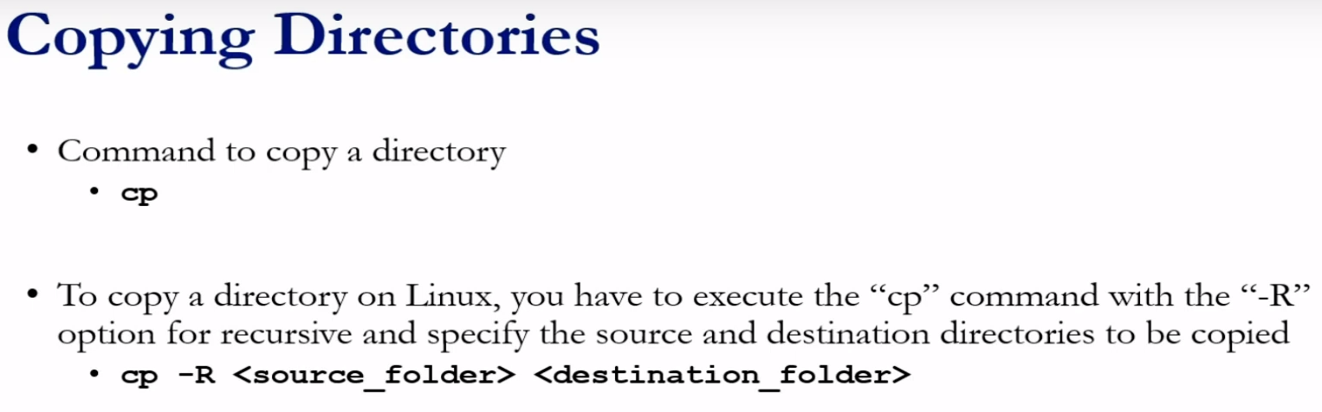

Copied config folder to tmp directory with a new name config-bak which contains config directory content in it.

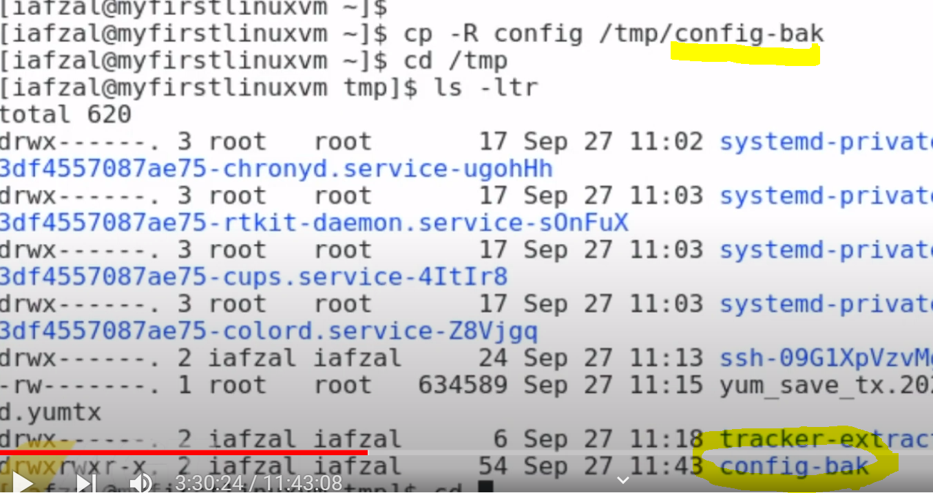

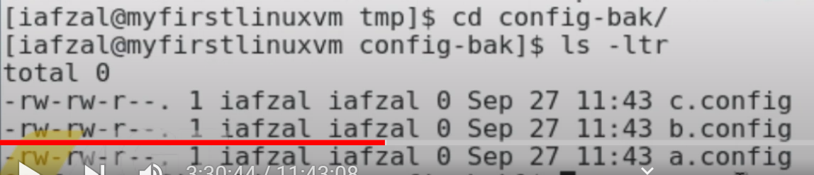

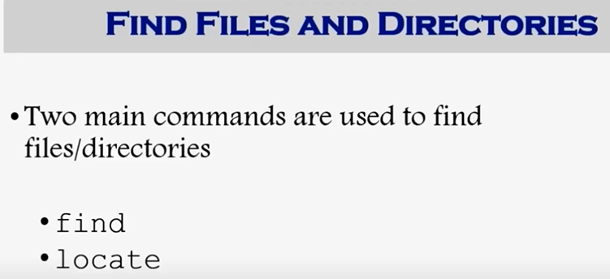

This find command will start finding from the current directory, one by one,

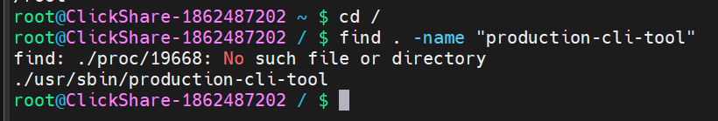

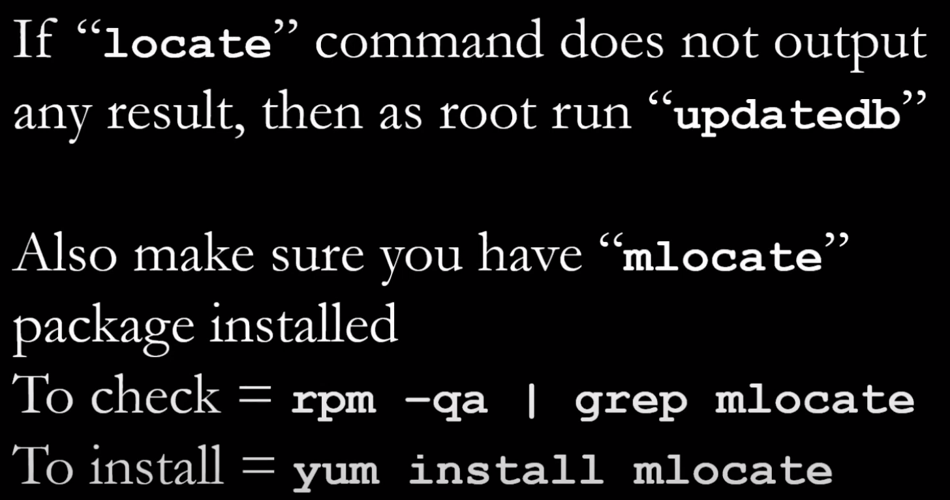

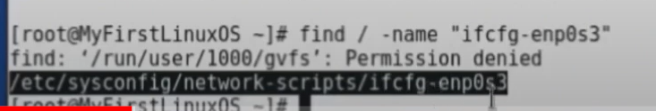

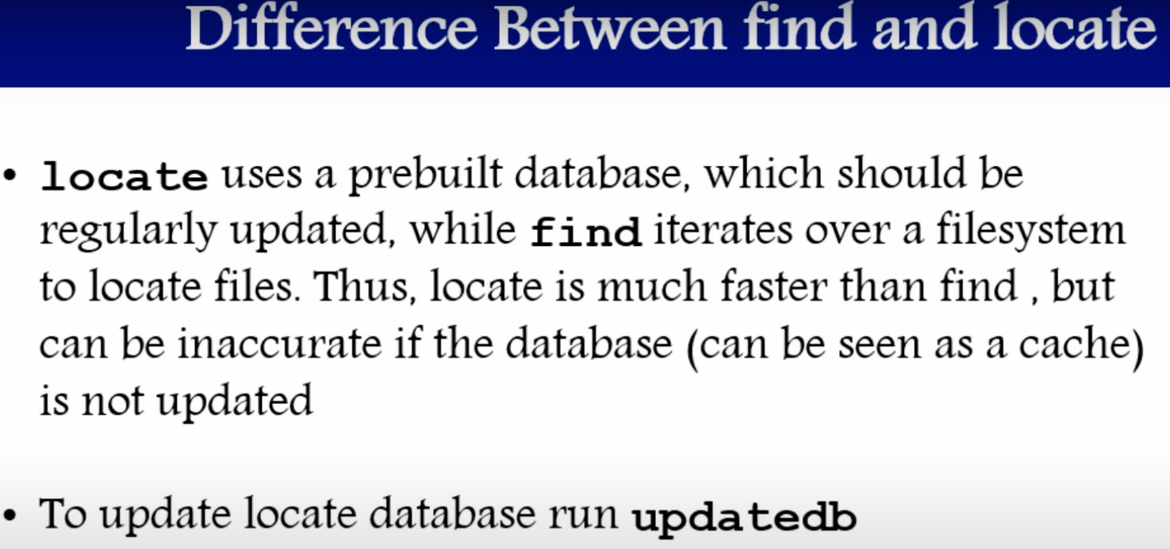

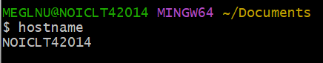 hostname gives this output

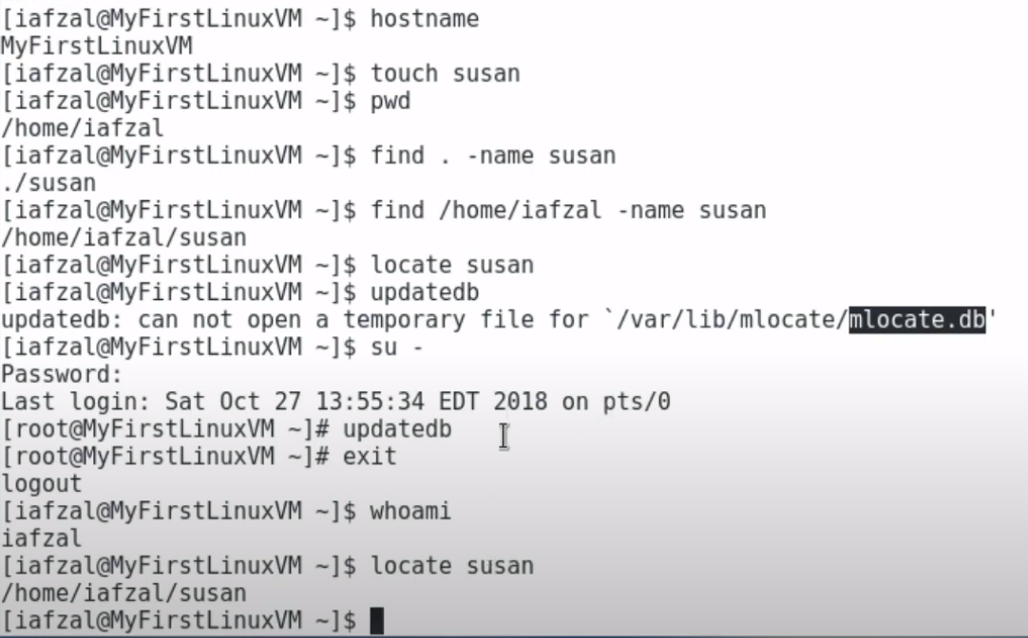

Wildcards in poker :  
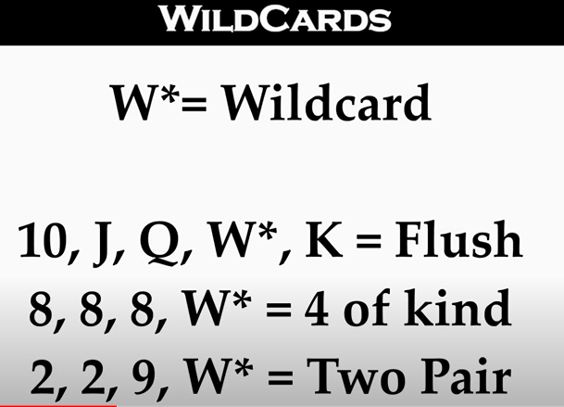

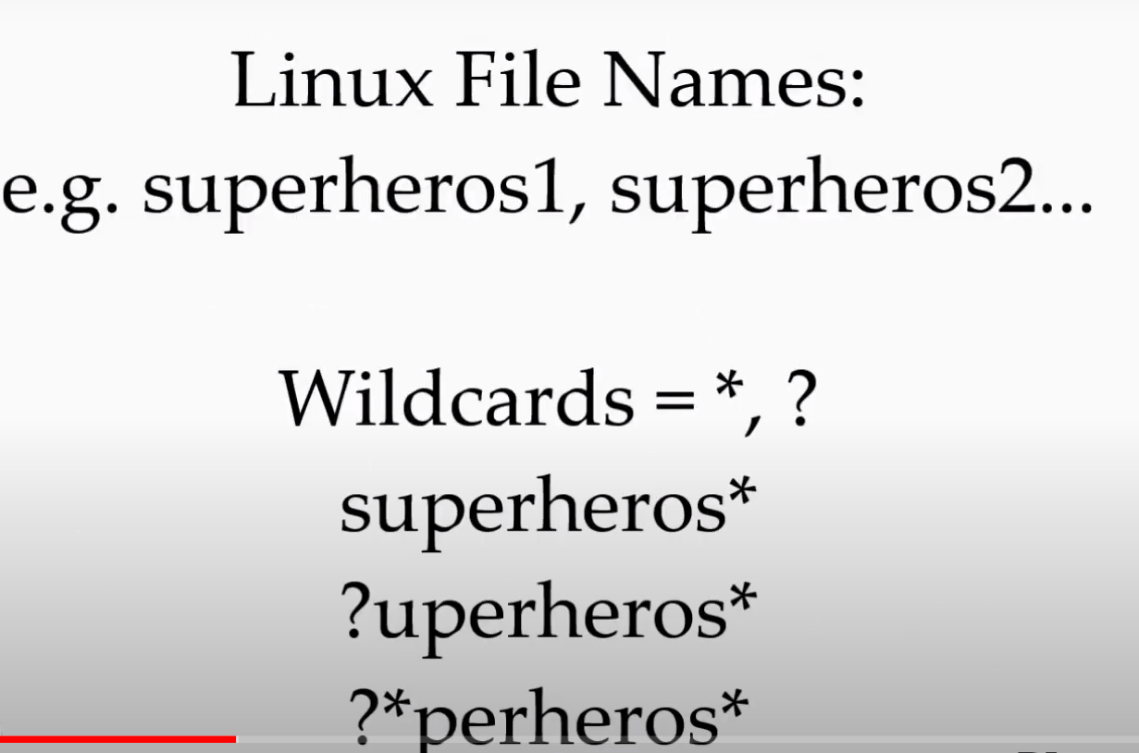

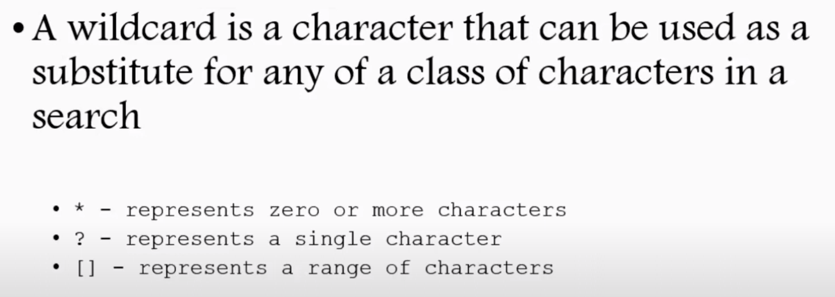

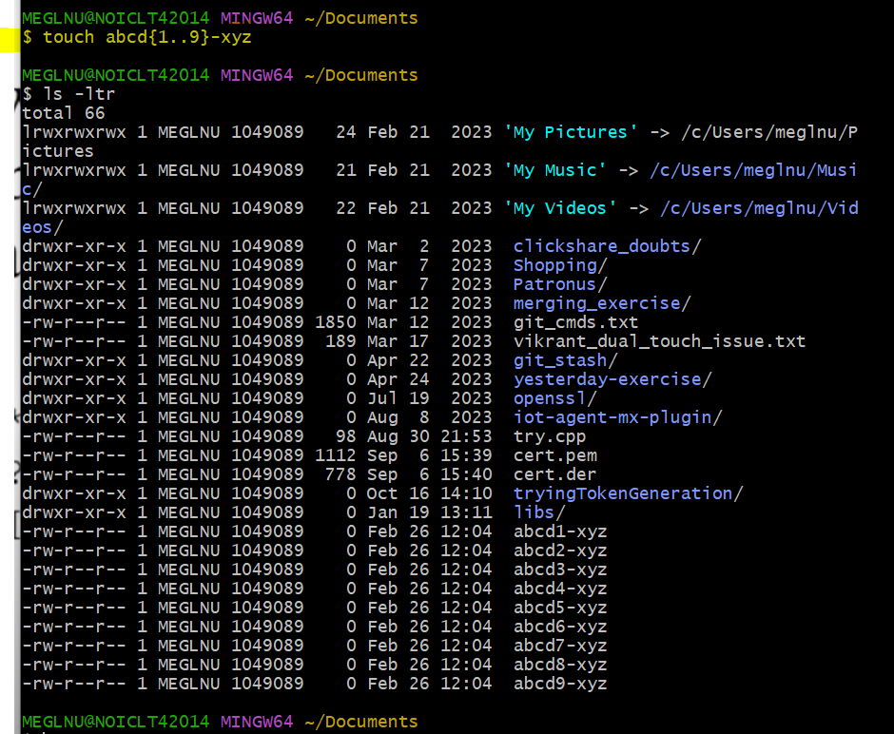

Instead of individually creating abcd1-xyz, abcd2-xyz… etc through touch commands, we have used wildcard like abcd{1..9}-xyz to create 9 such files.

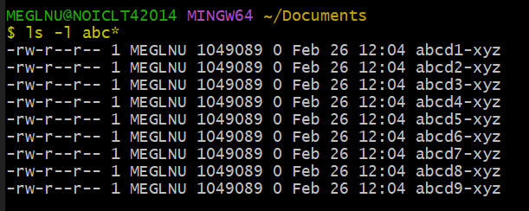

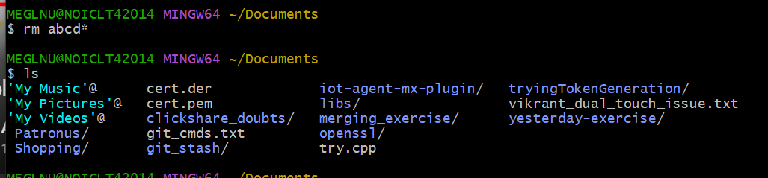

Using wildcard in front instead of back  
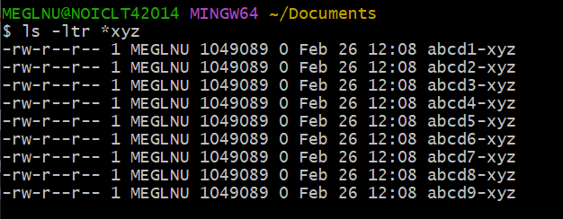

Here ? was used to replace first letter :  
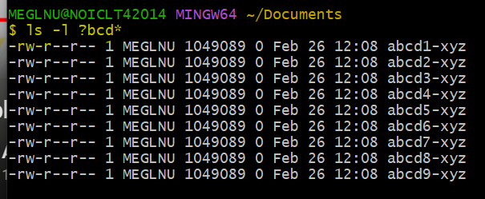

In Linux, the square brackets **[ ]** are used as part of a pattern matching mechanism called "globbing" to search for files matching certain criteria. Here's how you can use **[ ]** with wildcards:

1. **Matching Single Characters**:
   * **[abc]**: Matches any single character listed within the brackets. For example, **[abc]** would match any file containing either 'a', 'b', or 'c' as the first character.
2. **Range of Characters:**
3. **[a-z]: Matches any single character from 'a' to 'z'.**
4. **[0-9]: Matches any single digit from '0' to '9'.**
5. **[A-Z]: Matches any single uppercase letter from 'A' to 'Z'.**
6. **[!abc]: Matches any single character not listed within the brackets.**
7. **Combining Multiple Patterns:**
8. **[ab]*: Matches any file starting with 'a' or 'b'.**
9. **[0-9][0-9][0-9]: Matches any three-digit number.**
10. **[aeiou]*: Matches any file starting with a vowel.**
11. **Escaping Characters:**
12. **You can also use square brackets to match literal characters that have special meaning in globbing by escaping them. For example, [*] matches any file that contains an actual asterisk character.**

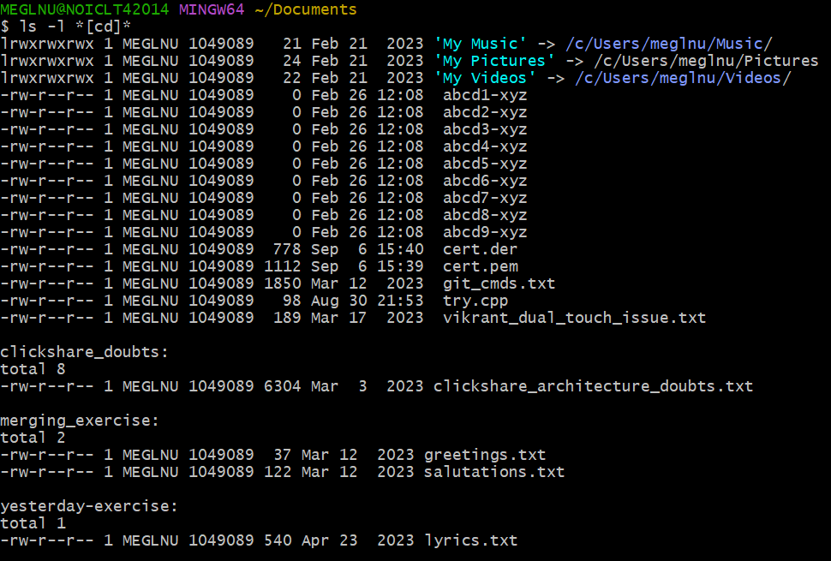

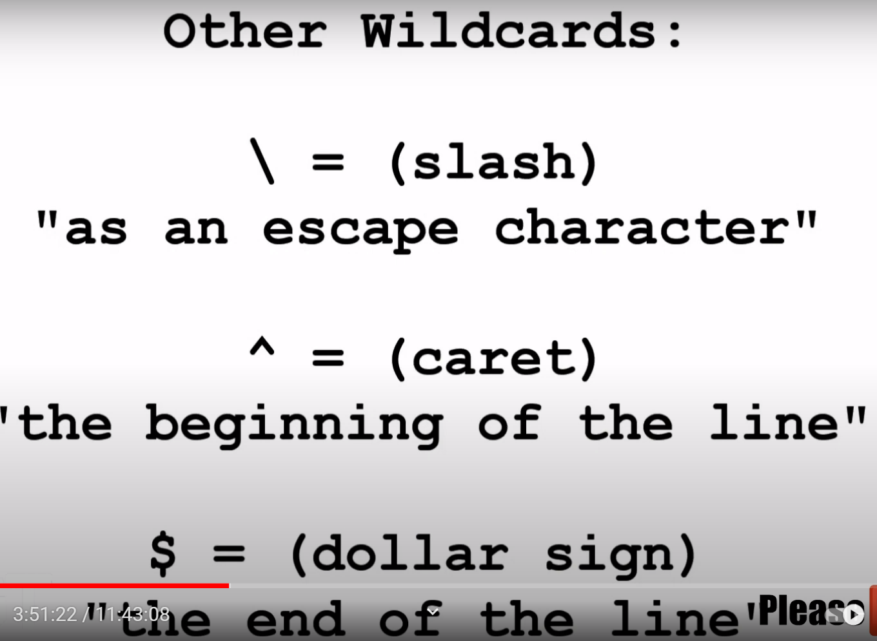

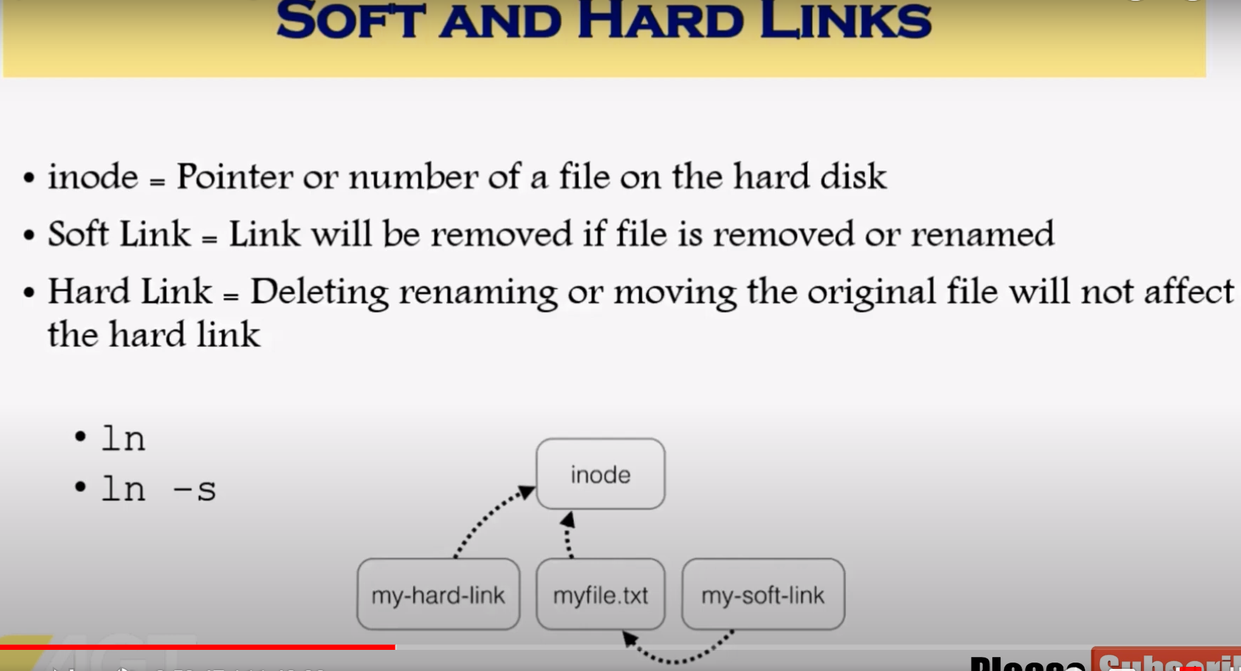

Whenever we create a file with certain name, we identify it with that name but kernel identifies it with a number stored on hard disk called inode. And links are like shortcuts in windows.

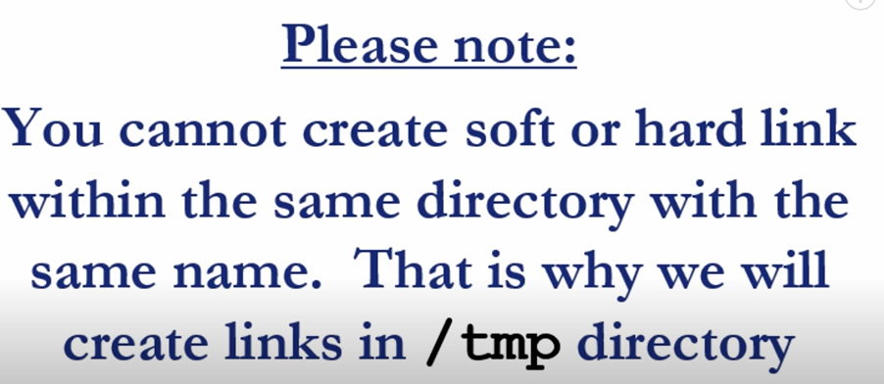

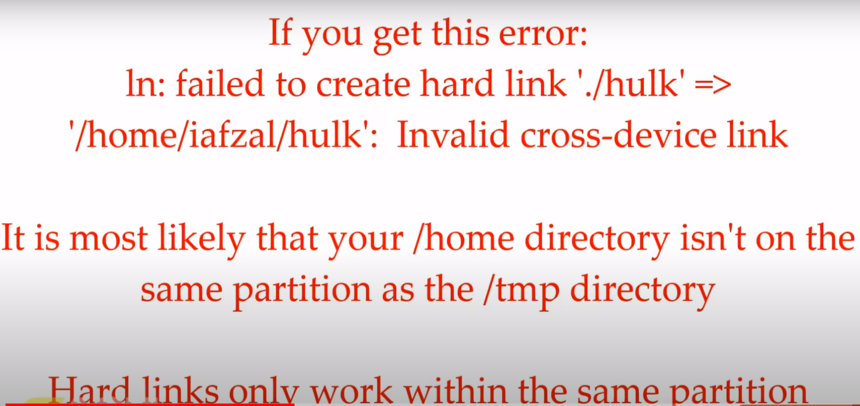

Soft links creation :

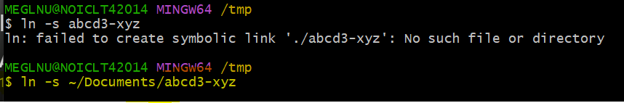

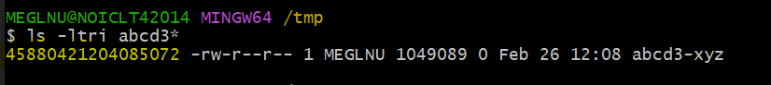

The highlighted one is the inode number of the shortcut file which is different from the original file. If we make some changes in the original file, they will be reflected here.

Its not working fine in git bash, ideally it should show “l” as starting character as it’s a link and it should get modified if the source is modified. Also it should get deleted if the source is deleted.

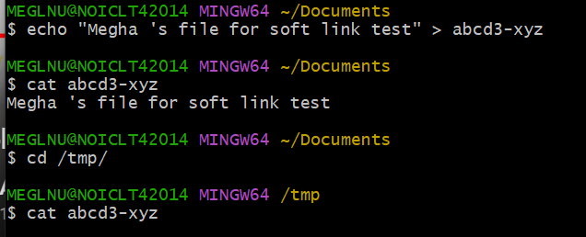

The inode values of original file and soft links are different.

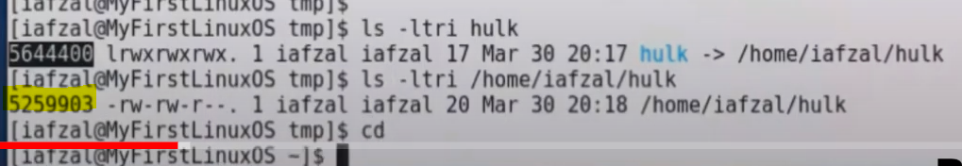

If original file is deleted, then this should happen to soft link :  
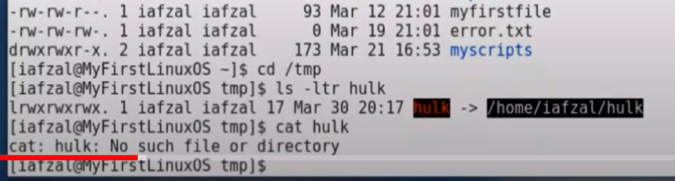

Creation of hard link : no “-s” option after ln.

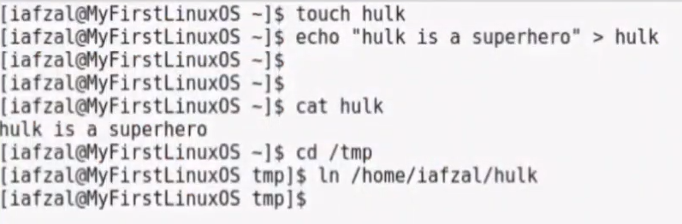

There is no pointing to other file in the link created: doesn’t start with l symbol  
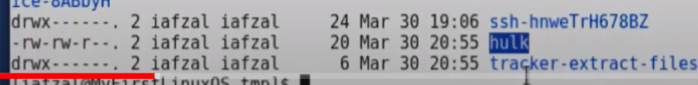

If source file modified, hard linked file also gets modified,  
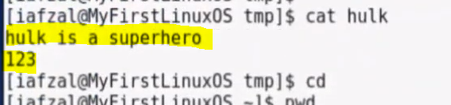

Even if you delete the original file, the hard linked file still exists and contains the same content as before.

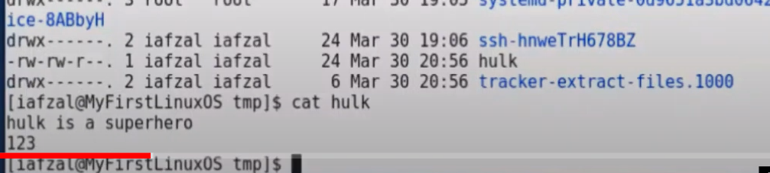

In Linux, both hard links and soft links (also known as symbolic links) are ways to create pointers or references to files, but they work differently and have distinct characteristics:

1. **Hard Links**:
   * A hard link is a directory entry that associates a filename with a specific inode (data structure that stores information about a file).
   * When you create a hard link to a file, you're essentially creating another name (or link) to the same data on the disk. Both the original file and the hard link point to the same inode.
   * Deleting a hard link does not delete the data on the disk unless it's the last remaining link to the inode. The data is only removed when all hard links to the inode are deleted.
   * Hard links cannot span filesystems or partitions because they are dependent on the inode number, which is unique within a filesystem.
2. **Soft Links (Symbolic Links)**:
   * A soft link, or symbolic link, is a special type of file that contains the path to another file or directory.
   * Unlike a hard link, a symbolic link does not directly point to the data of the target file. Instead, it points to the pathname of the target file.
   * Symbolic links can span filesystems and partitions because they reference the path rather than the inode.
   * If you delete a symbolic link, it only removes the link itself and doesn't affect the target file. However, if you delete the target file, the symbolic link becomes a "dangling link," pointing to a non-existent file.
   * Symbolic links can link to directories as well as files.

In summary, hard links create additional directory entries pointing directly to the same data, while symbolic links create separate files containing paths to the target files. Hard links maintain a stronger connection to the target file, whereas symbolic links provide more flexibility and can span filesystems.

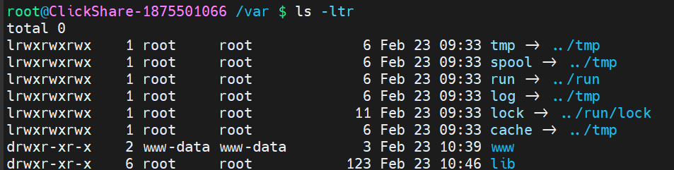

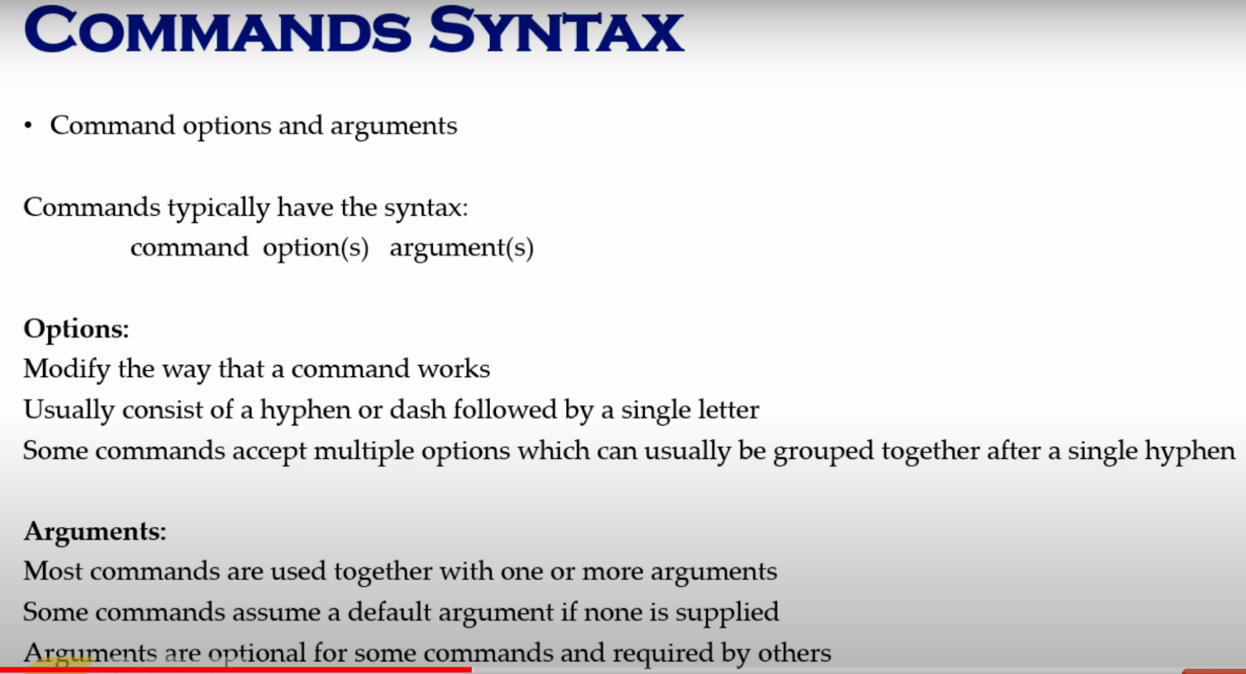

ls -l , ls -lt, ls -ltr, ls -ltri // they are all appending options.  
argument eg : ls a* : where a* lists all files starting with a.

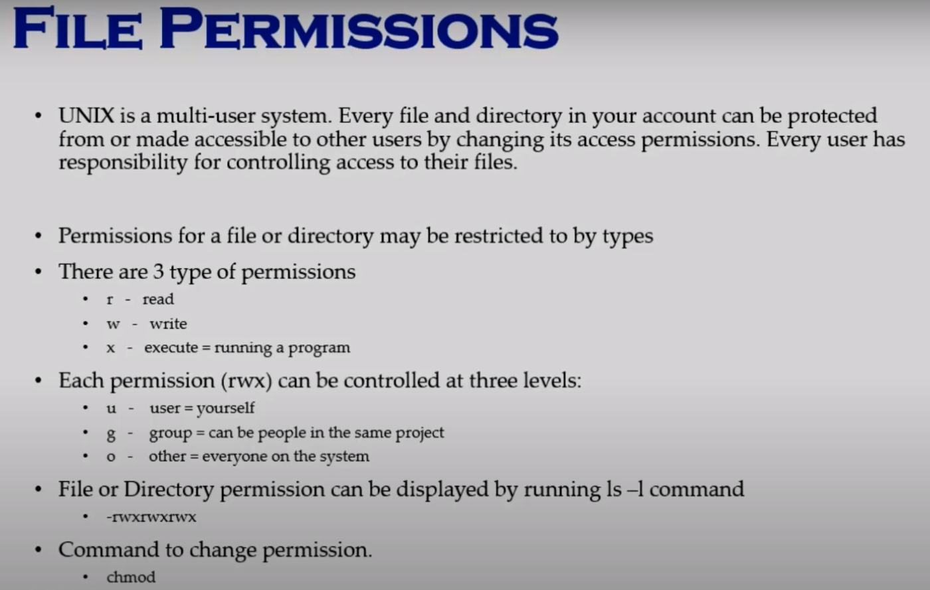

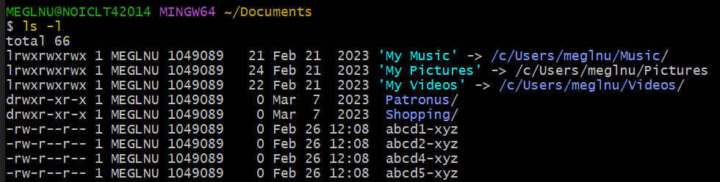

drwxr-xr-x // means d: directory , rwx: user(MEGLNU) has permission to read, write and execute,   
 r-x : means group (1049089) has permission to read and execute only  
 r-x : means others has same permission as group.

Changing permission : chmod g-x Patronus // means group can now not execute Patronus

Chmod a-r Patronus : // means no one can read Patronus

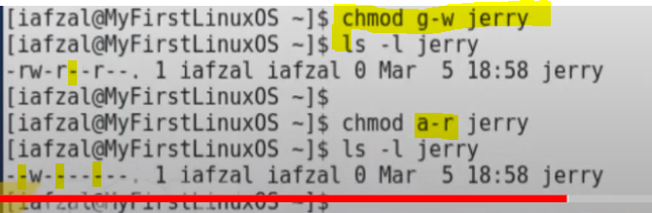

Taking away write permission from user also :  
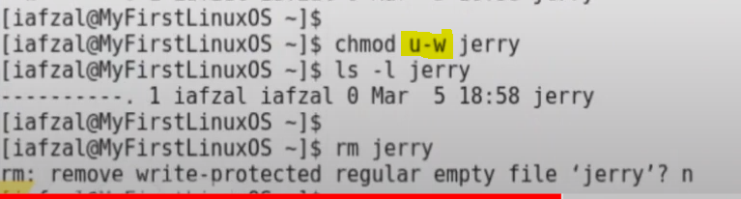

Creating permissions for all 3 individually :  
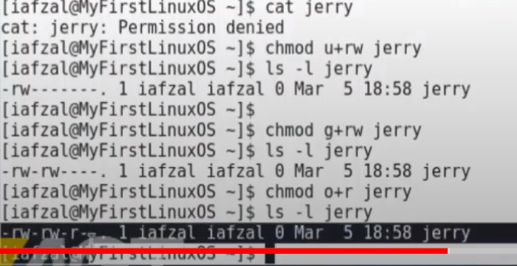

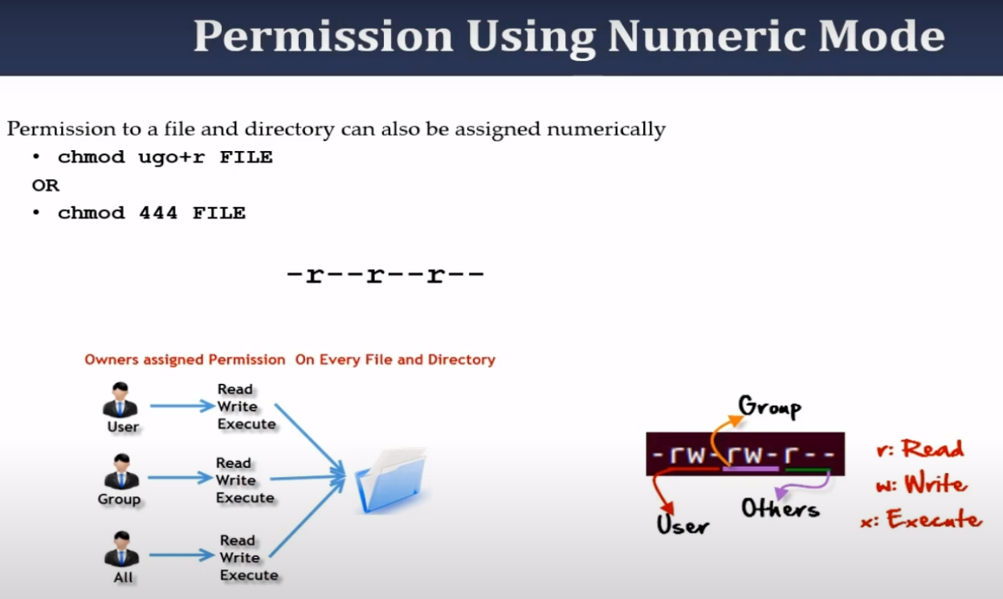

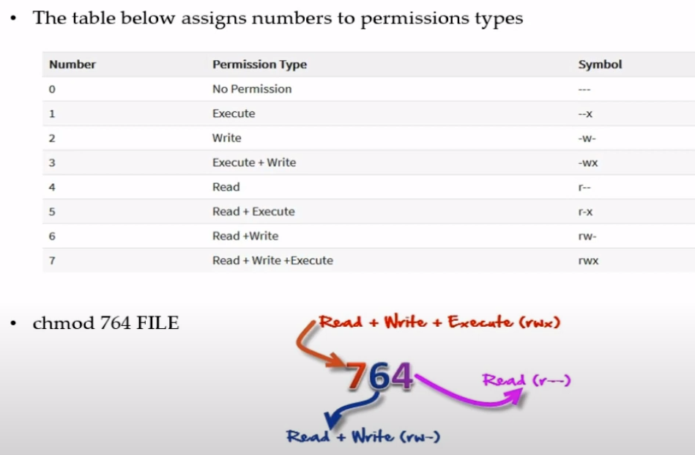

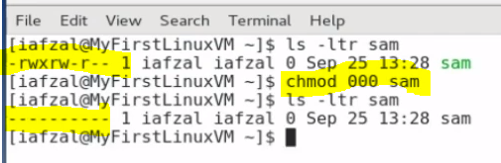

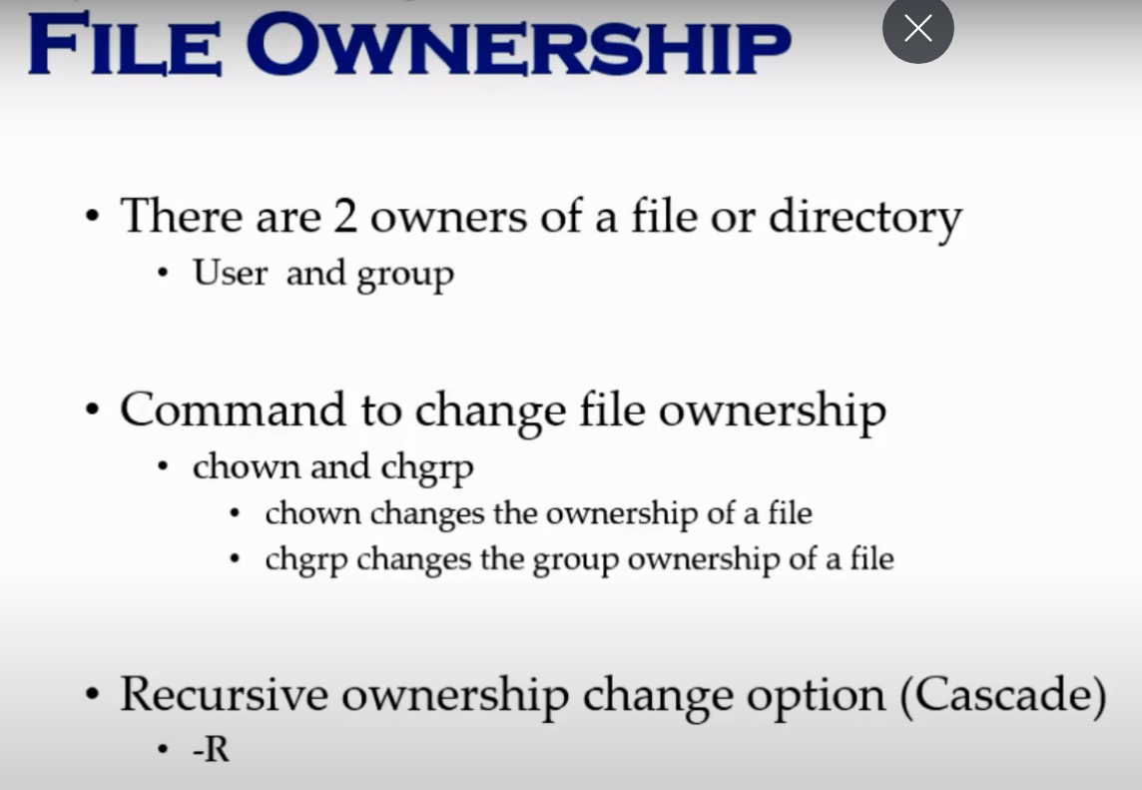

You need to be logged in as root to be able to change file permissions :   
chown <new_assignee> <filename>

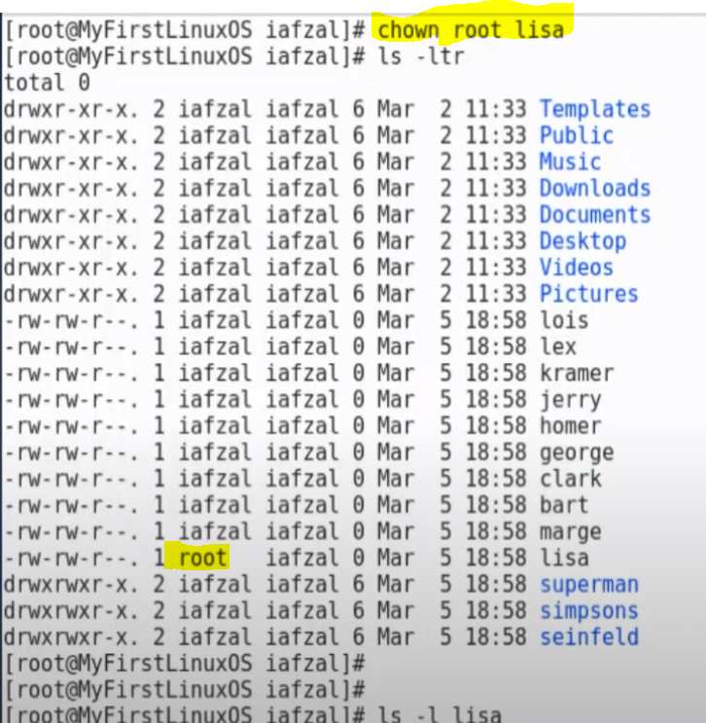

Chgrp <new_group_name> <filename>

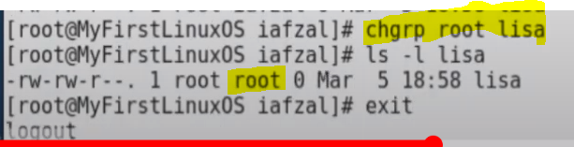

Exit cmd exits out of root account

To assign permission to a particular user or a particular group other than root and owner group, we use ACL.

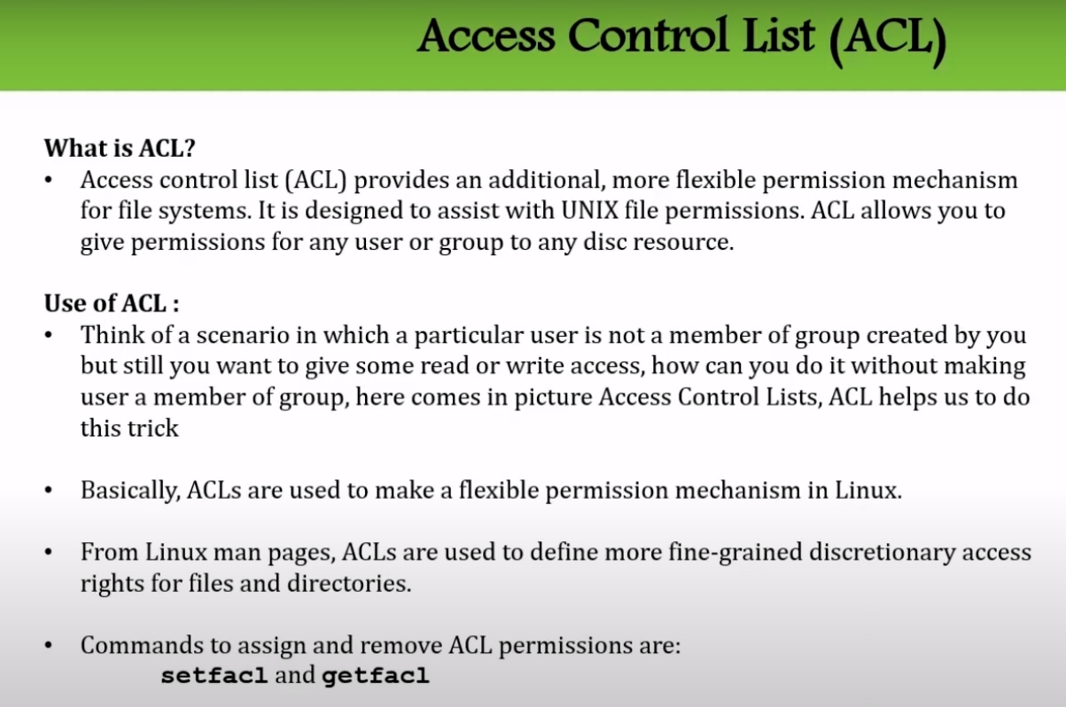

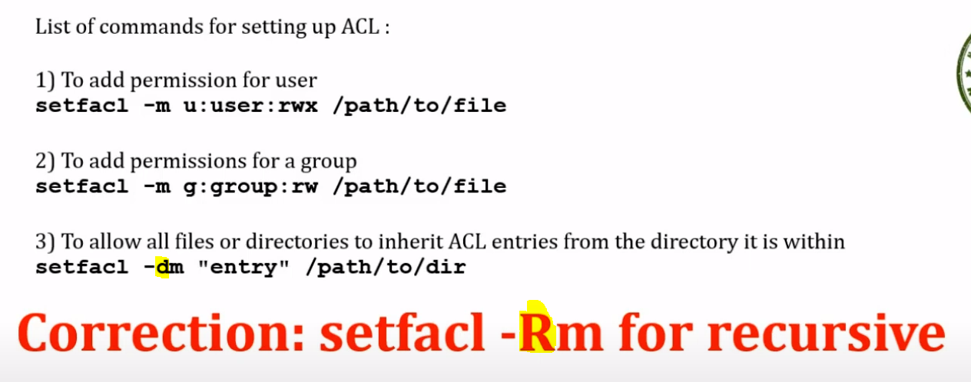

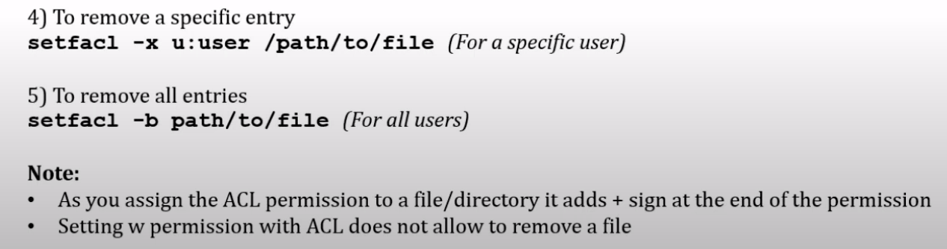

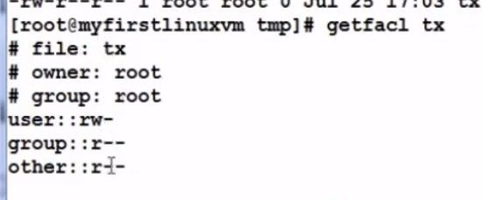

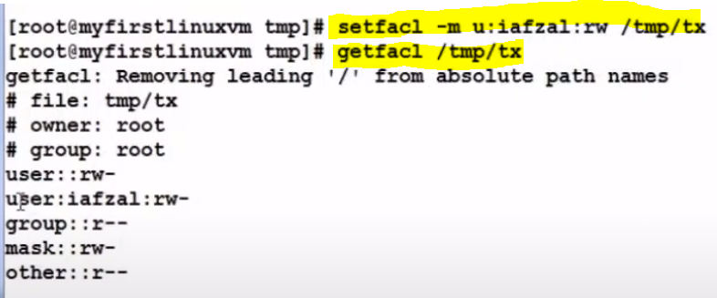

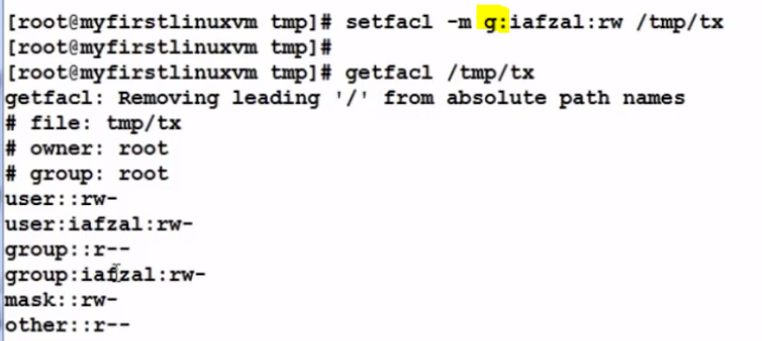

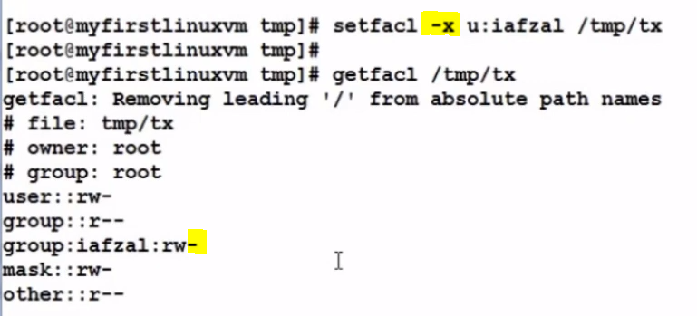

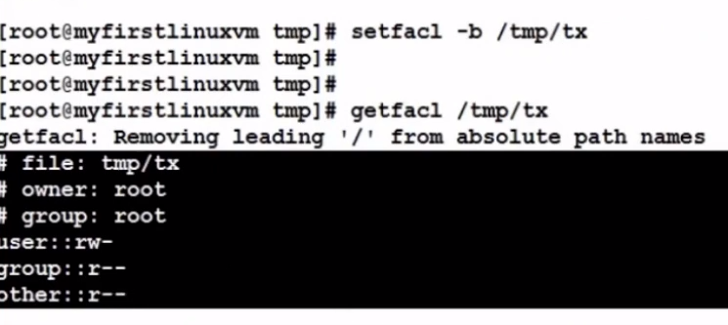

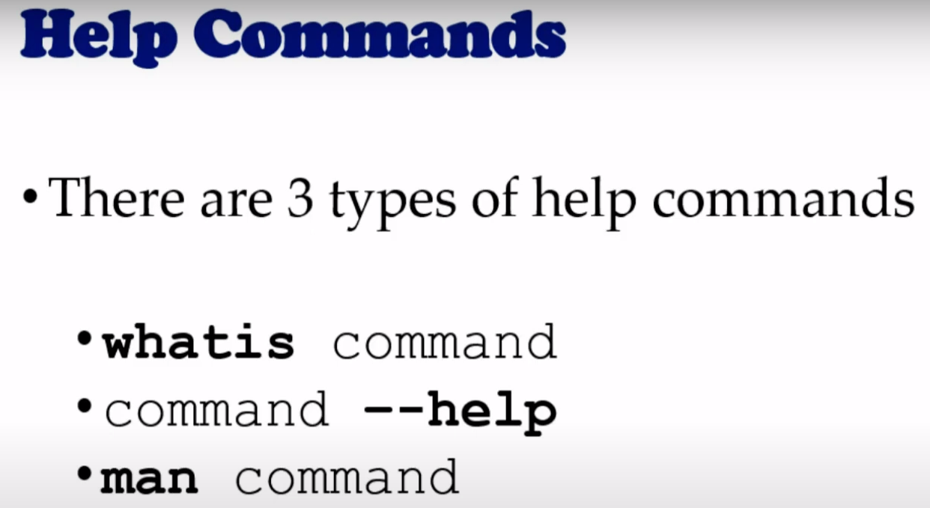

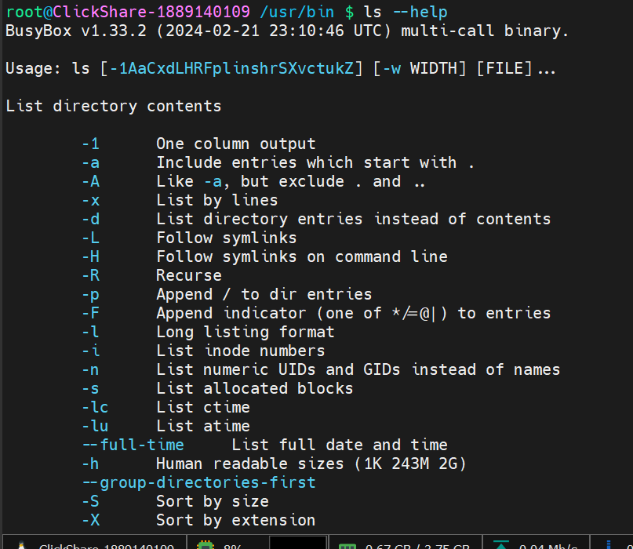

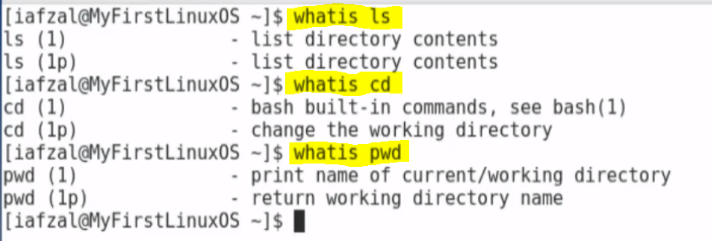

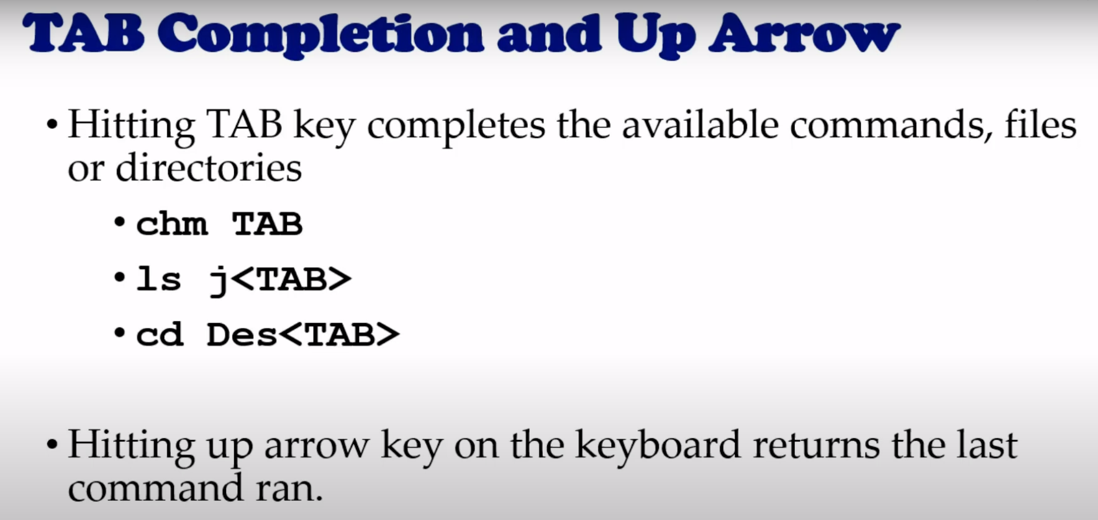

pressing ch and tab results in this : all possible commands are displayed :

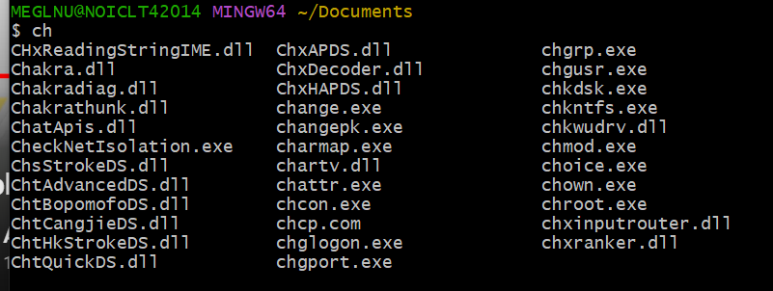

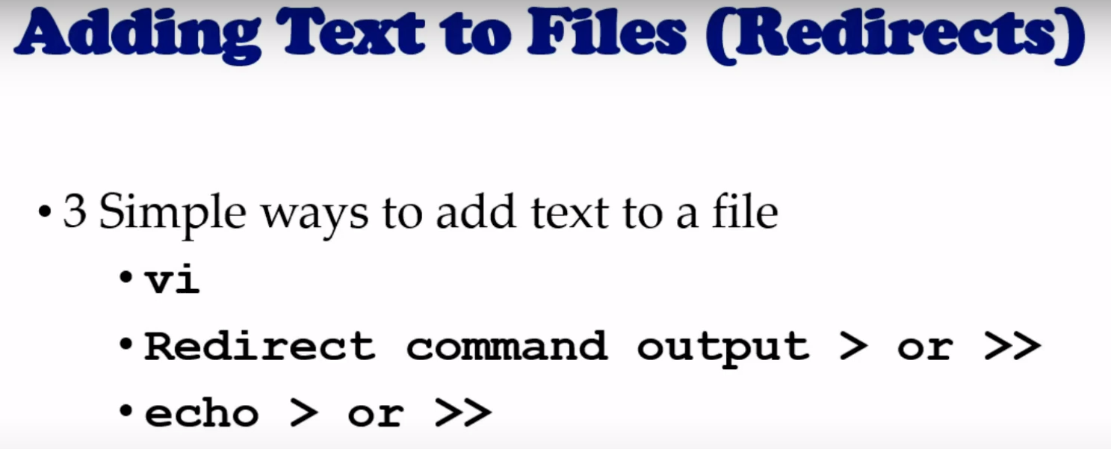

Single arrow > : overwrites  
double arrow >> : appends

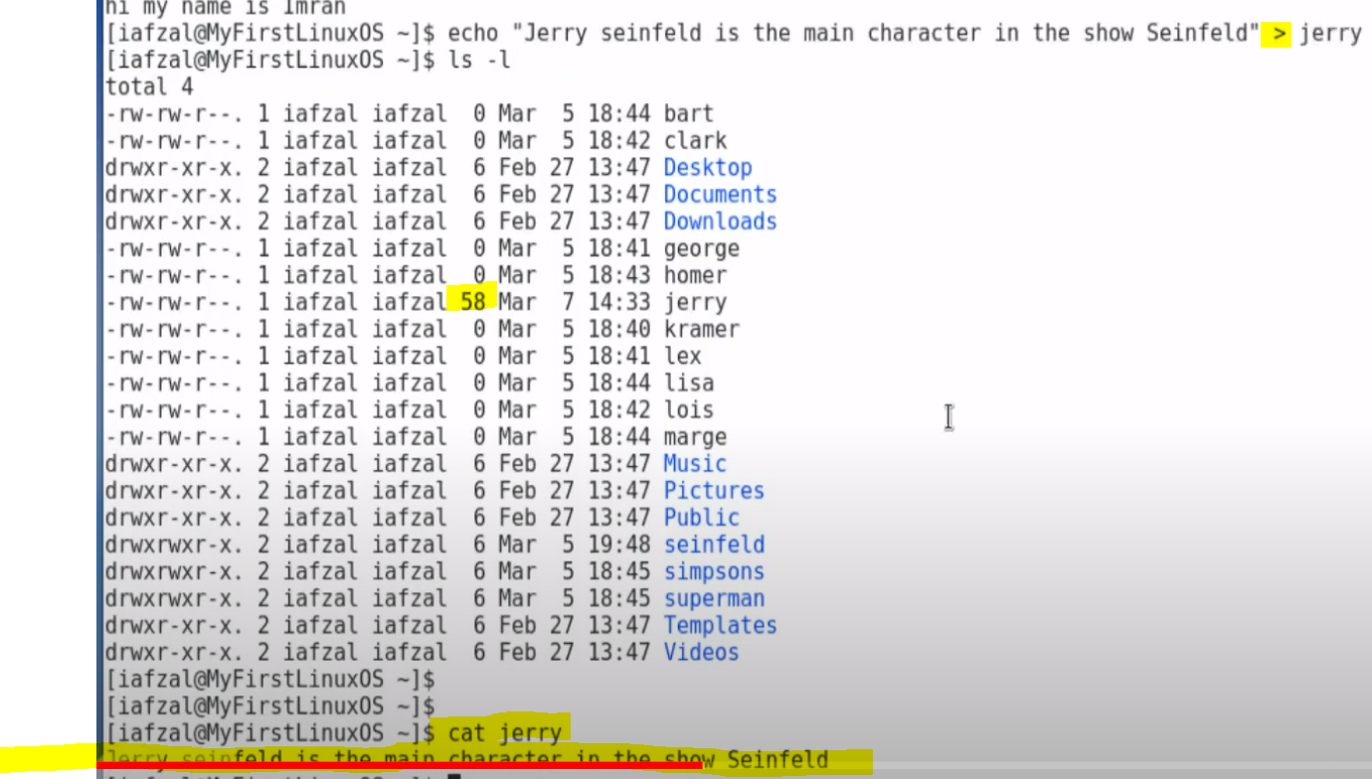

We can also write the output of a command using > operator



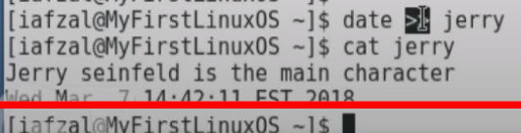

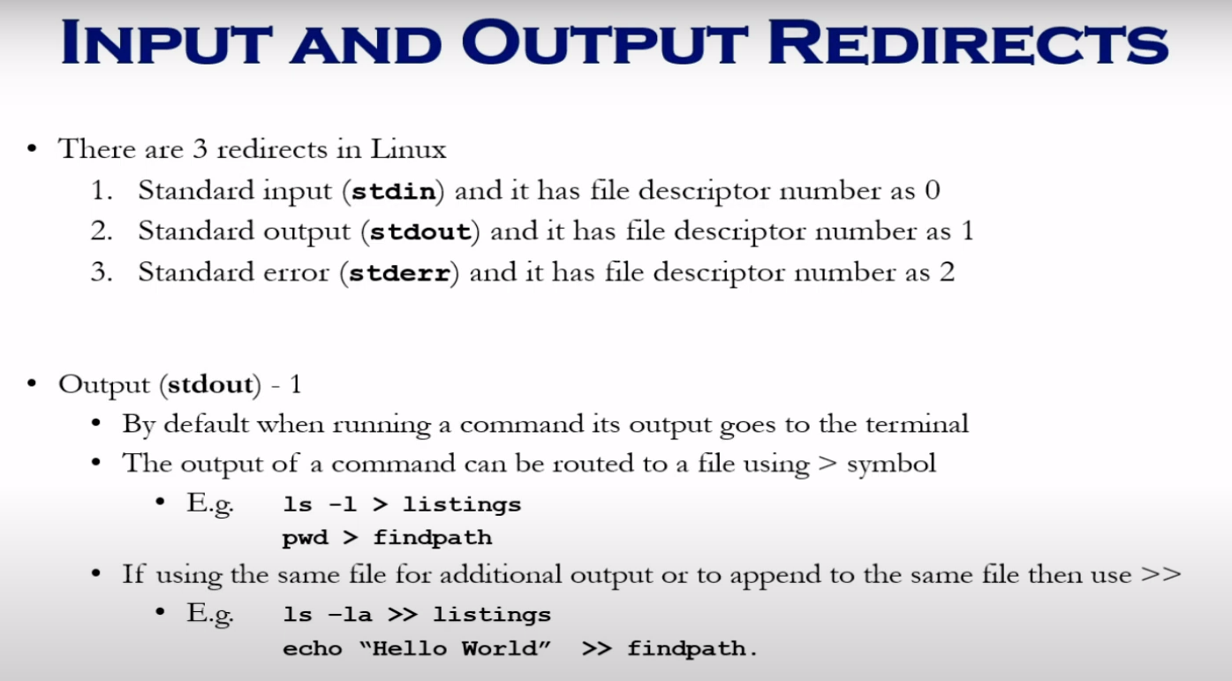

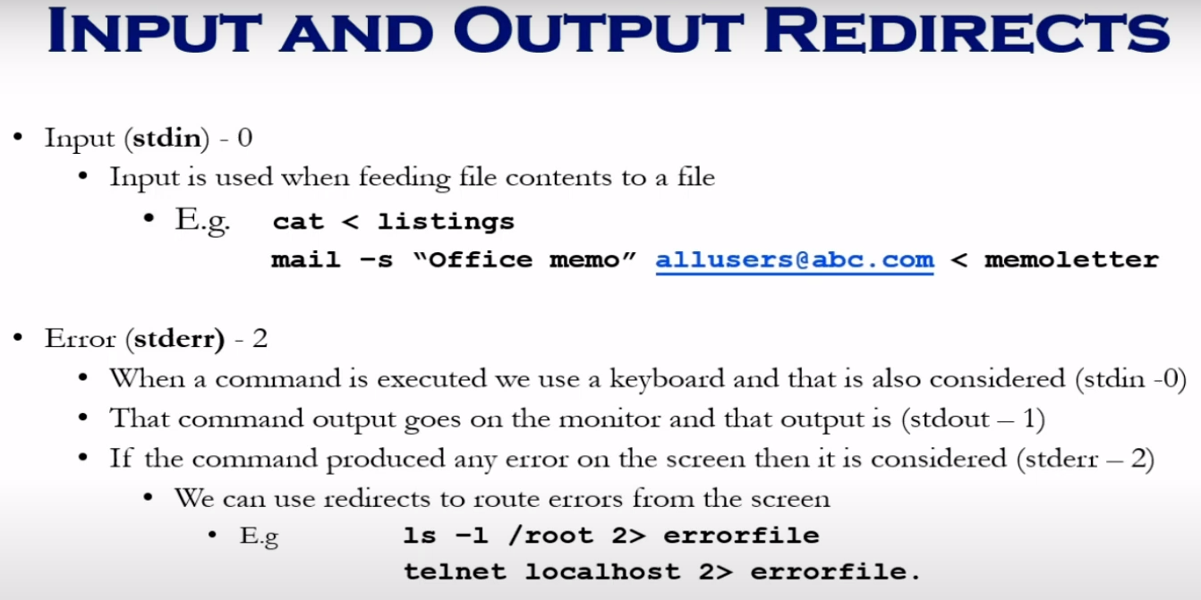

Routing error messages to a file : We need to use 2 number to show stderr file descriptor  
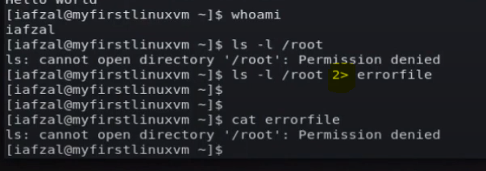

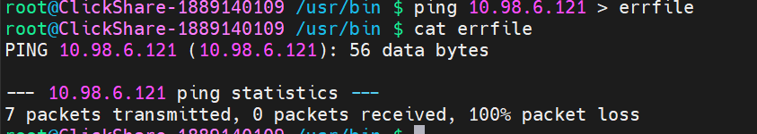

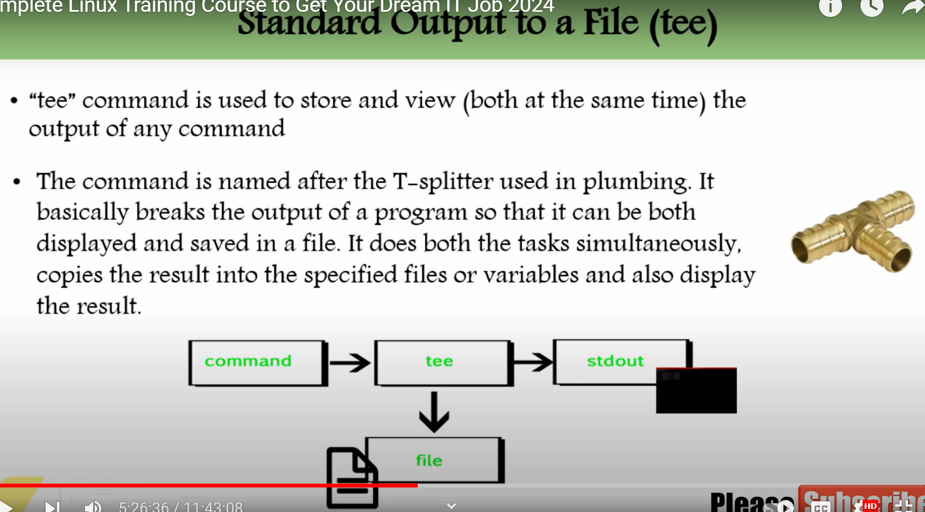

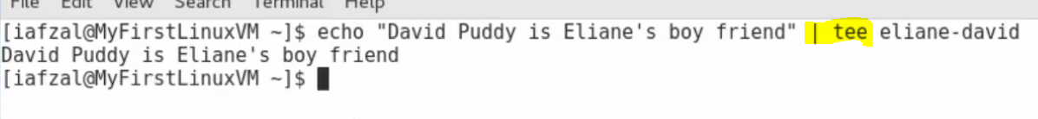

For appending to the file : -a

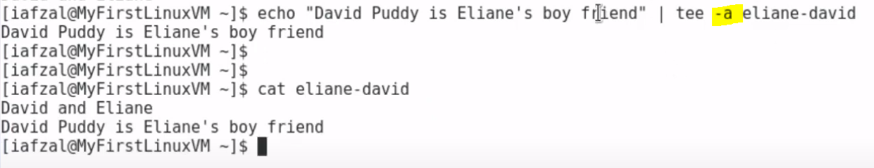

Counting number of characters in a file : wc :

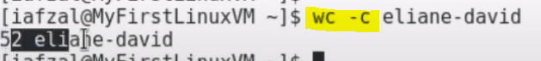

Outputting to multiple files :



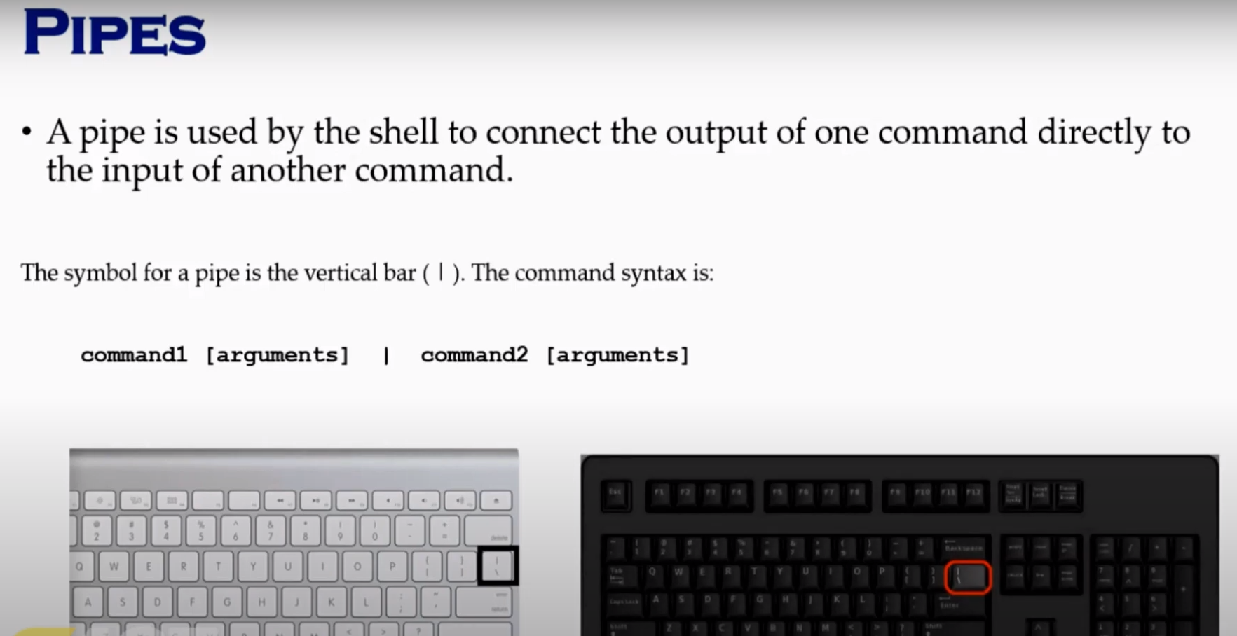

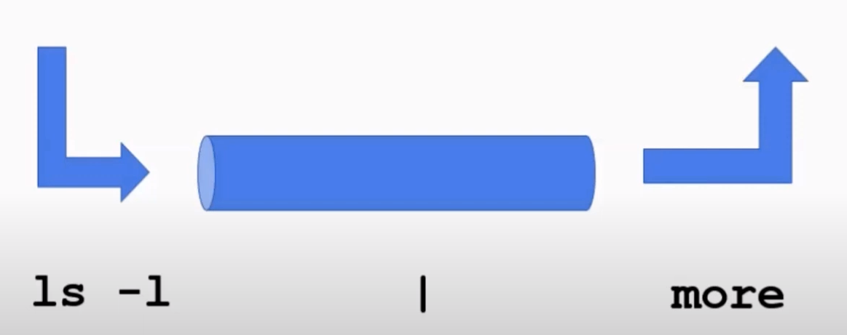

MORE: Displays files one page at a time if there are many of them: after this command keep pressing space bar to view files one page at a time.

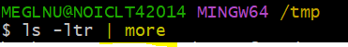

Short form of ls -l is ll

To get the last line of your output :

Ls -l | tail -1



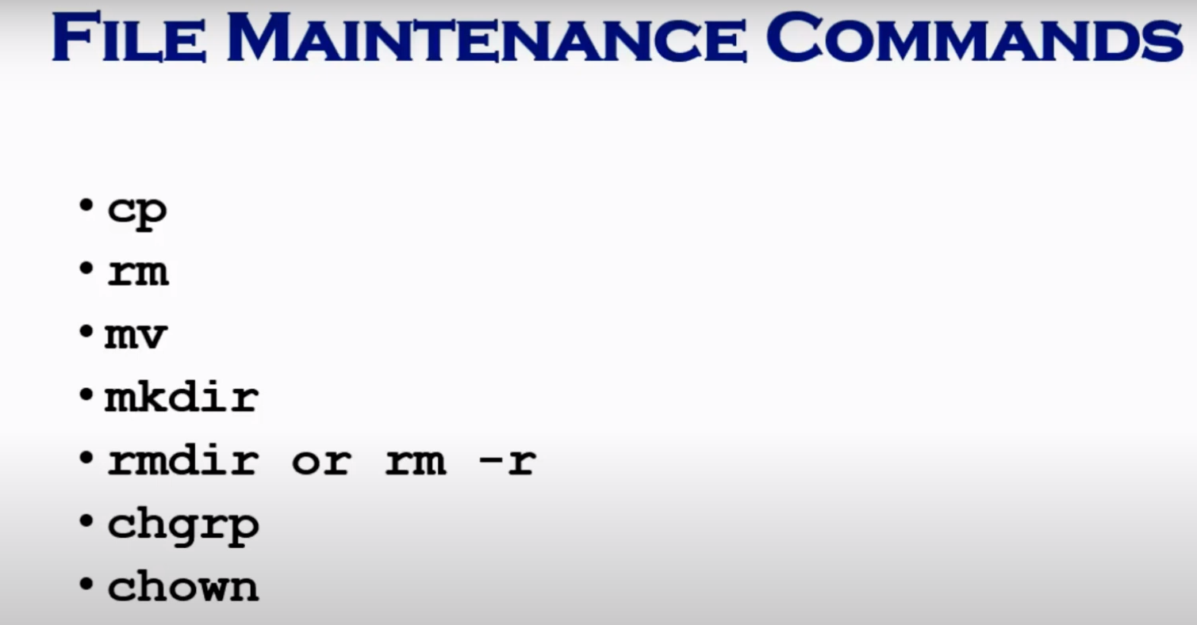

Command for deleting folder rmdir, rm -r , rm -rf  
  
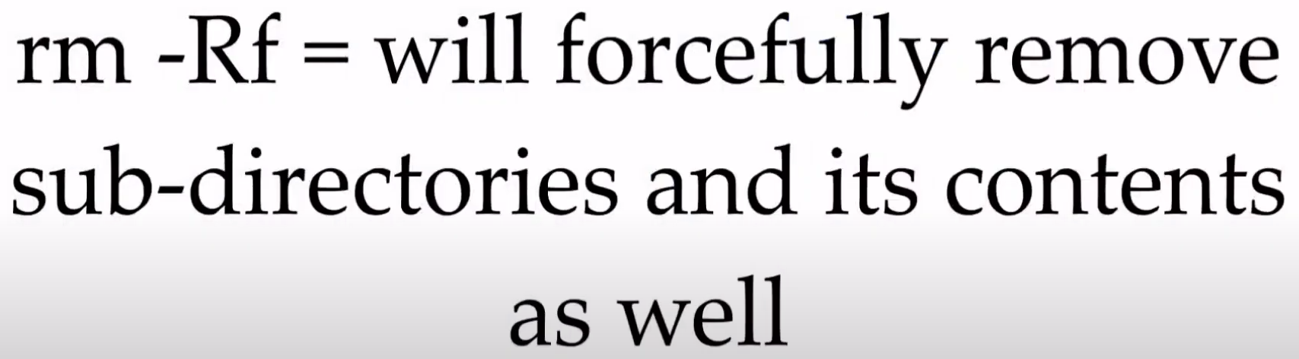

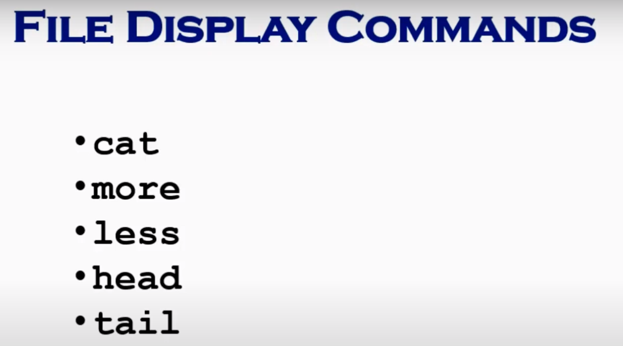

To copy a file at pwd : use .

We can use cat, vi , more, less commands to view a file content. Using more or less , use space bar to scroll through the content.

* You can press the spacebar to view the next page, or press Enter to view the next line.
* **more** does not support scrolling backward; once you have advanced to the next page, you cannot go back.

* **less** is an improved version of **more** with additional features and functionality.
* It allows scrolling both forward and backward within the file or command output. You can use the arrow keys, Page Up, Page Down, or Spacebar to navigate.
* **less** can handle large files more efficiently than **more** because it does not need to read the entire file into memory before displaying it.
* **less** supports searching within the file using the **/** command followed by the search term.
* It also supports various options and commands for manipulating and interacting with the displayed text, such as jumping to specific line numbers, marking positions, and more.

To check first 2 lines of the file :  
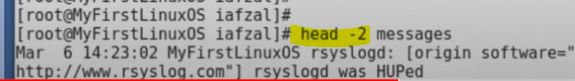

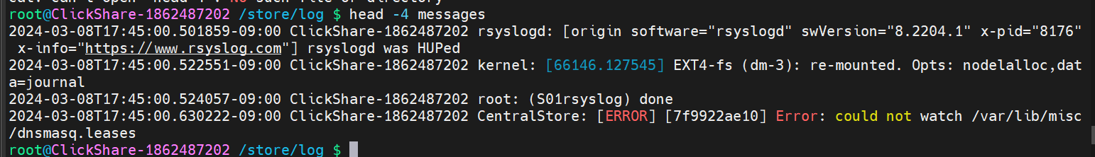

Similarly, tail -2 messages : for last 2 lines of the file.

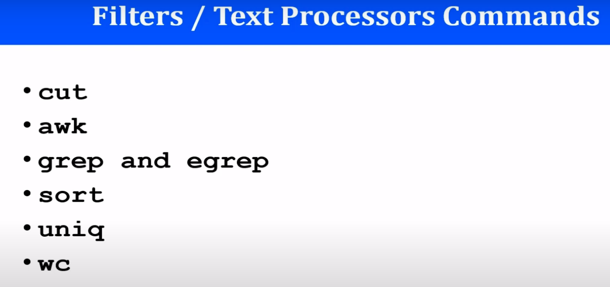  
  
CUT command : for cutting specific characters from a file and displaying it. Like awk displays at field level, cut diplays at character level.

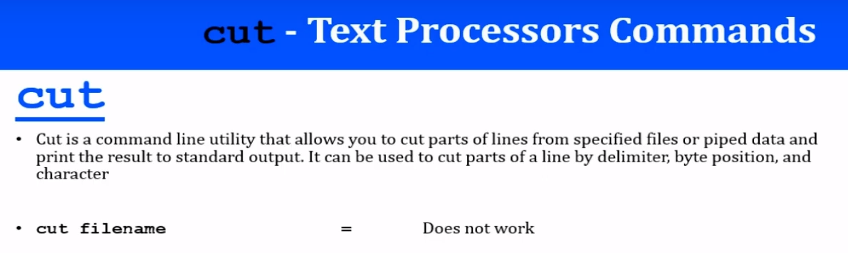

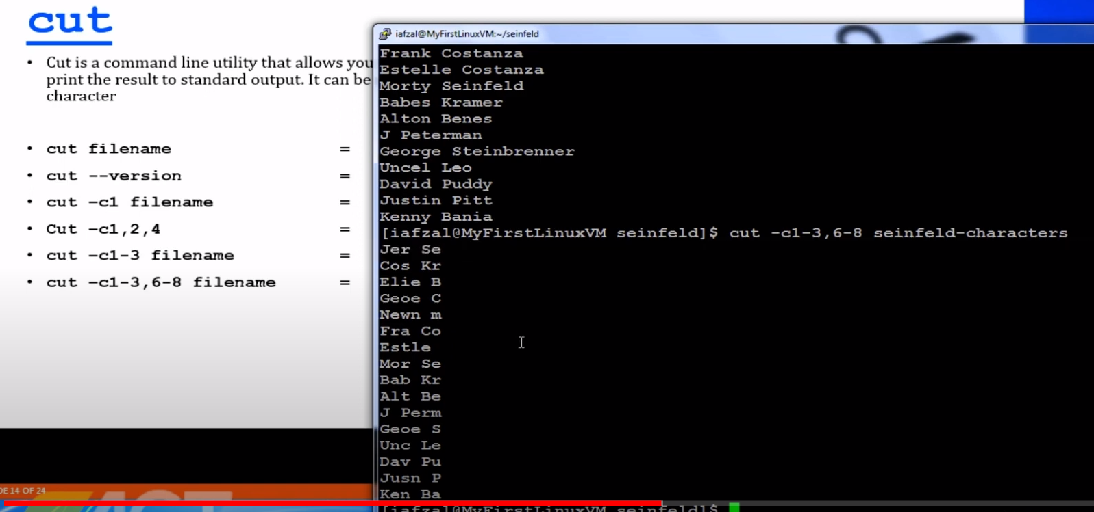

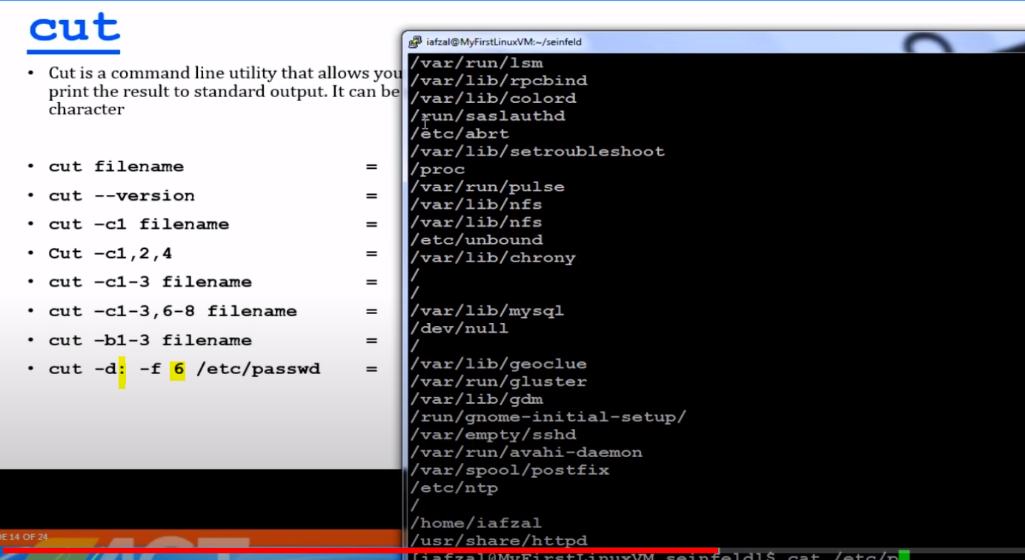

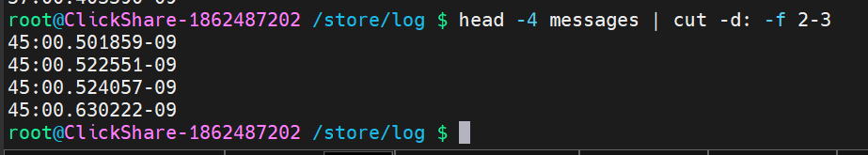

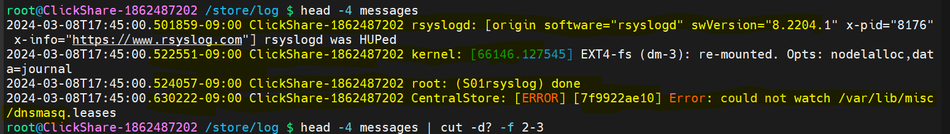

Printing fields starting from delimiter mentioned : see above



D: delimiter, f: field : cmd gives 6th field after the delimiter “:”  
  
**head -4 messages | cut -d: -f 2-3**

This command is a combination of two Unix commands, **head** and **cut**, used in a Unix/Linux shell environment. Let's break down what each part of the command does:

1. **head -4 messages**:
   * The **head** command is used to output the first part of files, by default it outputs the first 10 lines.
   * In this command, **head -4** means to output the first 4 lines of the file or input stream.
   * **messages** is the file name or input stream being processed. It could be a text file, or it could be the output of another command piped into **head**.
2. **cut -d: -f 2-3**:
   * The **cut** command is used to extract sections from each line of input, and print them to standard output.
   * The **-d:** option specifies the delimiter to use, in this case, it's a colon (**:**).
   * The **-f 2-3** option specifies the fields to extract. It means to extract fields 2 through 3 (inclusive).
   * So, **cut -d: -f 2-3** will cut each line of input based on the colon delimiter, and output fields 2 through 3 (inclusive).

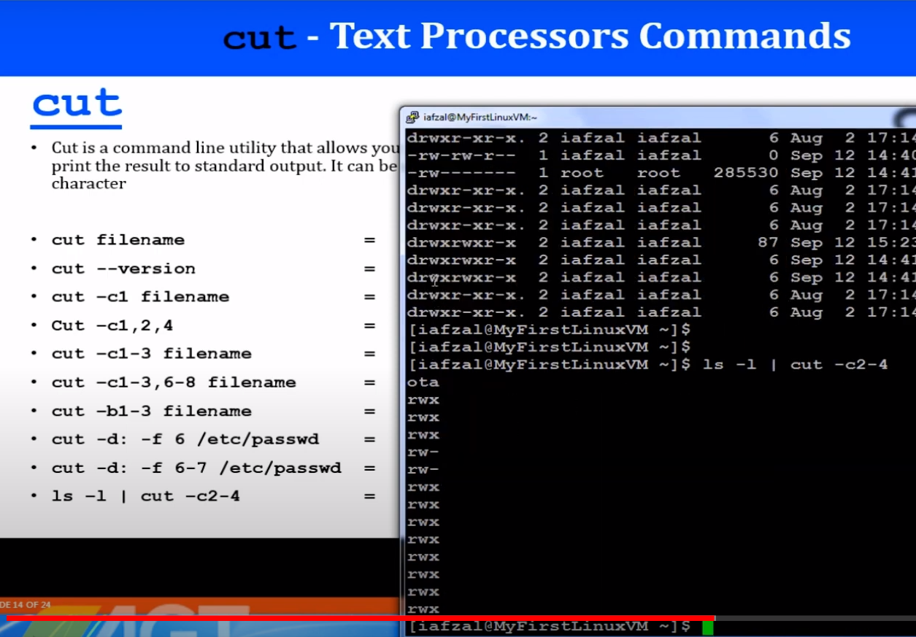  
  
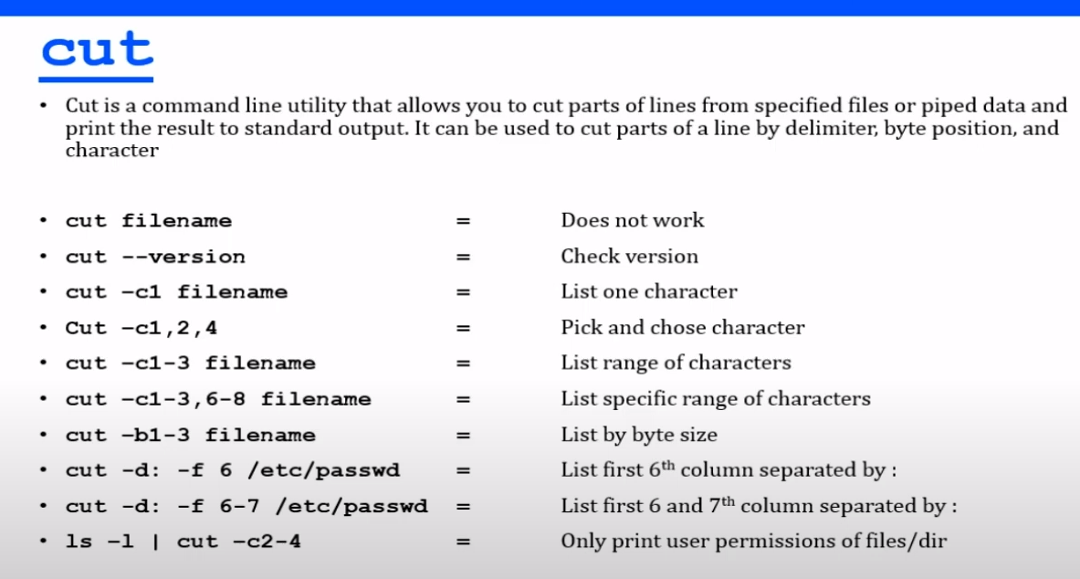

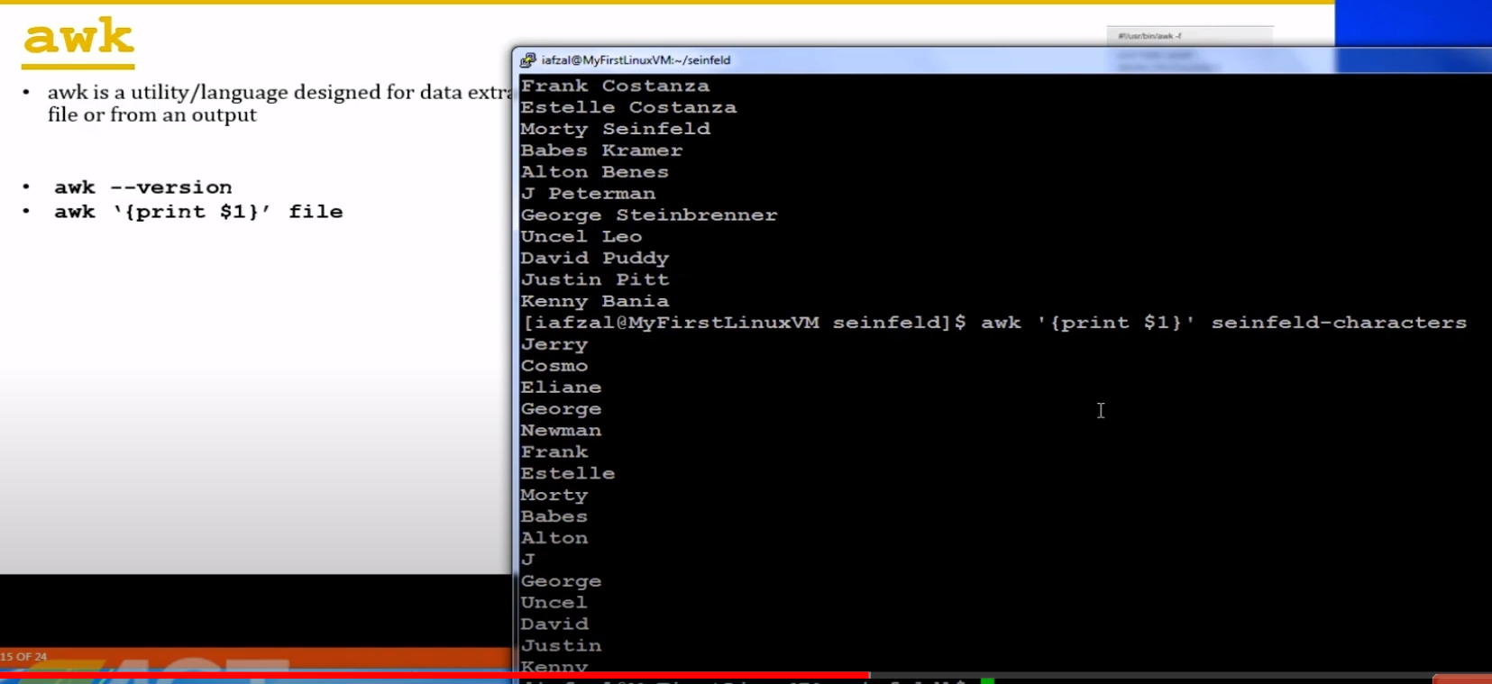

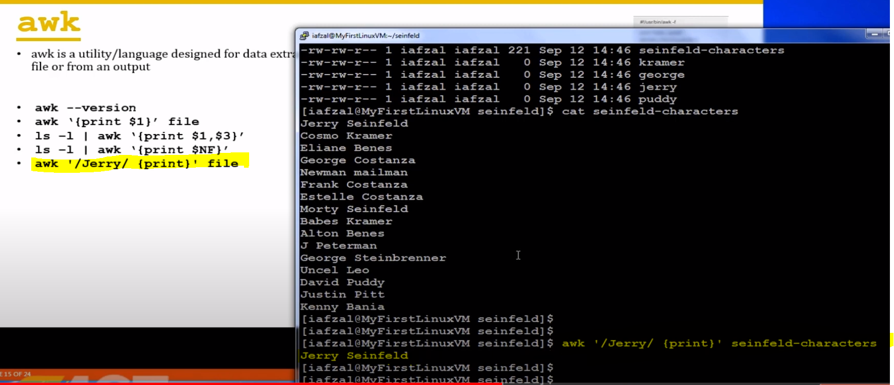

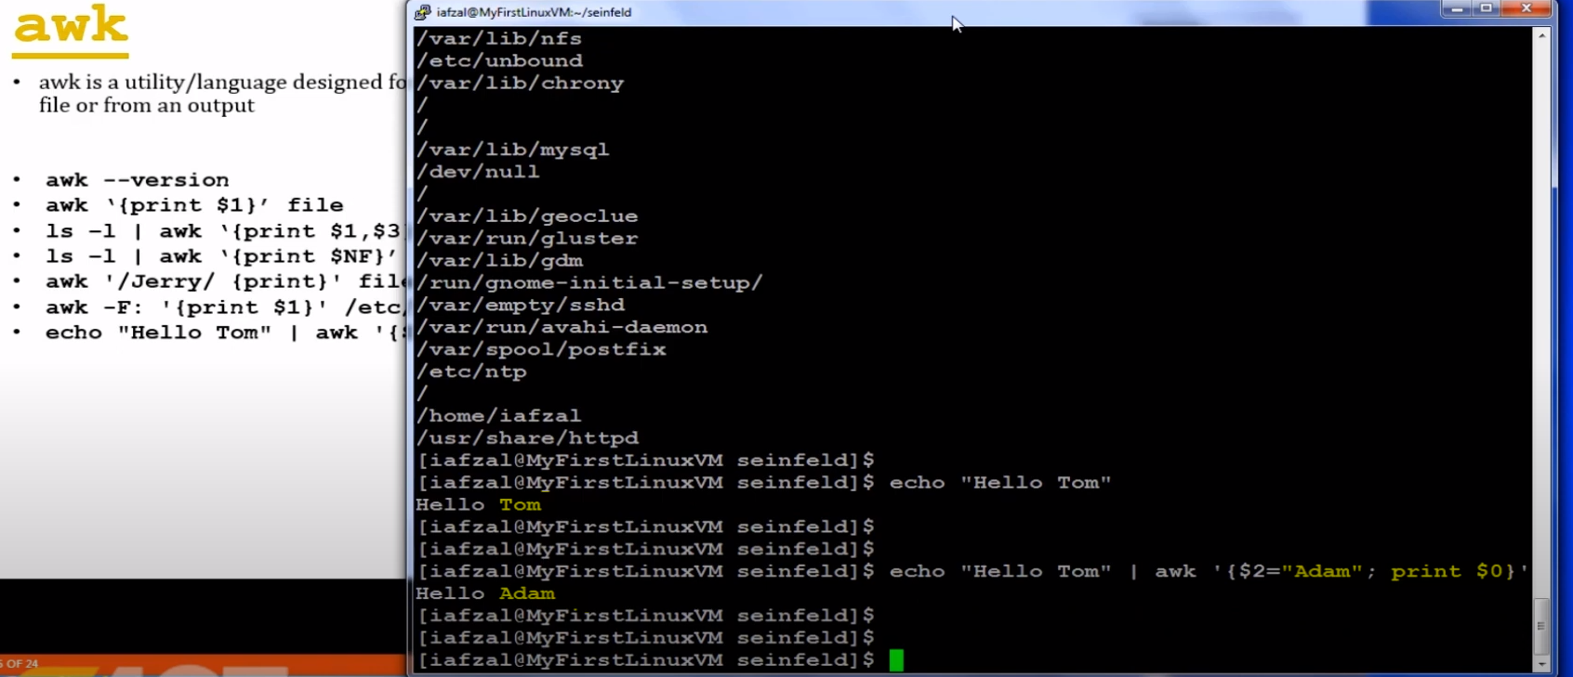

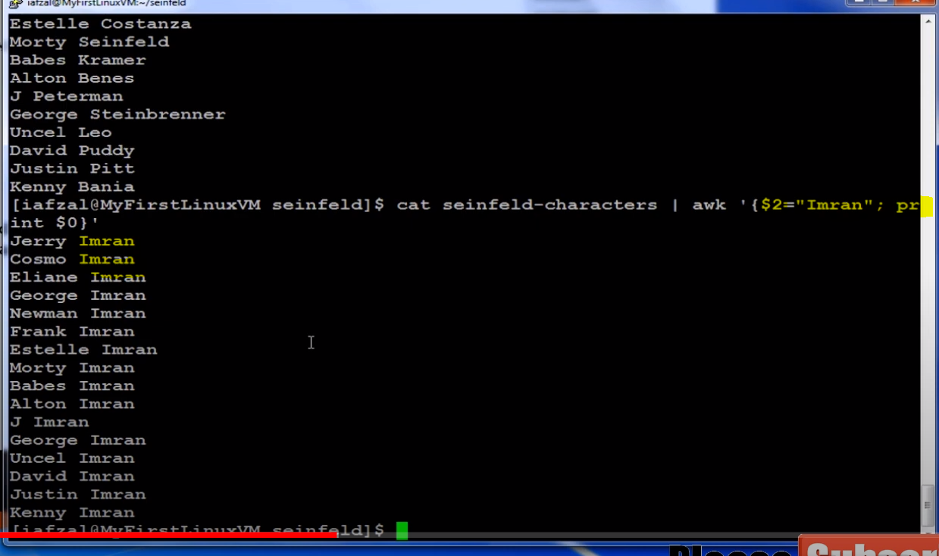

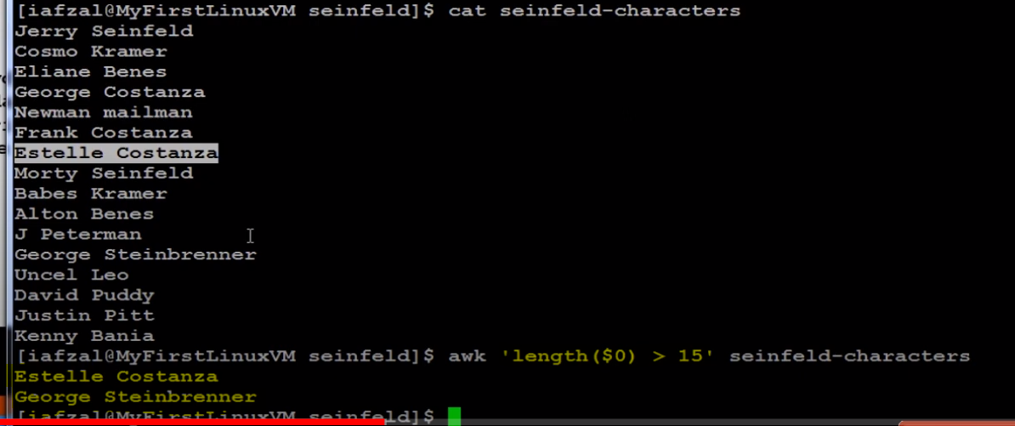

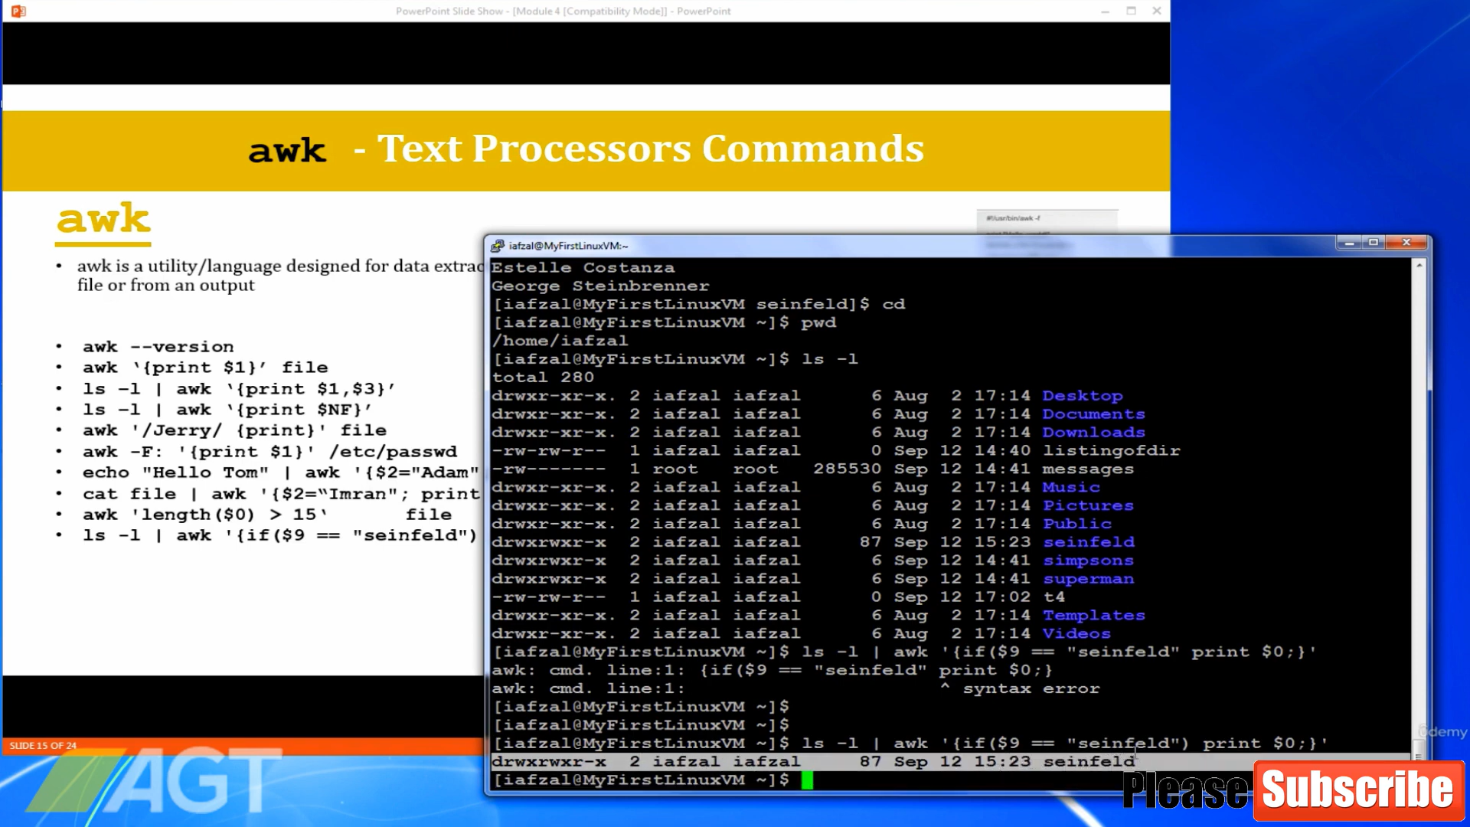

In the context of the **awk** command, **$0** represents the entire input record (or entire line) being processed.  
In the context of the **awk** command, **$NF** represents the last field of the input record (or line). [number of fields]

$9 : means 9th column  
When you run a script or a command in the shell and pass arguments to it, these arguments are represented by positional parameters. These parameters are assigned numbers starting from **$0** for the name of the script or command itself, **$1** for the first argument, **$2** for the second argument, and so on. **$9** specifically represents the ninth argument passed to the script or function.

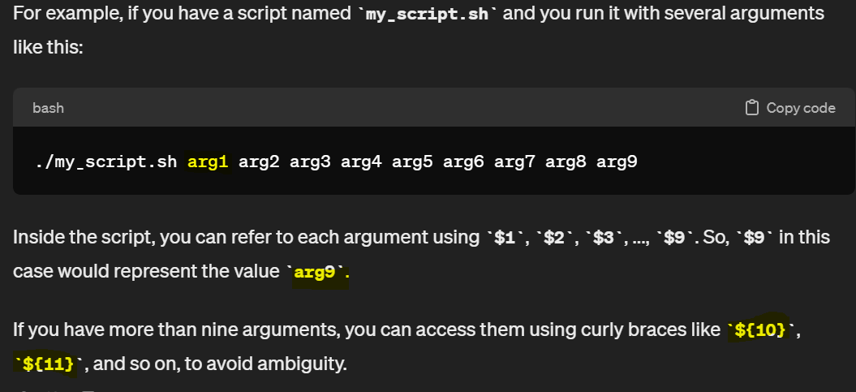

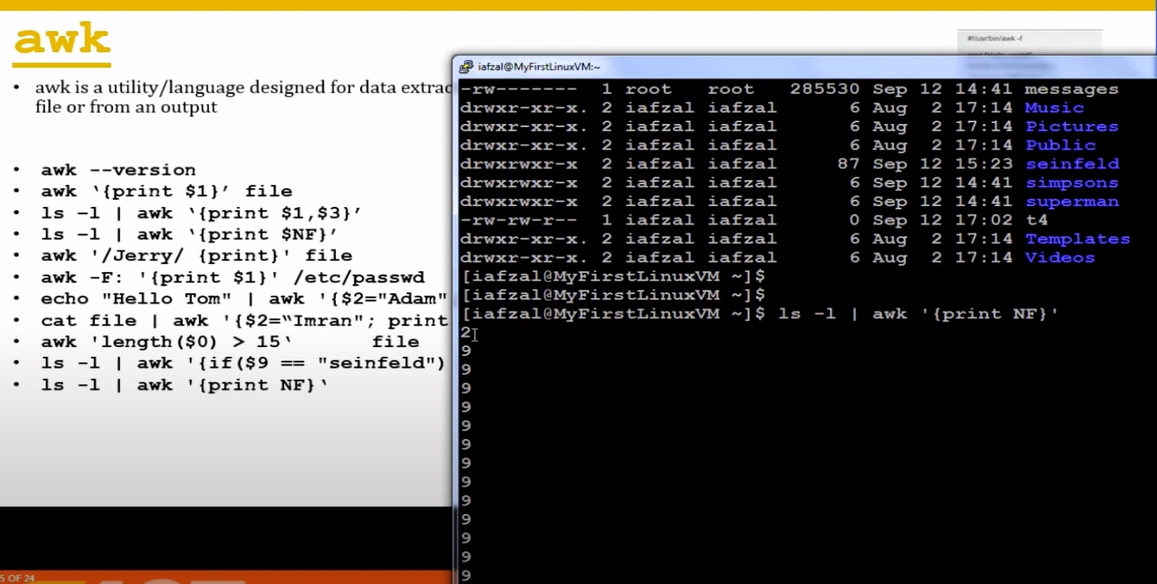

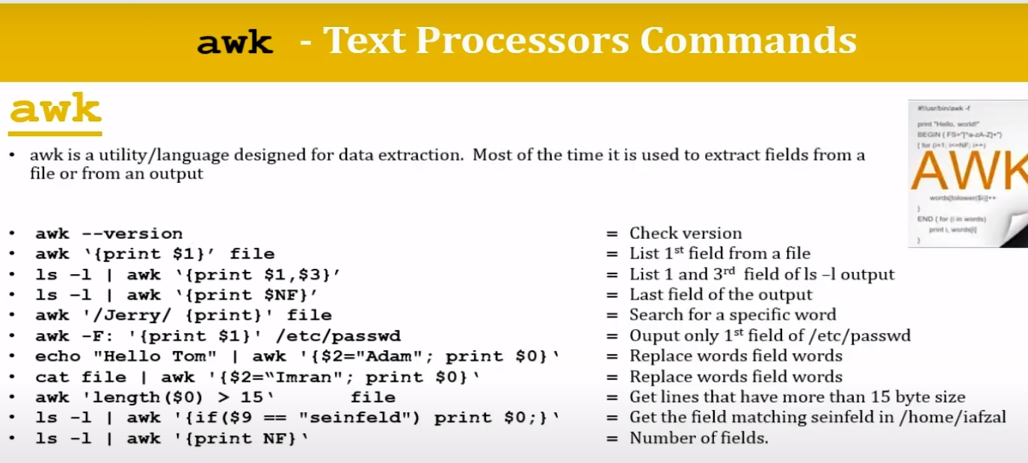

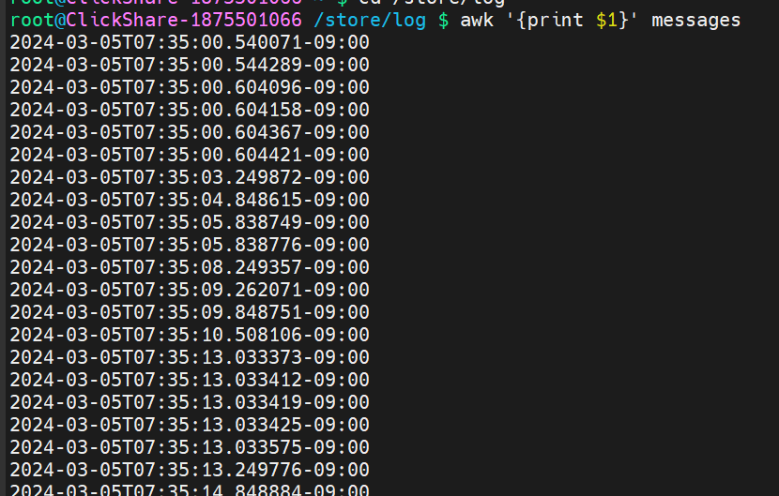

Prints everything : print0  
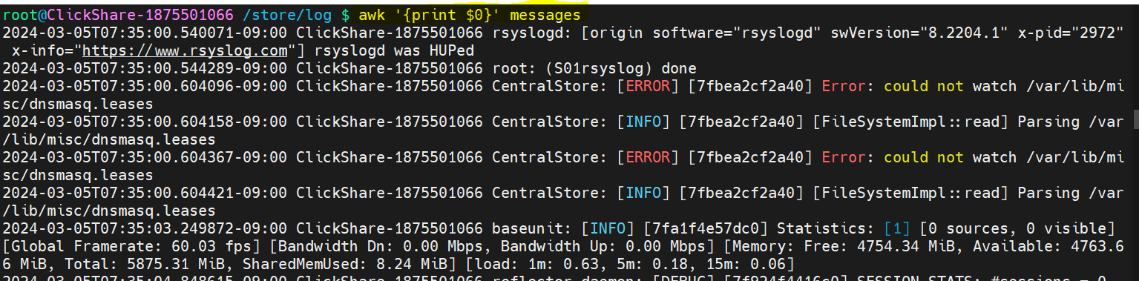

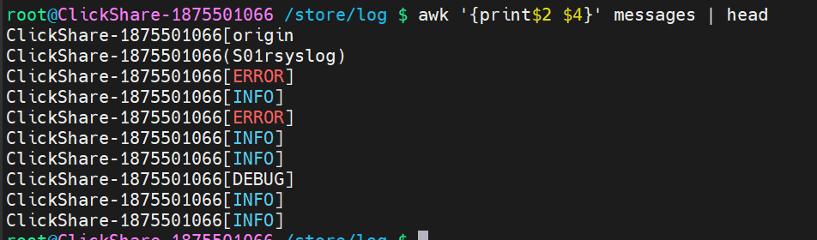

Prints last column :$NF

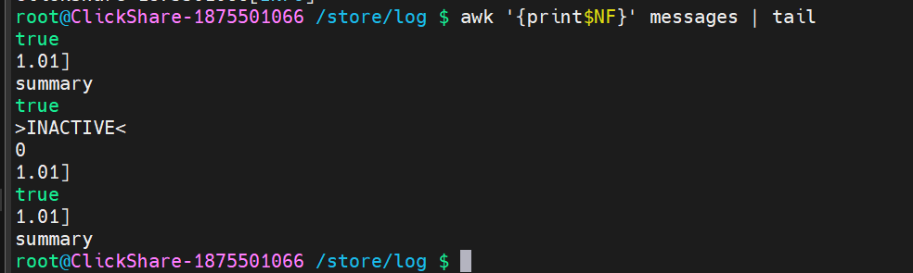

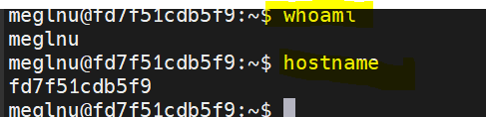

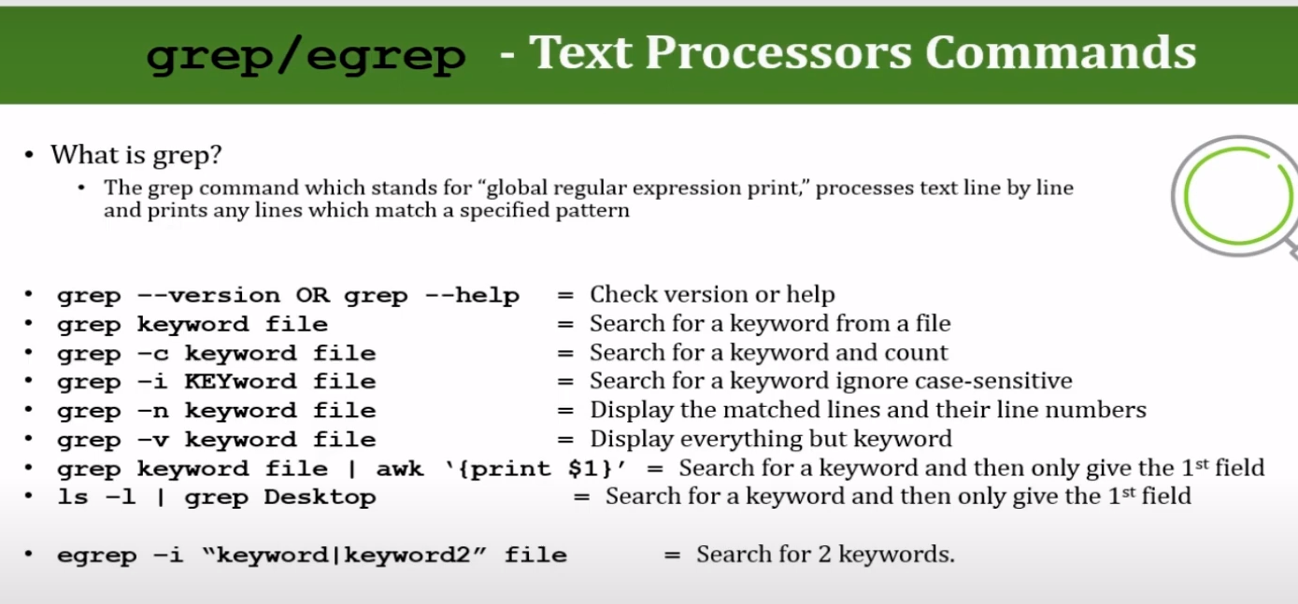

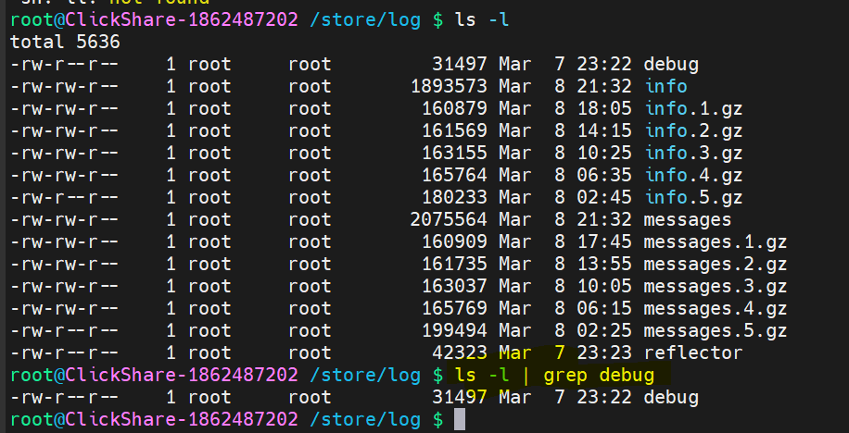

Count how many times Clickshare appears in messages log : -c  


If we ignore case sensitivity : -i  


Shows results aling with line numbers : -n   
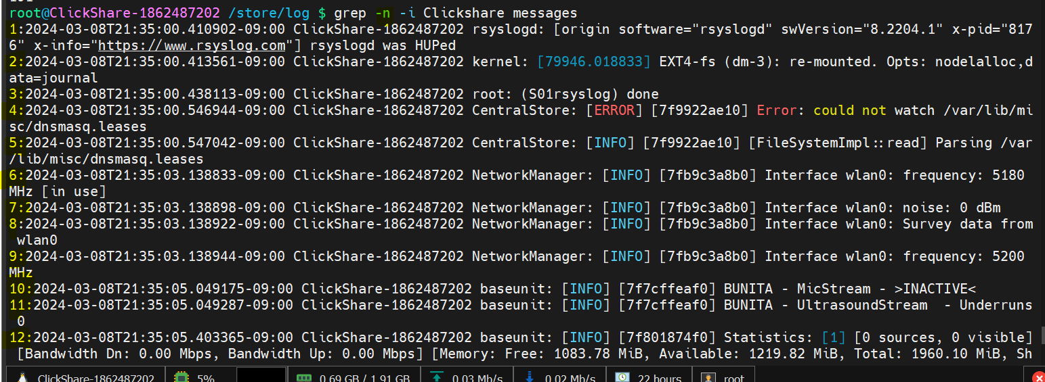

There is no line in clickshare logs with clickshare word in it. -v : command used to print everything not having this particular word in it  


There are lines without baseunit though :  
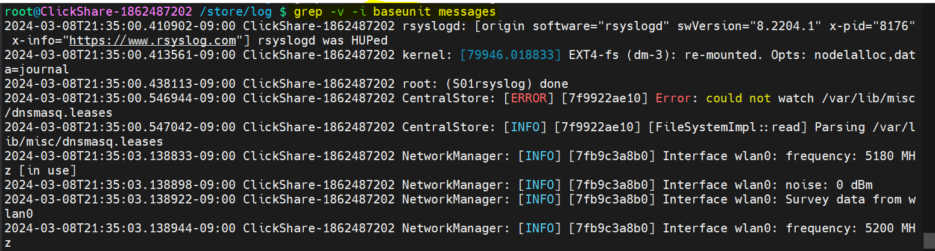

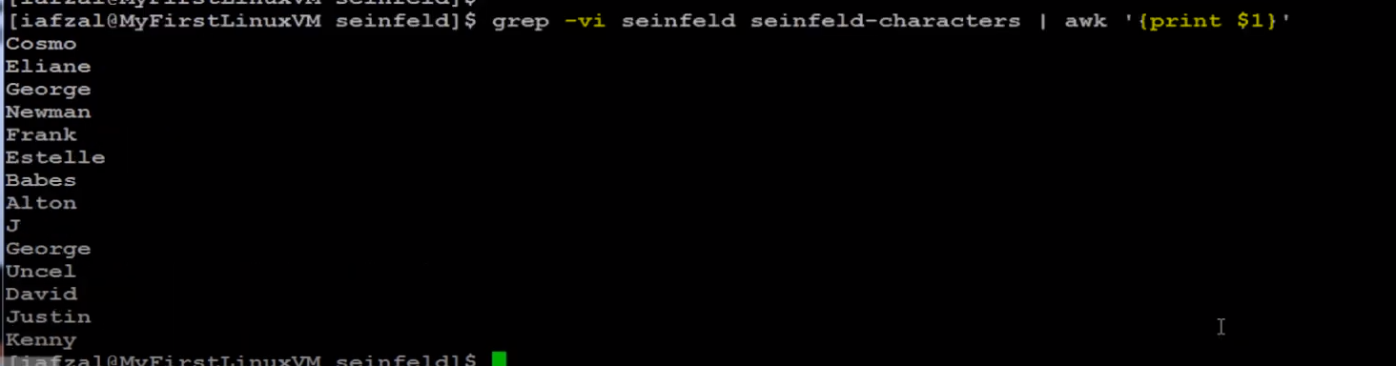

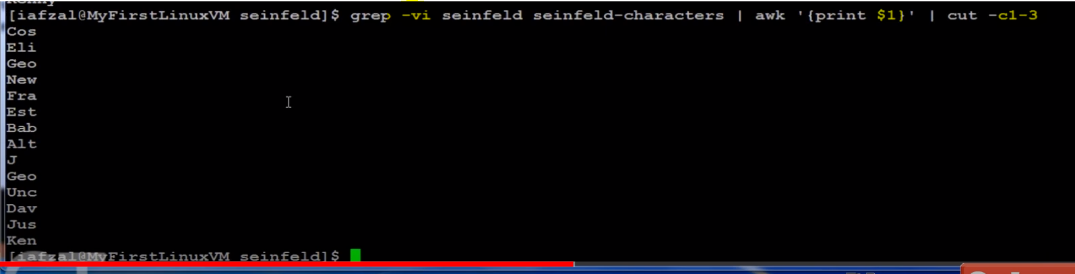

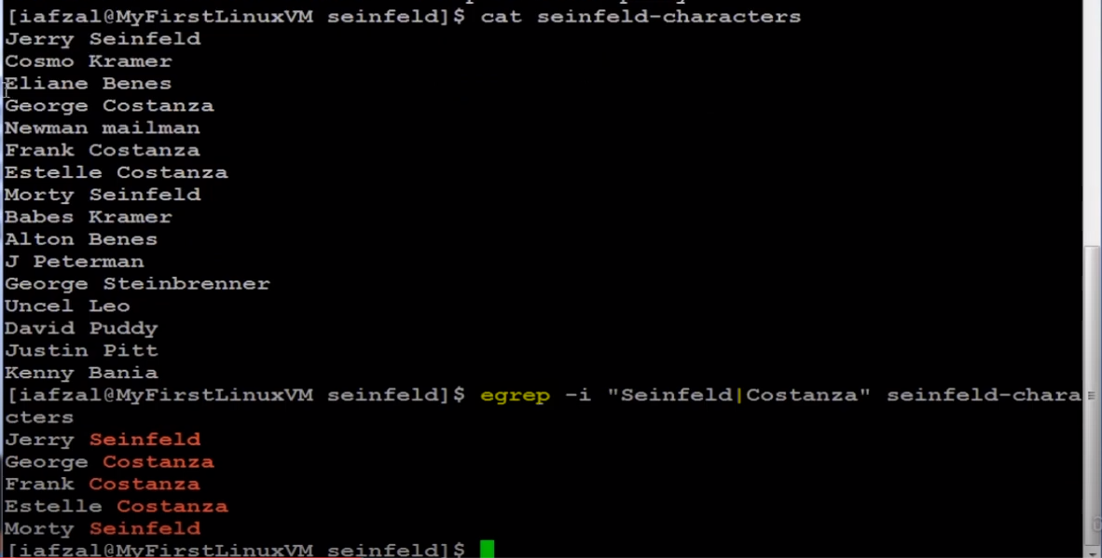

The command **tail -f <filename>** is used to display the last part of a file (**tail**) and to continually display any new lines added to the file in real-time (**-f** stands for "follow").

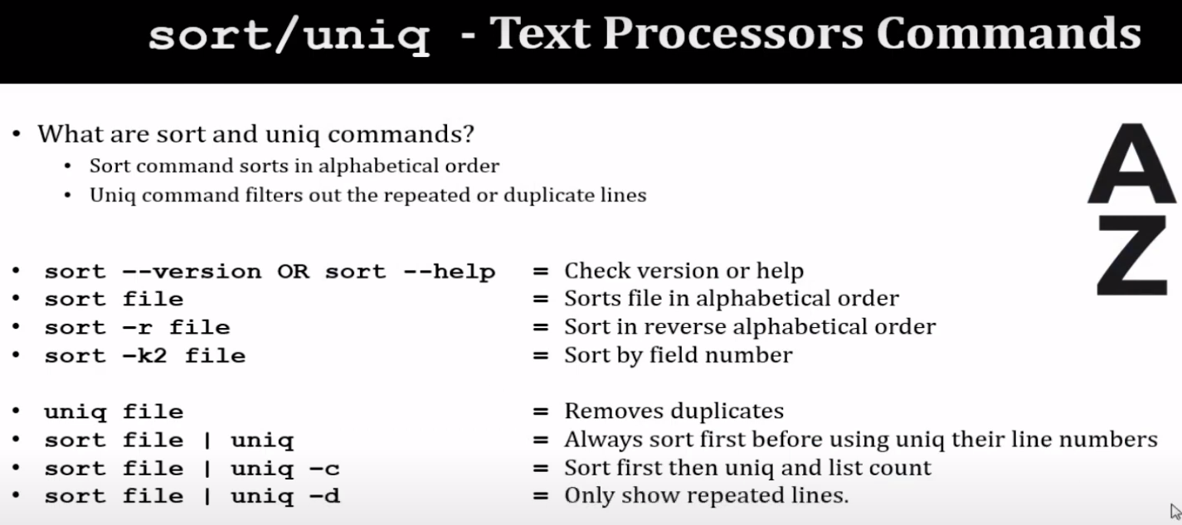

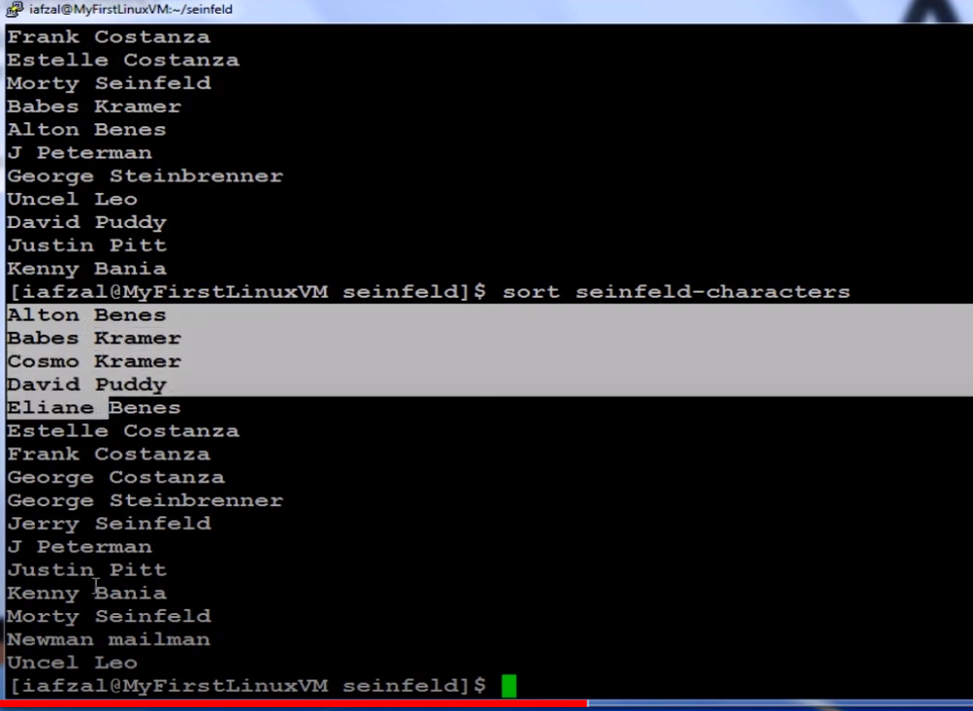

Sorting by second field:  
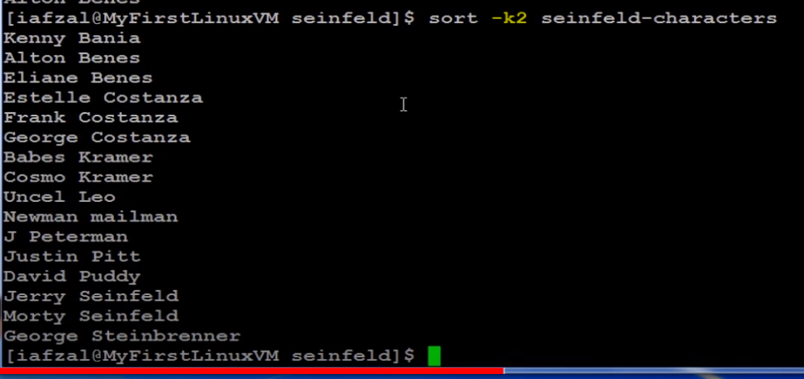

Sorted by last column :  
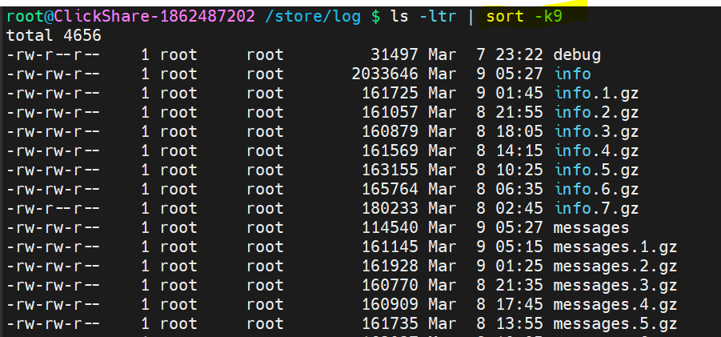

Uniq command alone doesn’t remove duplicates :  
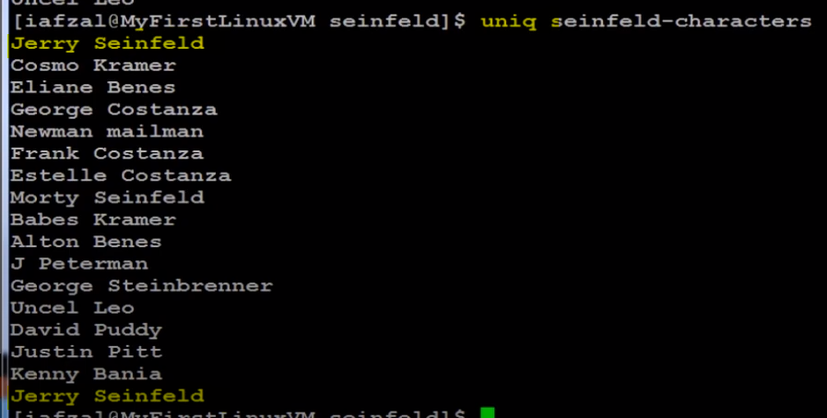  
  
First duplicates need to be arranged next to each other before being removed :  
  
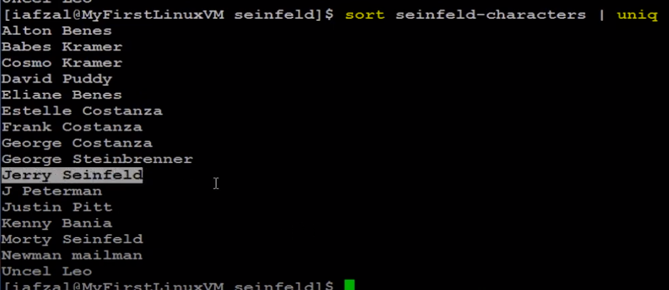

For showing the count of the duplicates removed :  
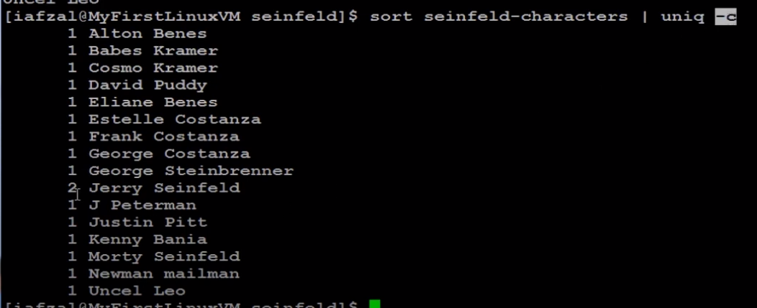

Shows only duplicate line :  


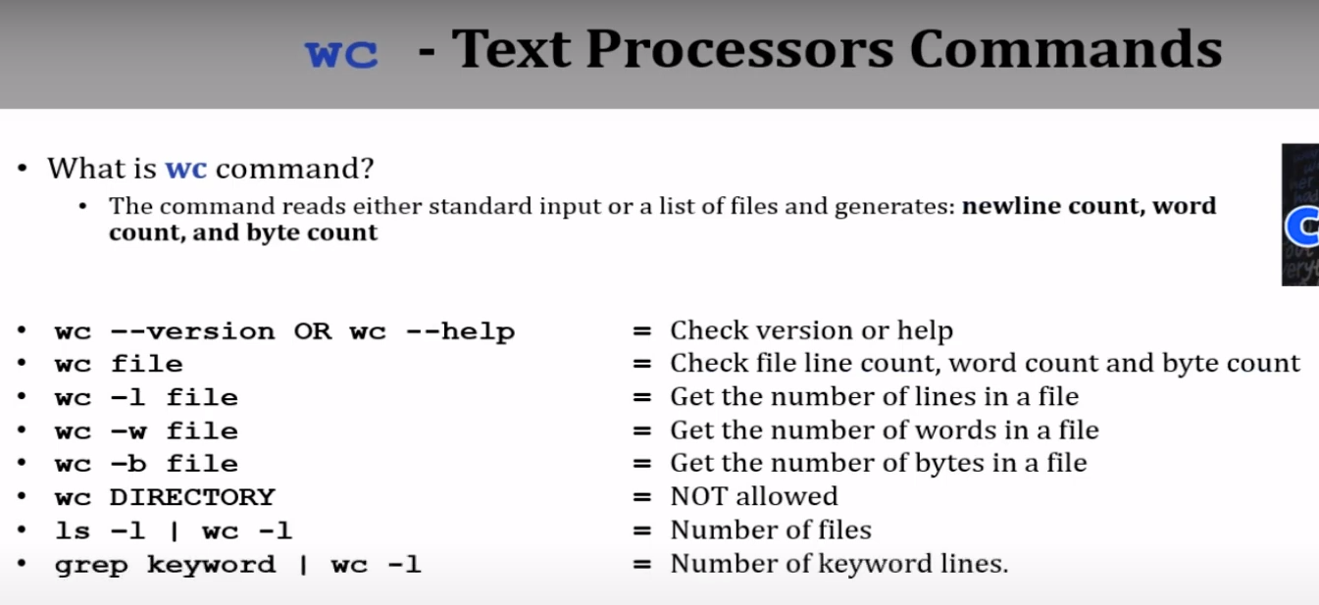

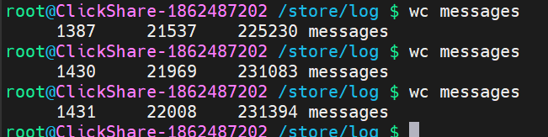

1431 lines, 22008 words, 231394 bytes

Following only gives the number of lines :  
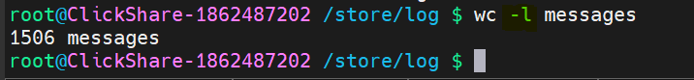

L : lines, w : words, c : bytes

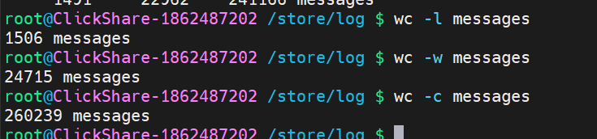

ls -ld :  
The command **ls -ld** is used to list directory information for a given directory.  
This is useful for quickly checking the properties of a directory without listing its contents.

This is telling info of log directory.



Another way to list only directories :  
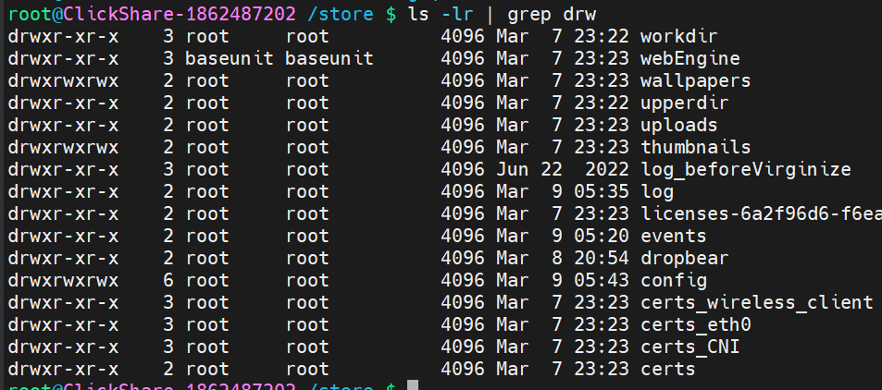

Command to list only directories : ls -d */  
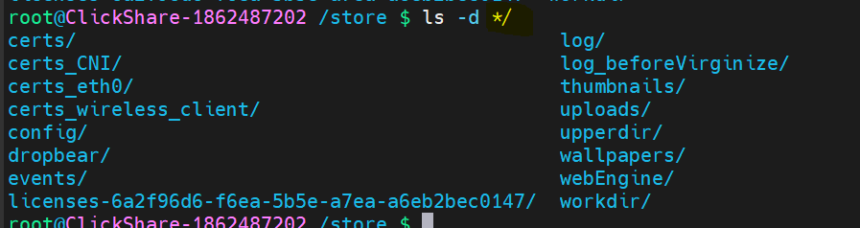

To find out how many with a particular keyword : grep keyword | wc -l

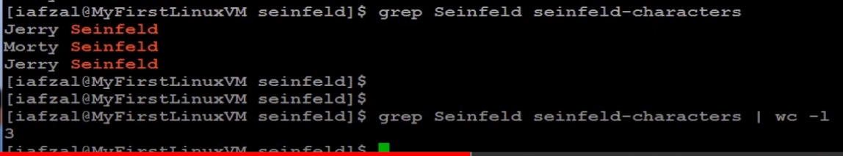

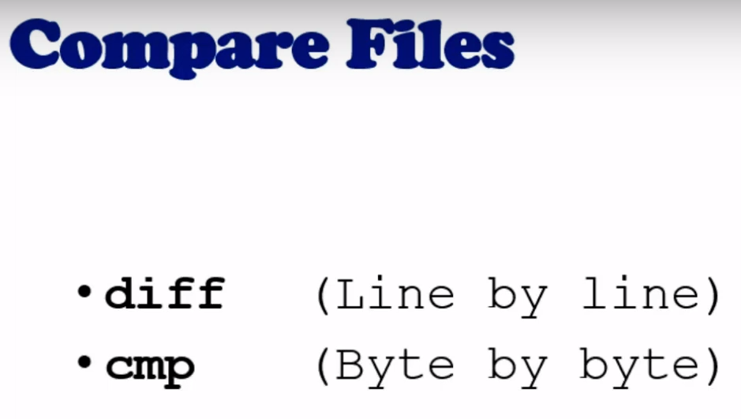

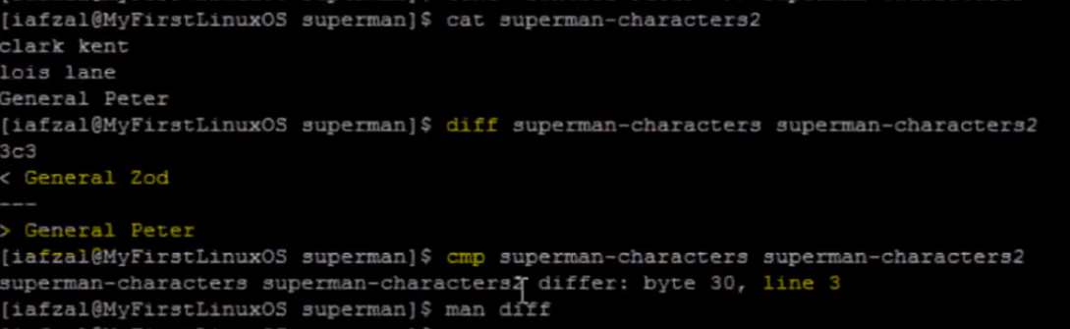

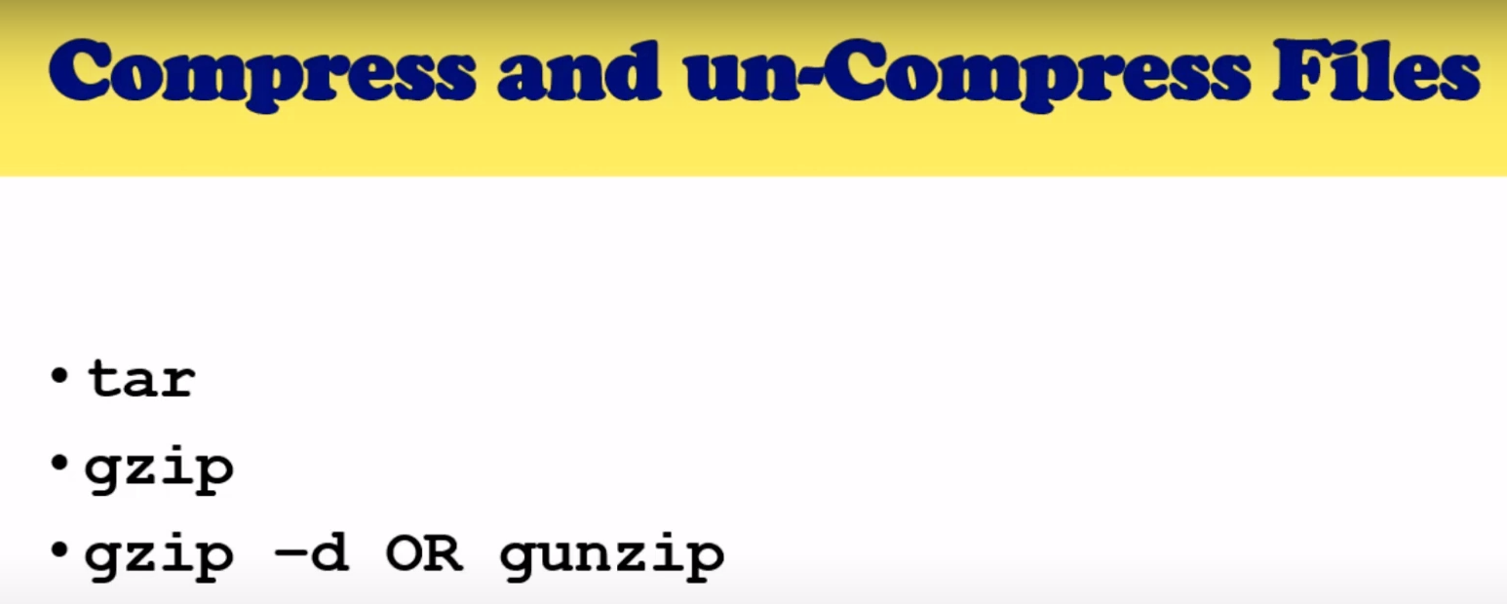



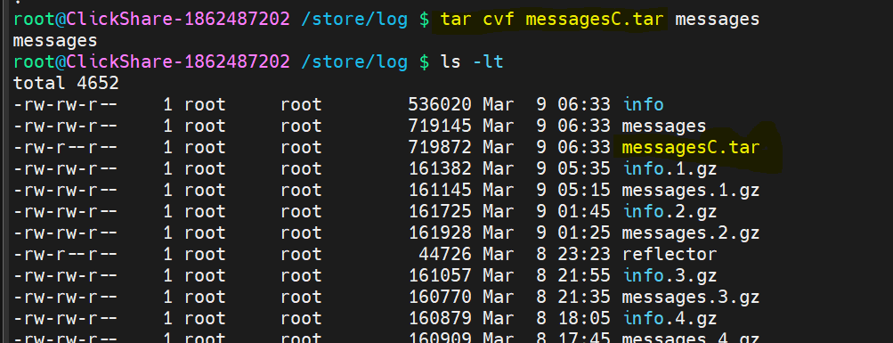

Untars with the name that was originally used to create the tar

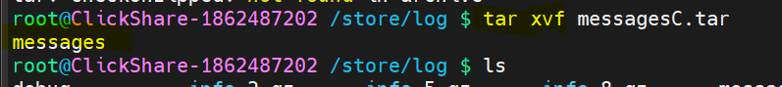

Gzip on tar further reduces size :  
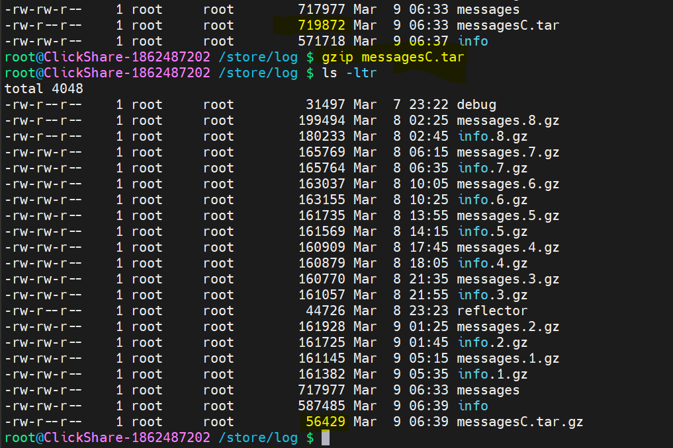

To create tar again from gzip :  
  
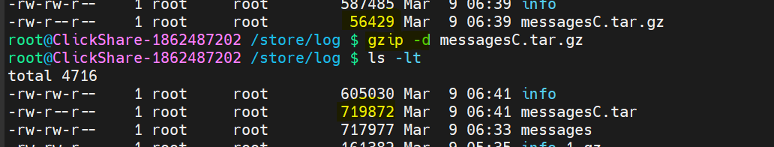

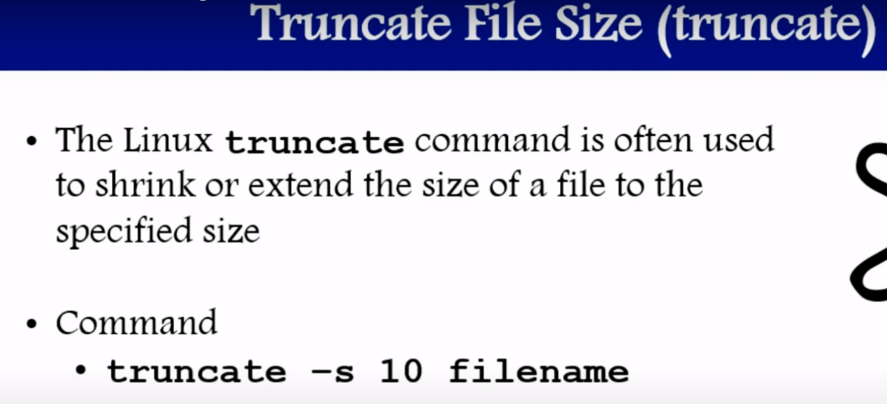

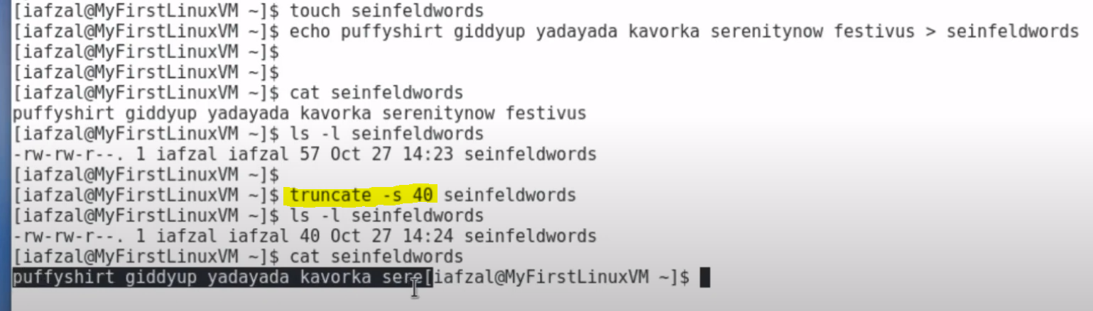

We can also use truncate to increase the size of a file. However it doesn’t bring back the truncated content.

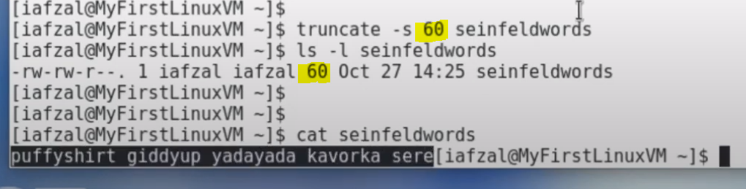

Increasing filesize like this adds special characters at the end of the file, visible in vi editor.

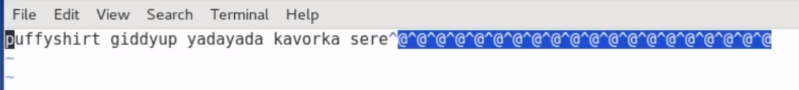

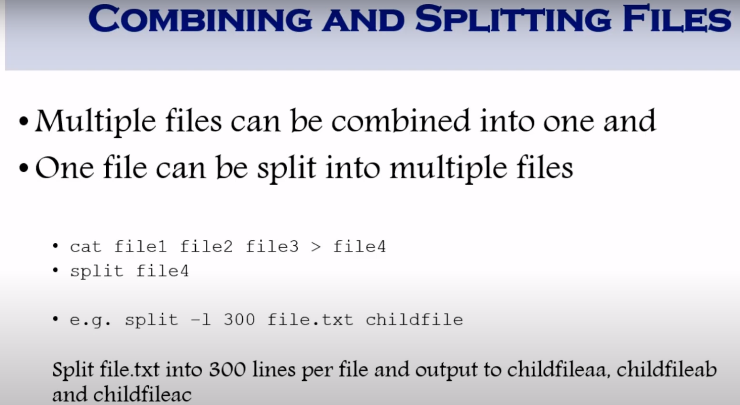

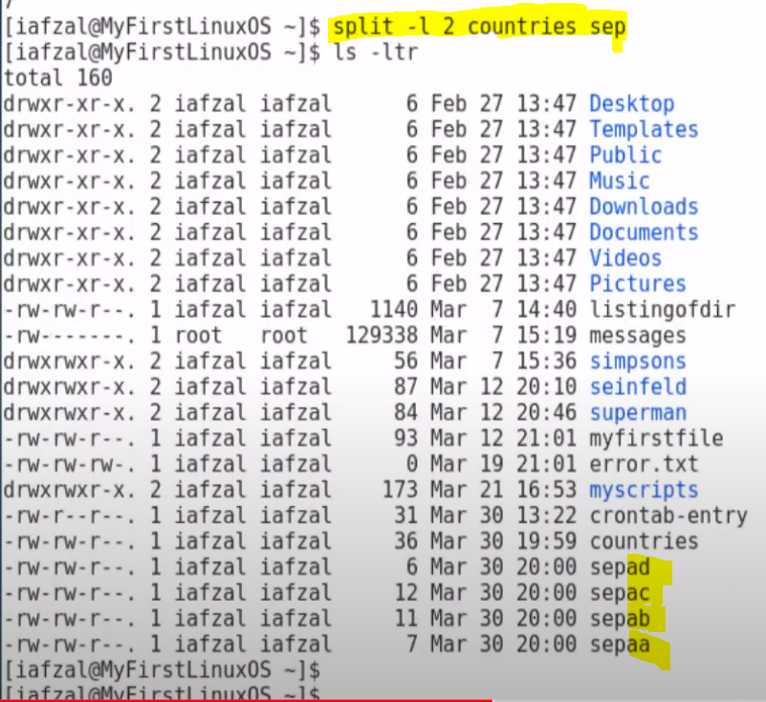

The content was evenly distributed amongst each other, except for the last file, for which we didn’t have the option to split files evenly.

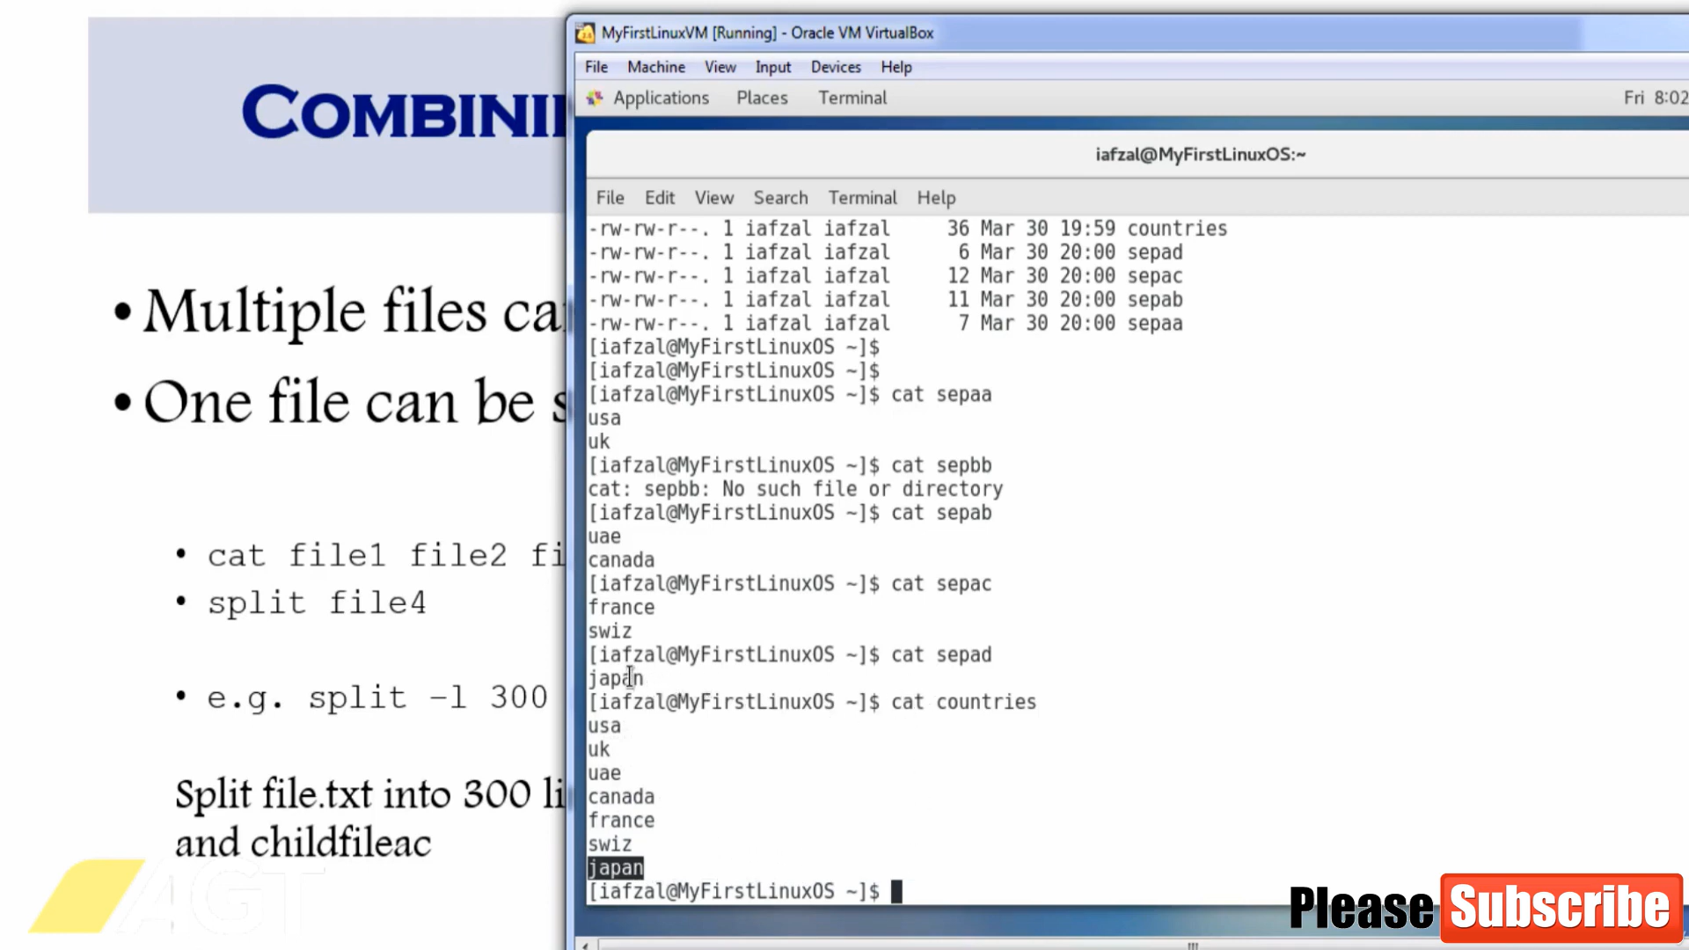

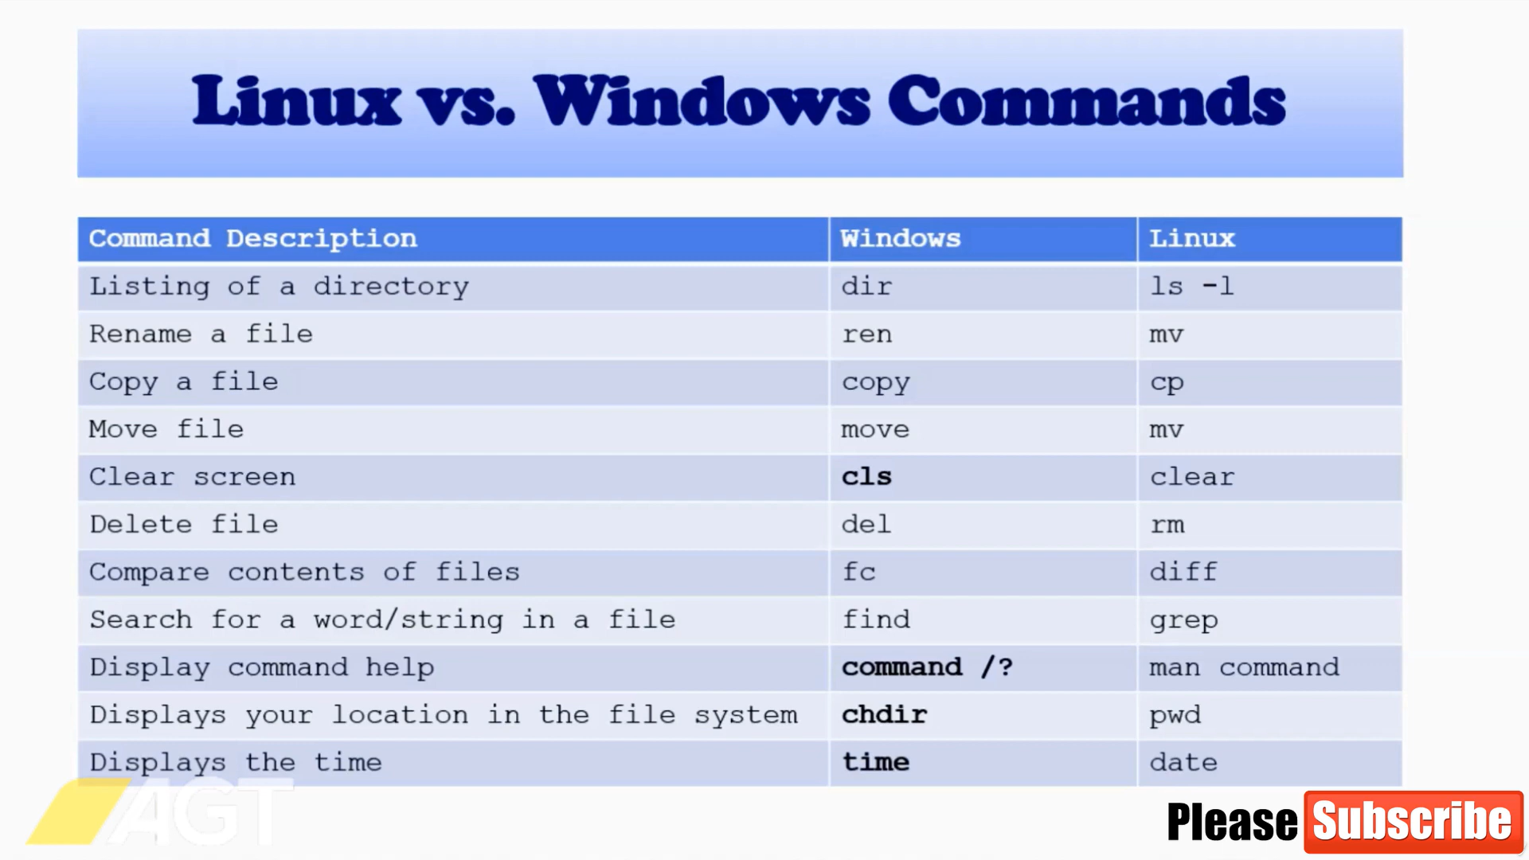

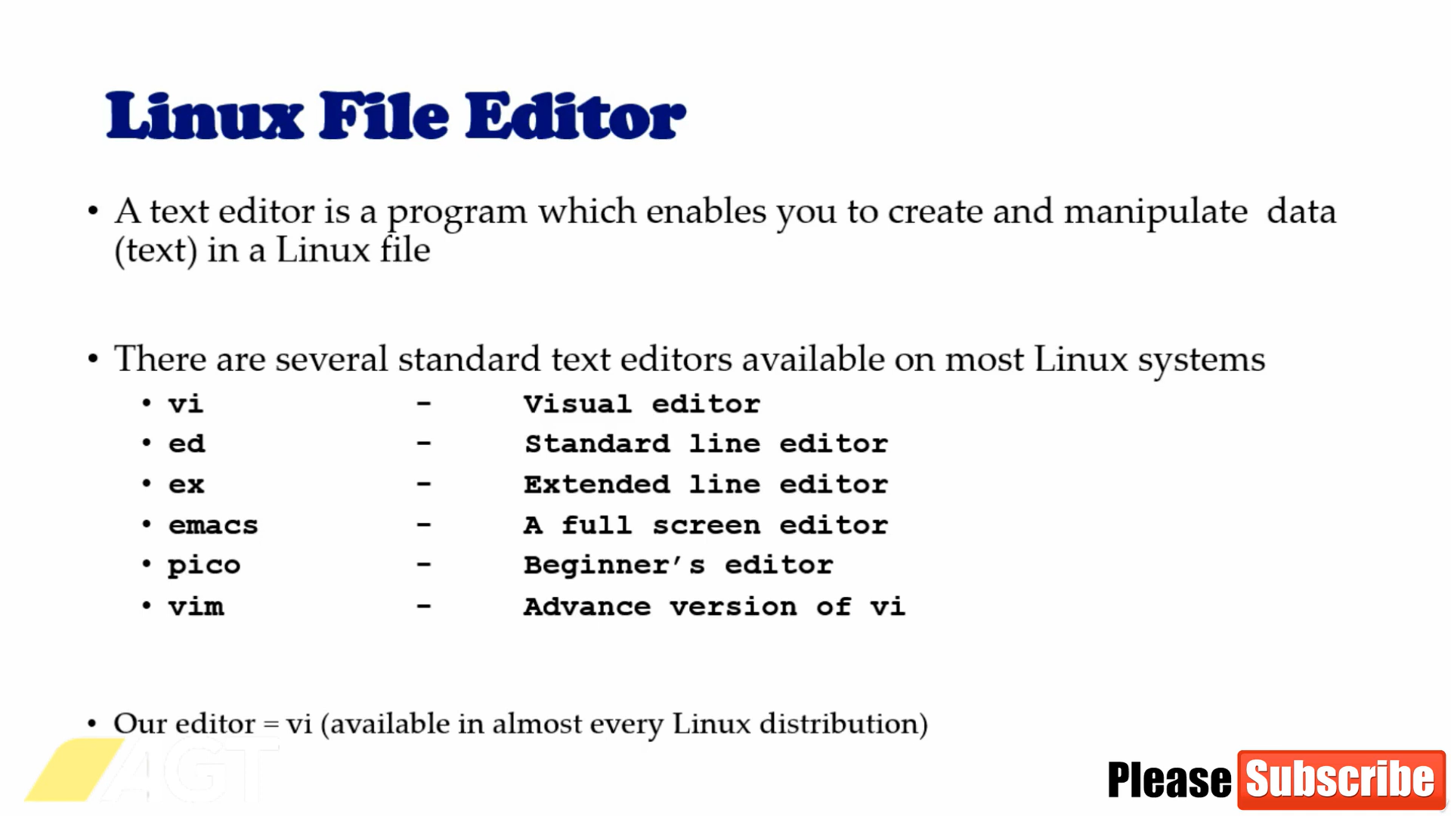  
  
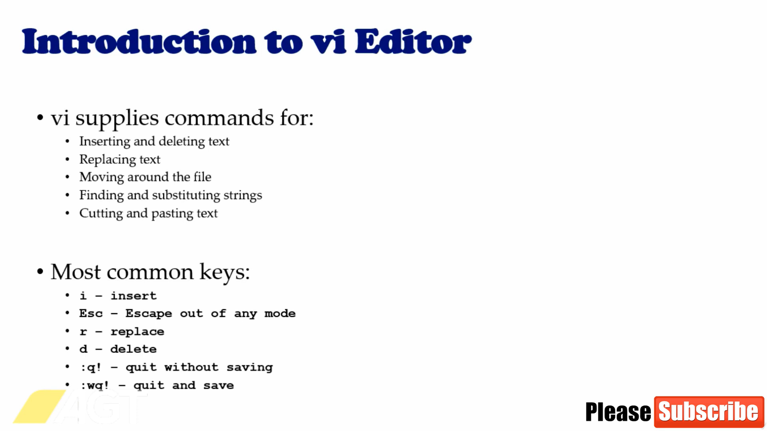

d : deletes entire line

x: removes single first character of line

u : undo operation

search using / followed by word to be search in non insert mode in vi  
  
